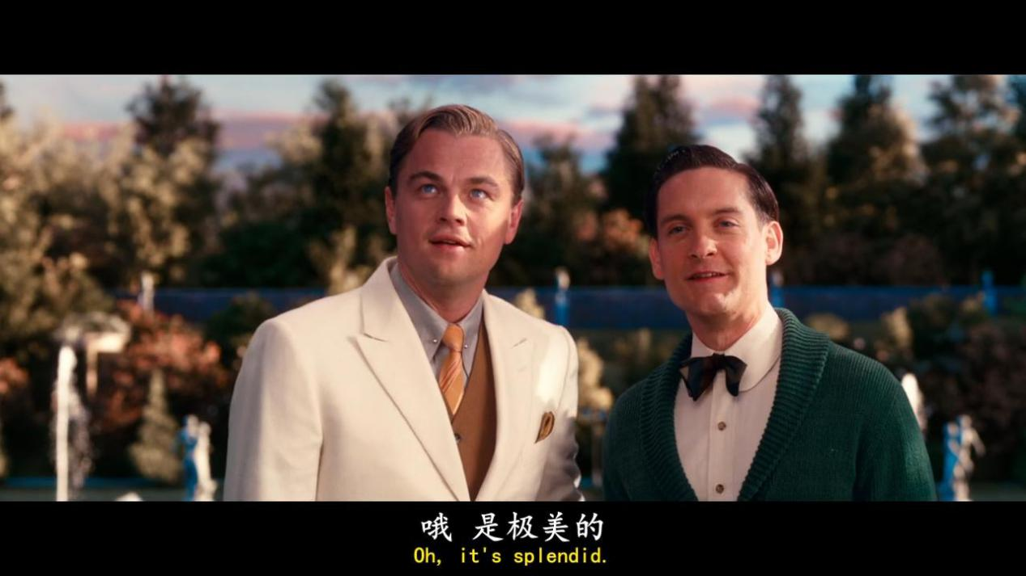

**Oh it’s splendid**

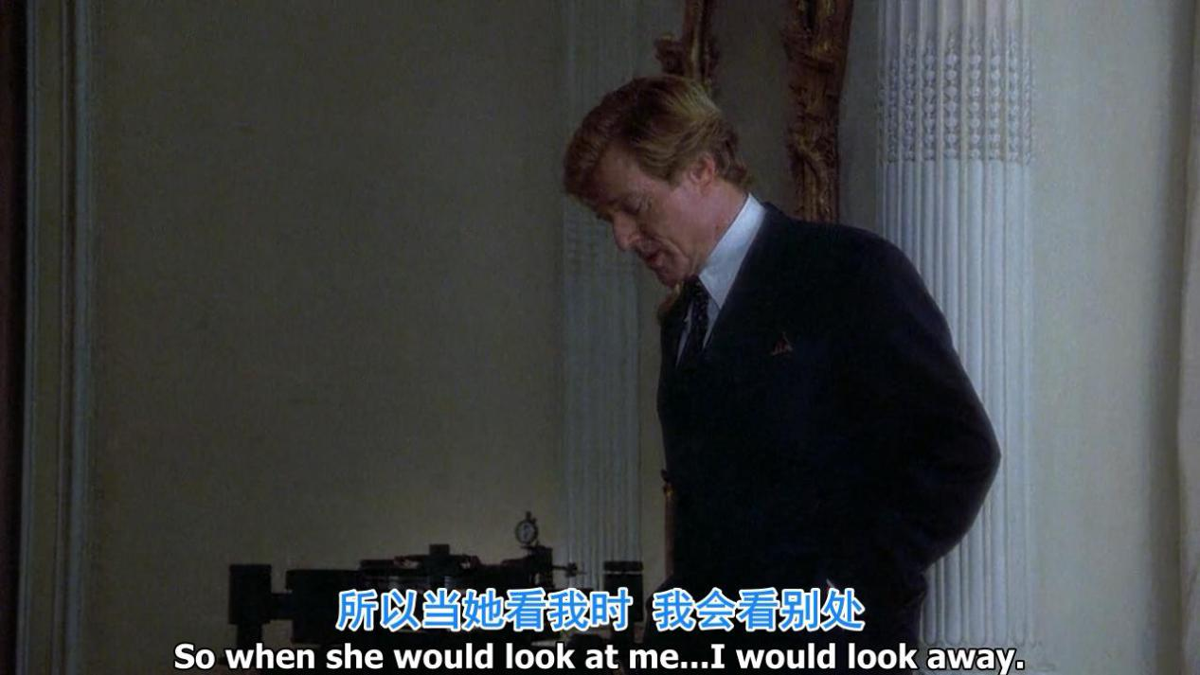

**So when she would look at me ...i would look away**

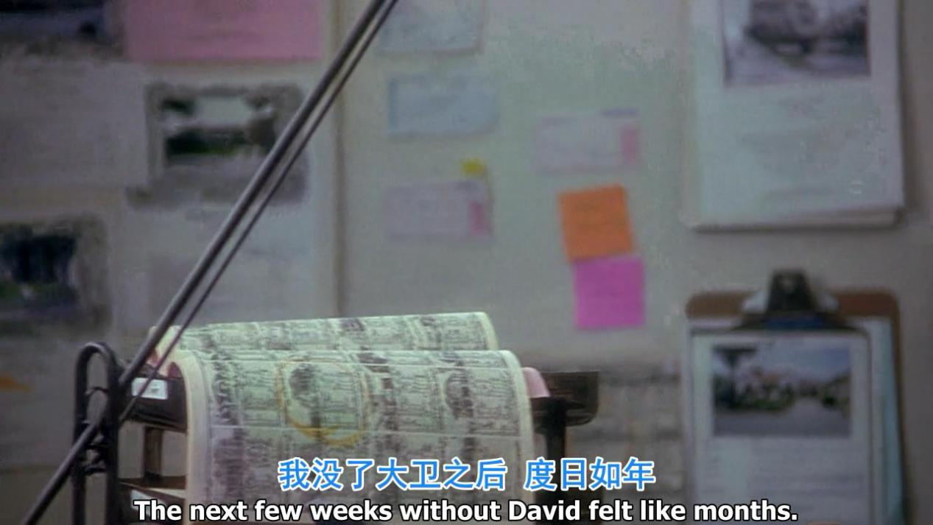

The next few weeks without you like months

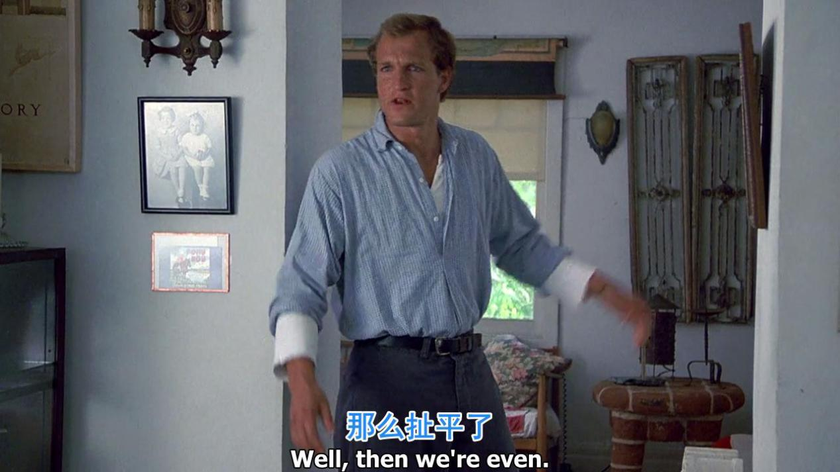

Well, then we are even

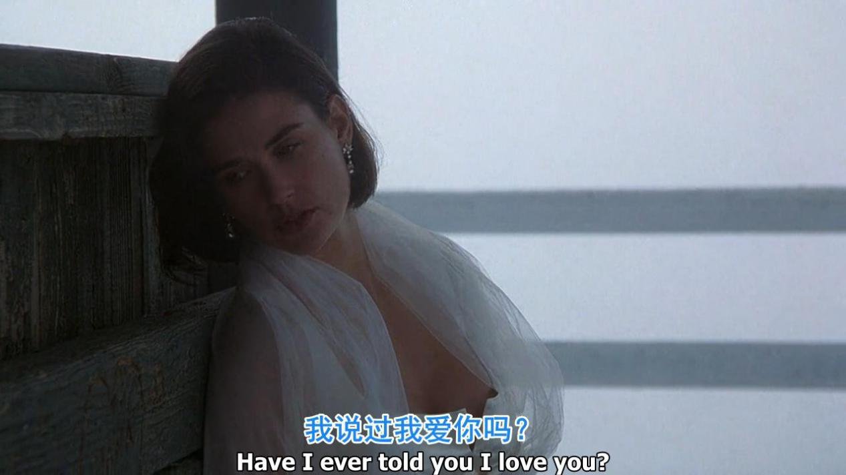

Have i ever told u i love u

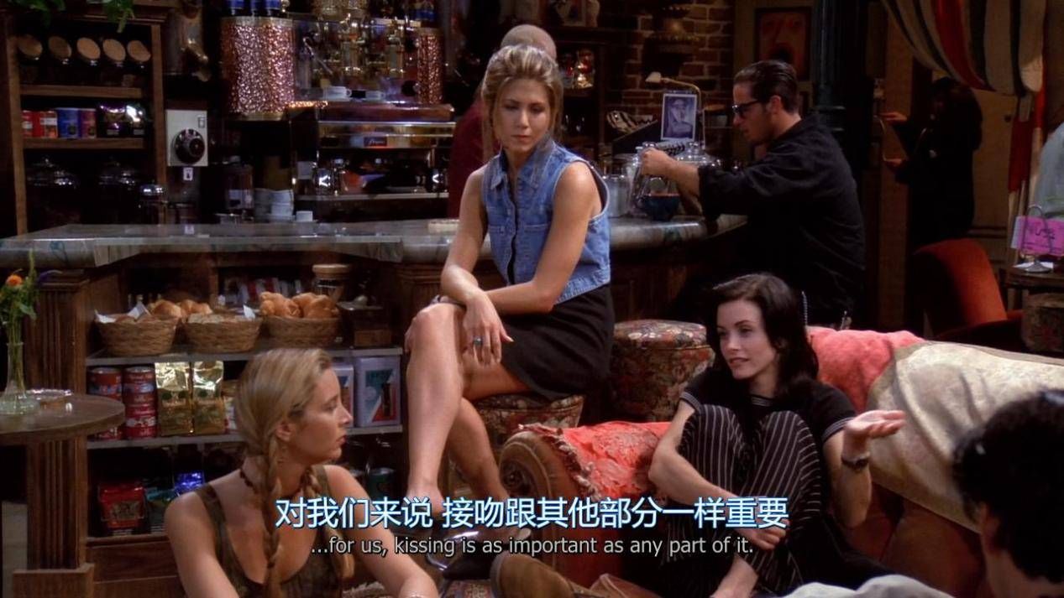

For us,kissing is as important as any part of it.

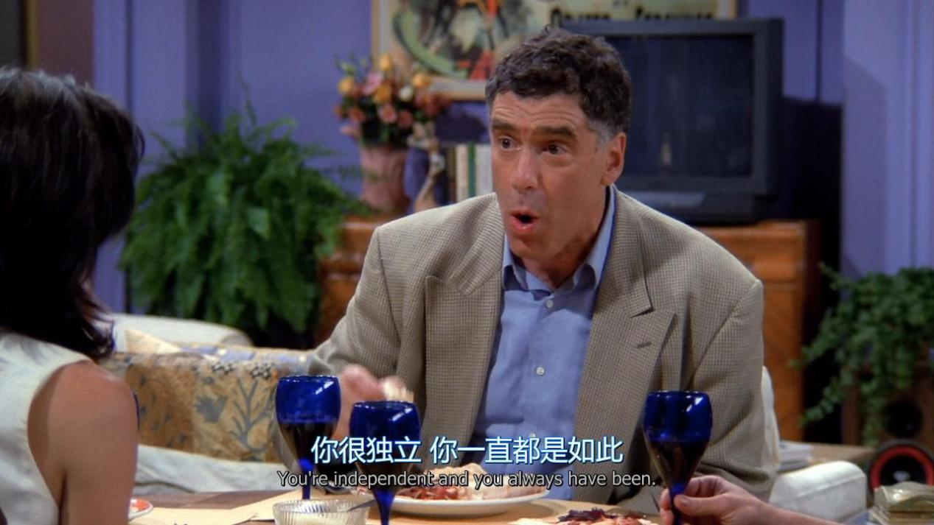

You are independent and you always have been

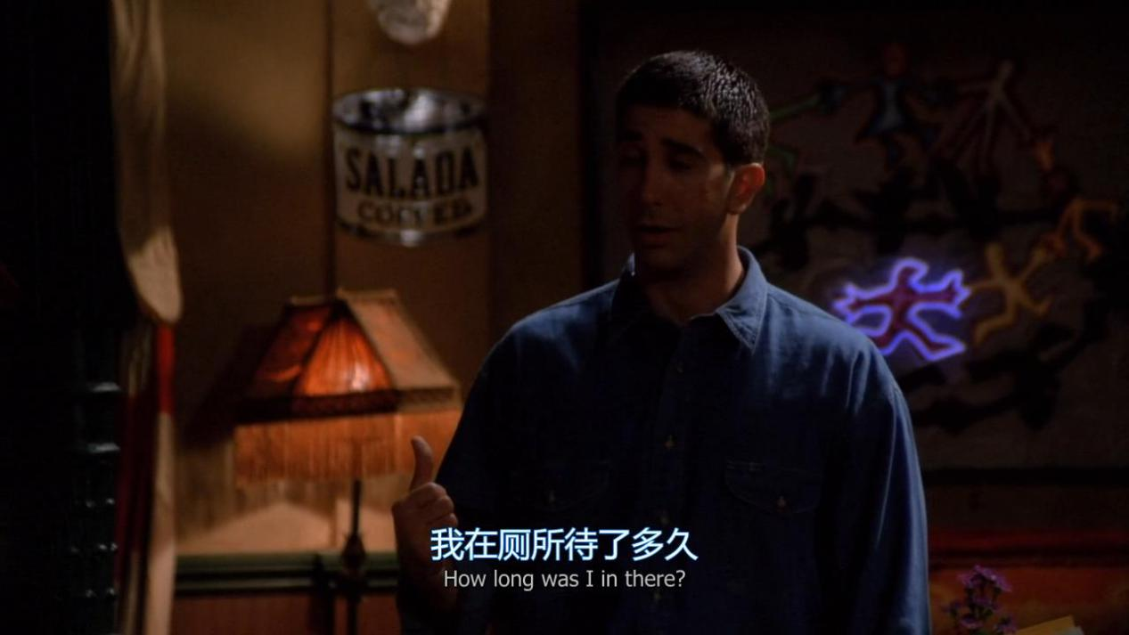

How long was i in there?

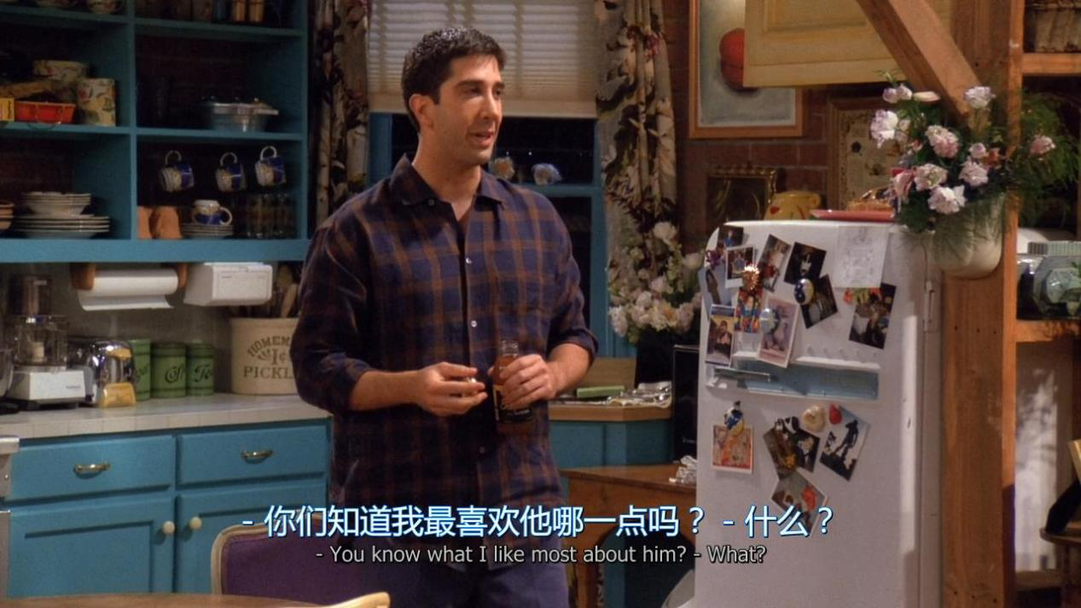

You know what i like most about him?

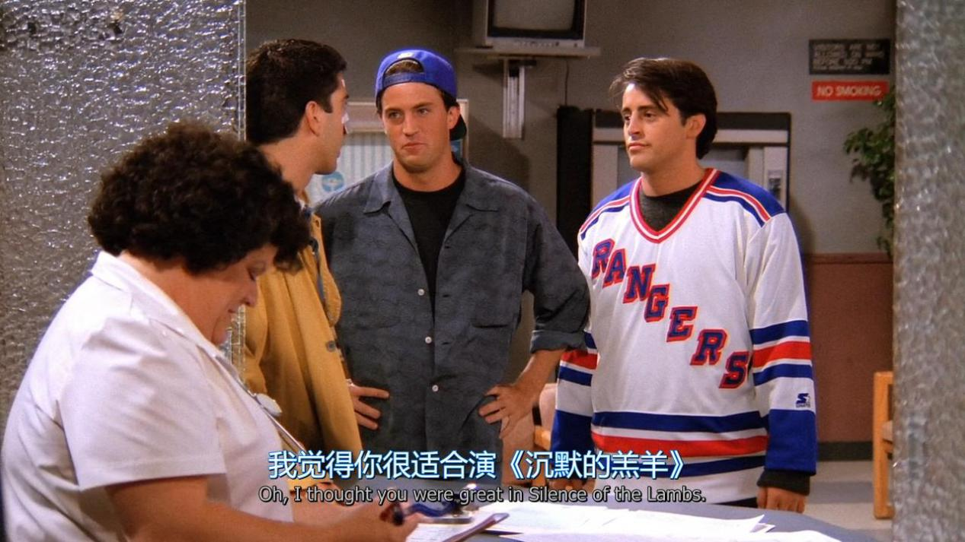

Oh,i thought you were great in Silence of the Lambs

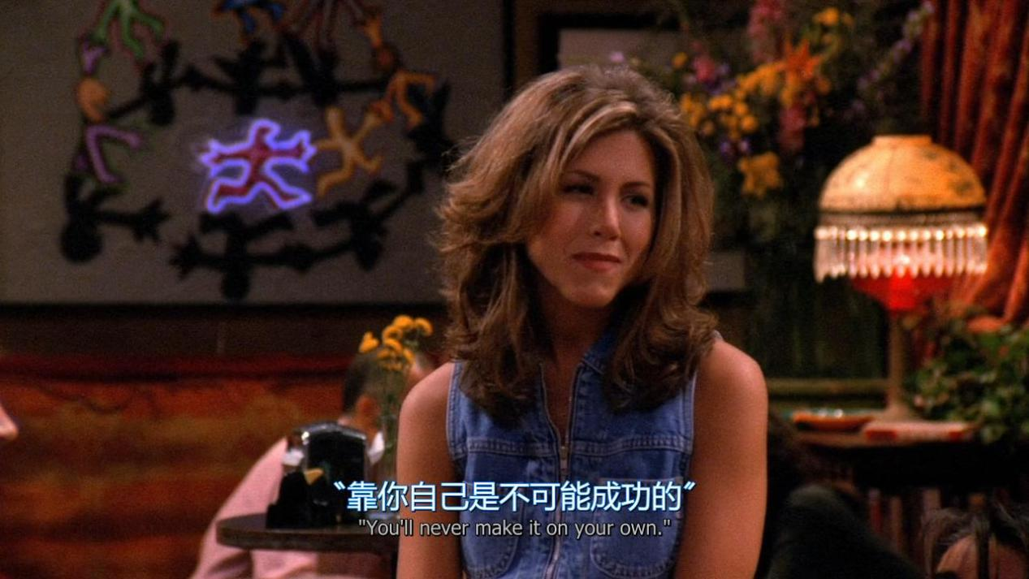

You will never make it on your own

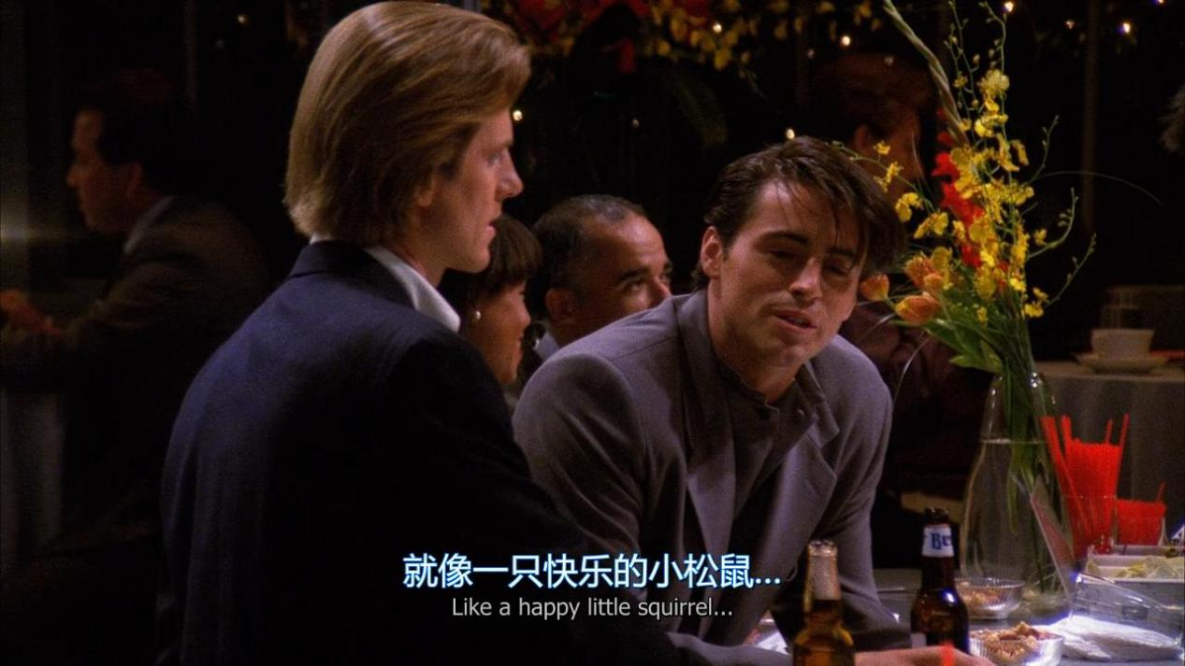

Like a happy little squirrel

1. "前肯后否"型句式  
   He is a student,isn't he?（他是一个学生,不是吗?）   
   Yes,he is.（是的,他是.） / No,he isn't.（不,他不是.）  
   She likes apples,doesn't she?（她喜欢苹果,不是吗?）  
   Yes,she does.（是的,她喜欢.） /No,she doesn't.（不,她不喜欢.）   
   二."前否后肯"型句式  
   He isn't a student,is he?（他不是一个学生,对吗?）   
   Yes,he is.（不,他是.）/ No,he isn't.（对,他不是.）   
   She doesn't like apples,does she?（她不喜欢苹果,对吗?）  
   Yes,she does.（不,她喜欢.） /No,she doesn't.isn't.（对,她不喜欢.）

I don’t give a shit 我才不在乎.（生气状态或者很屌的时候说的）

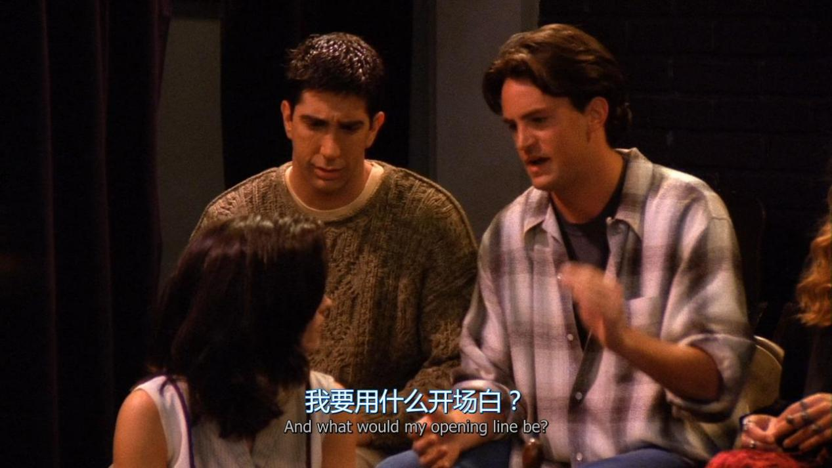

And what would my opening line be ?

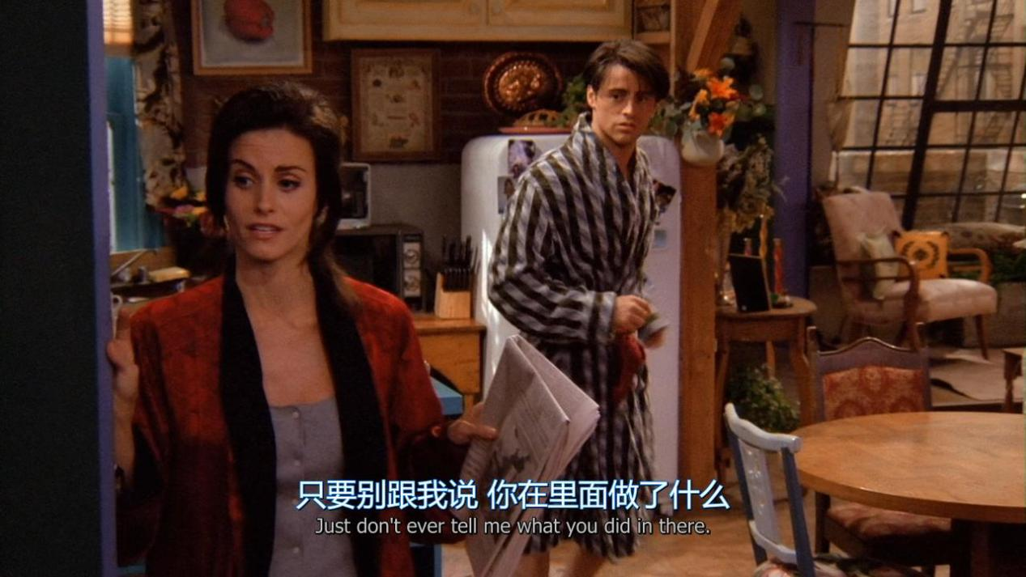

Just don’t ever tell me what you did in there

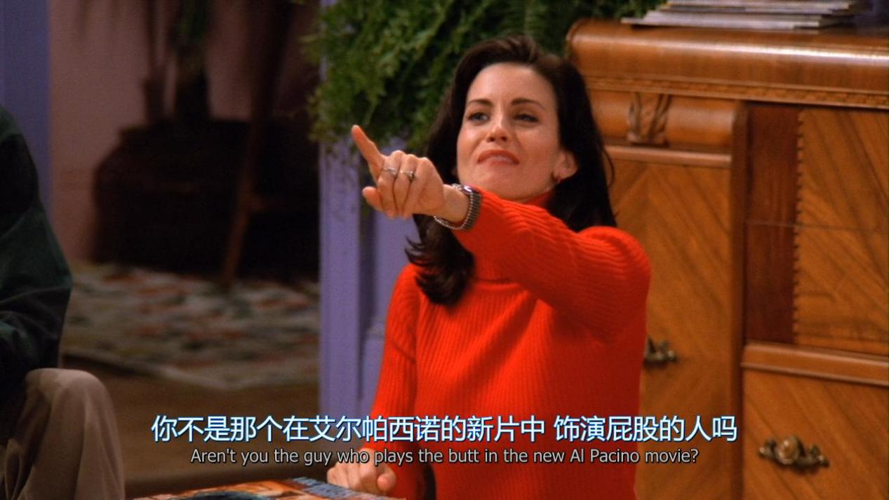

Aren’t you the guy who plays the butt in the new XX movie ?

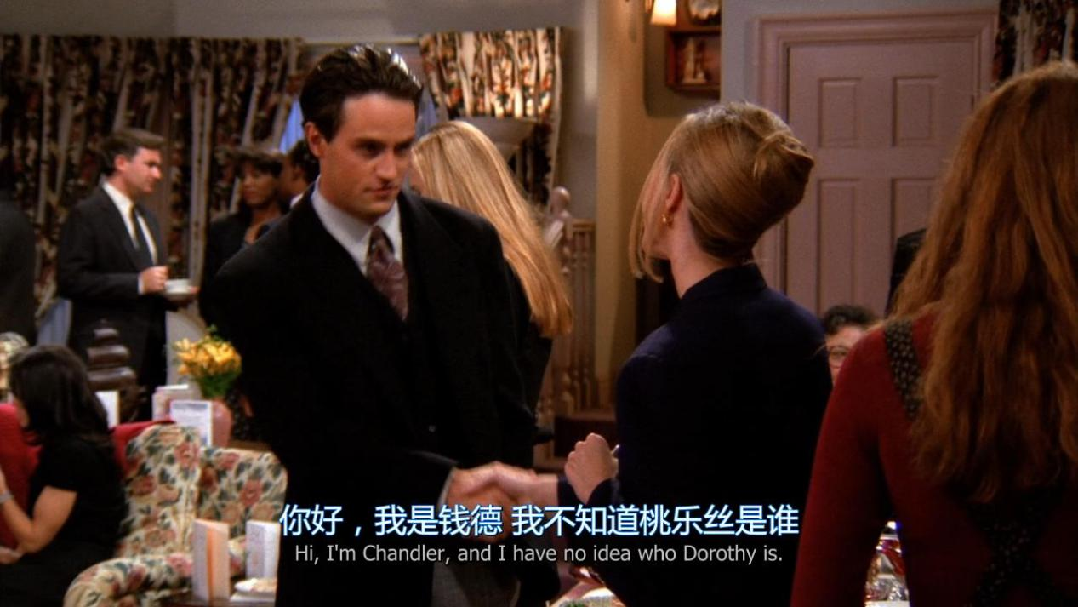

I have no idea who Ming is.

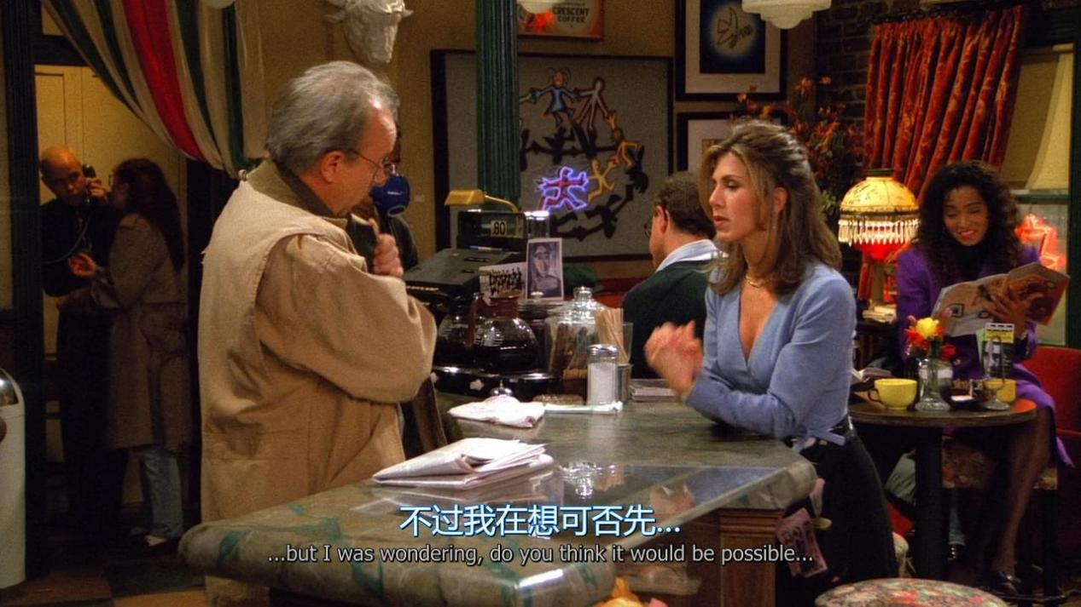

But i was wondering, do you think it would be possible

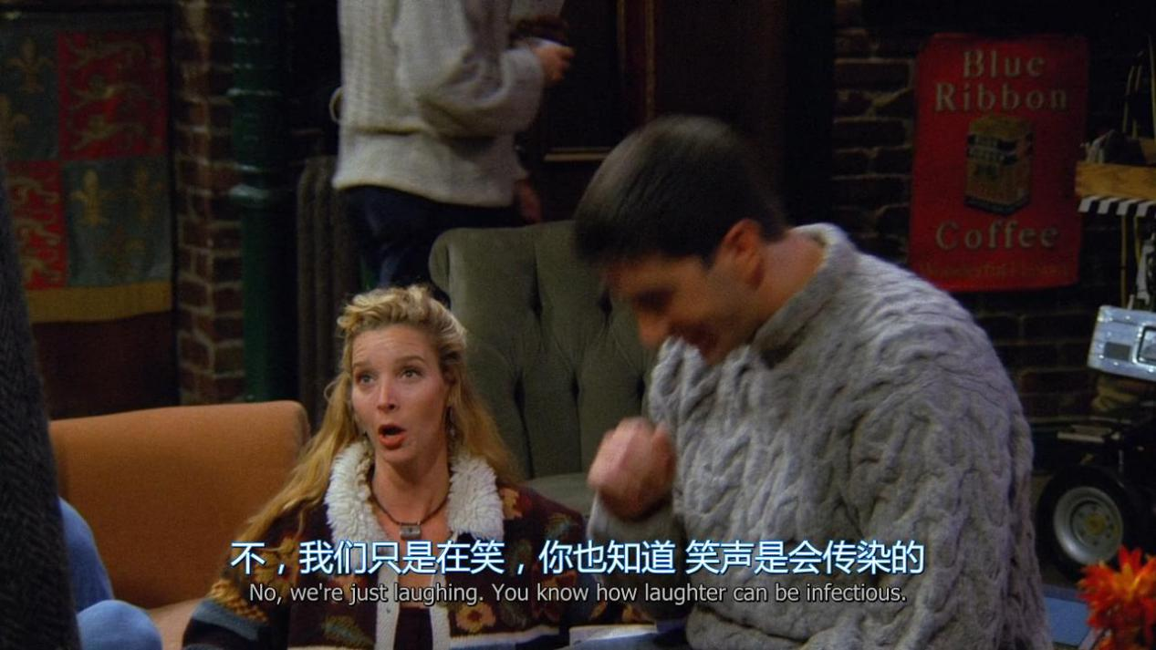

We are just laughing.you know how laughter can be infectious

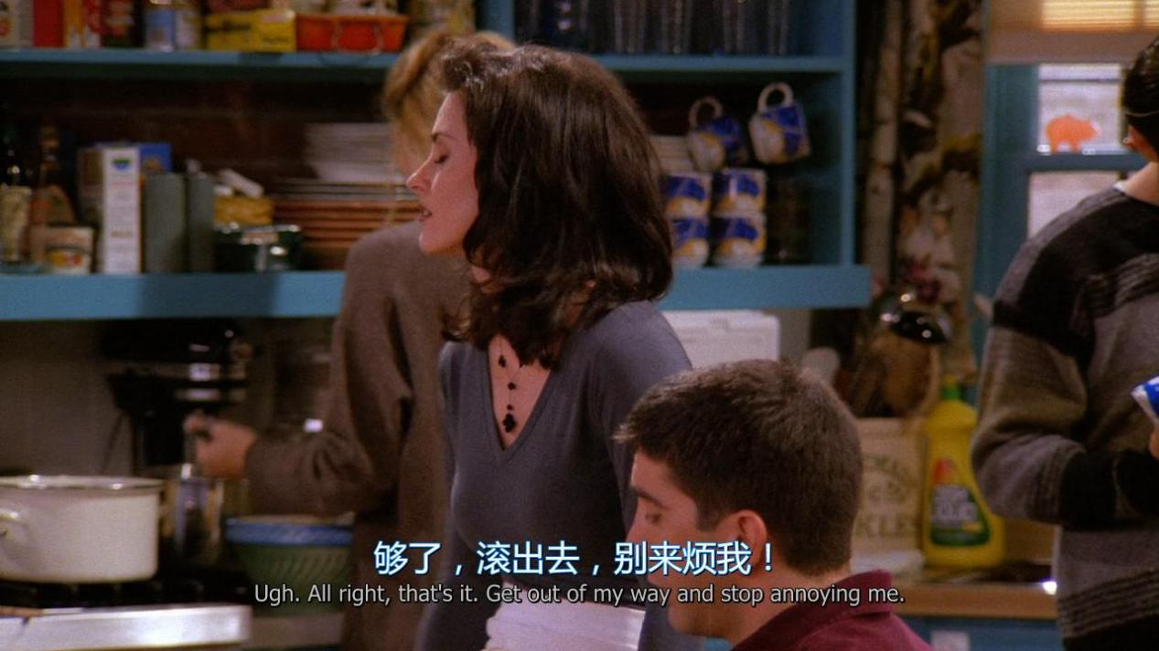

Get out of my way and stop annoying me.

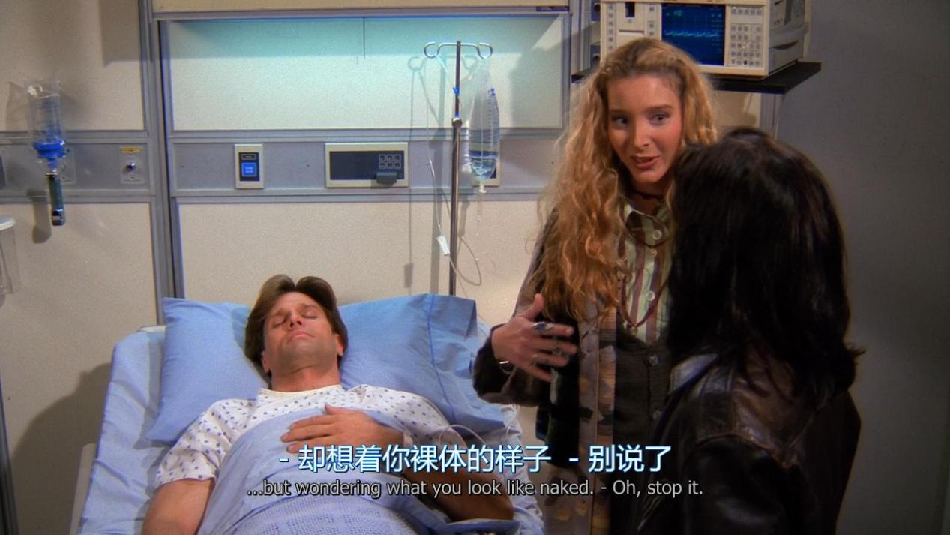

but wondering what you look like naked.

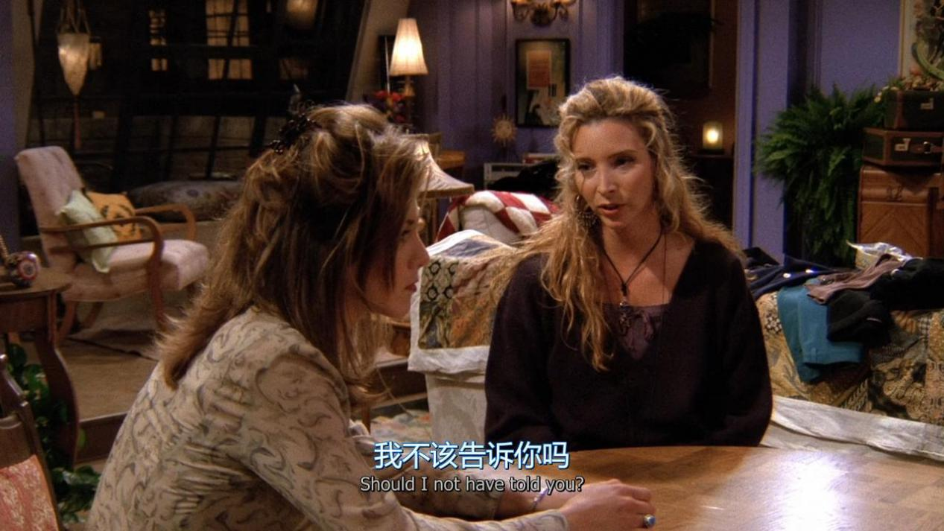

Should i not have told you ?

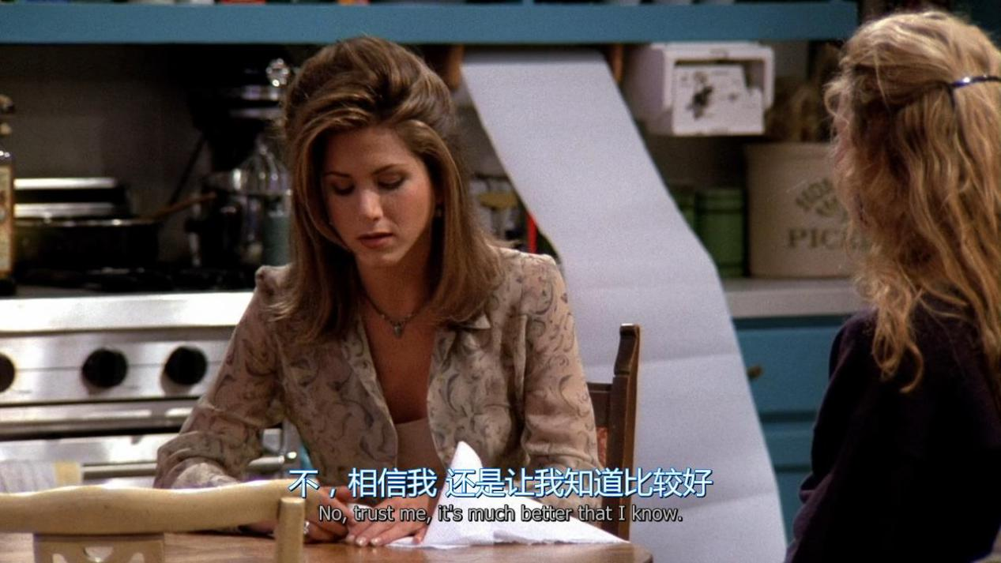

No , trust me,It’s much better that i know

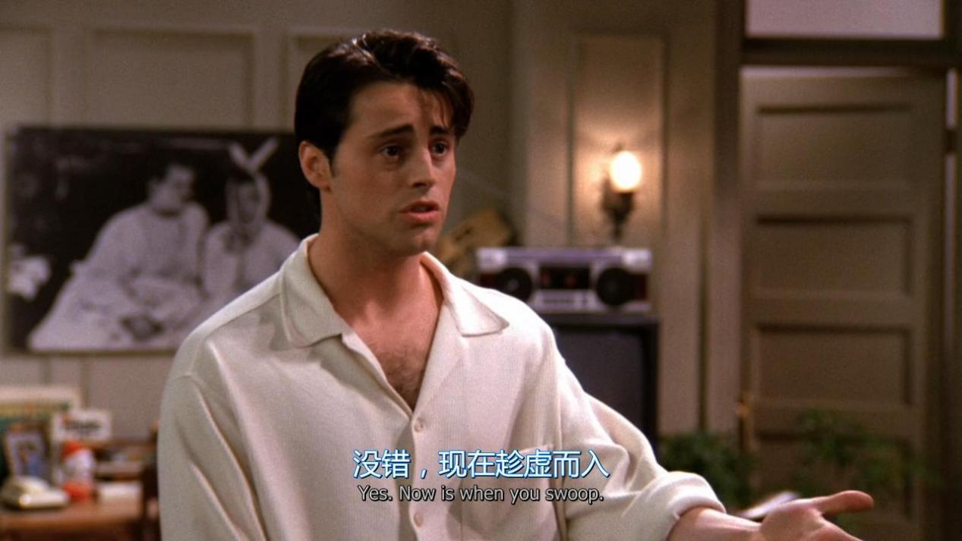

Now is when you swoop

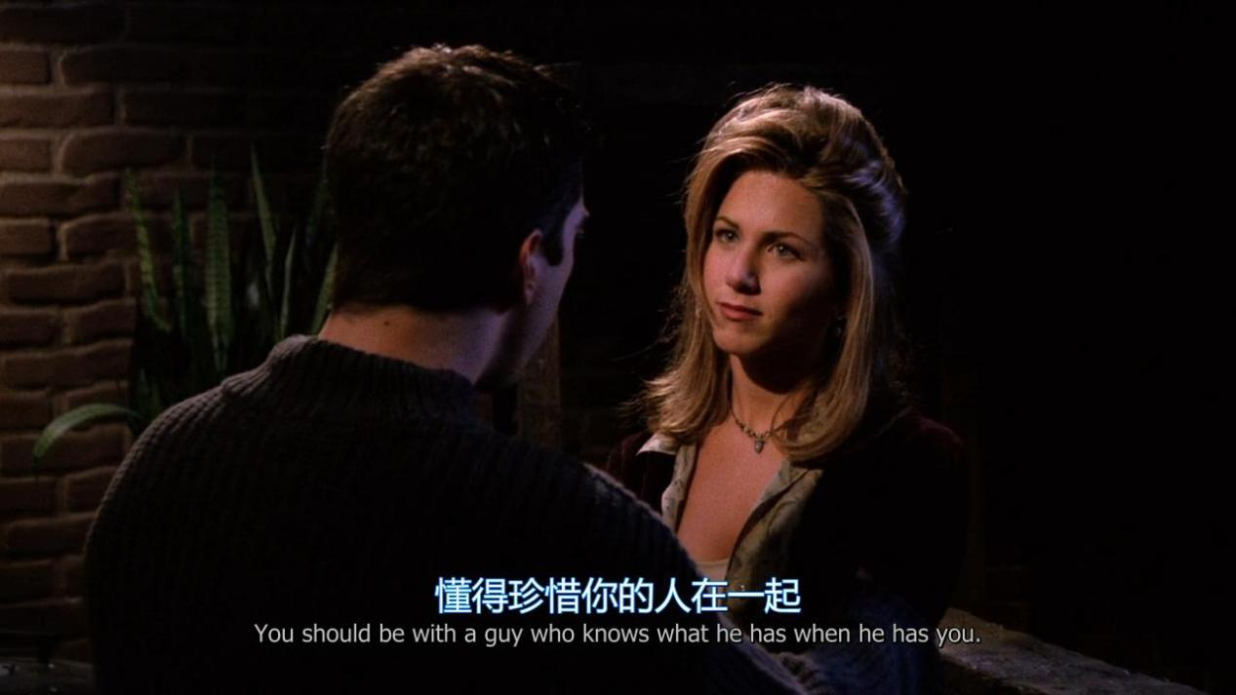

You should be with a guy who knows what he has when he has you

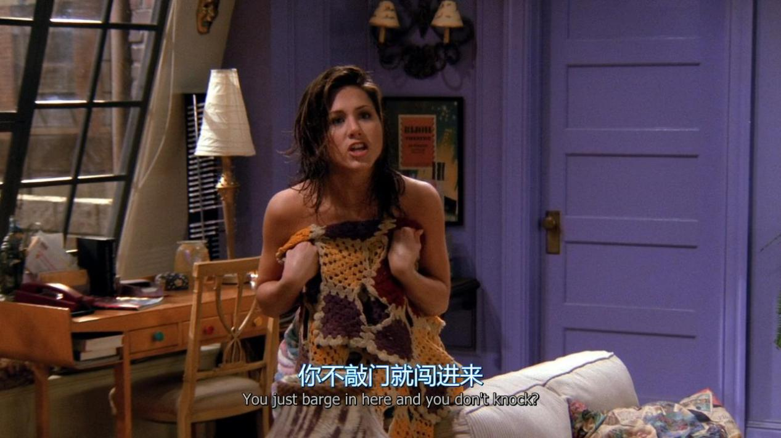

You just barge in here and you don’t knock

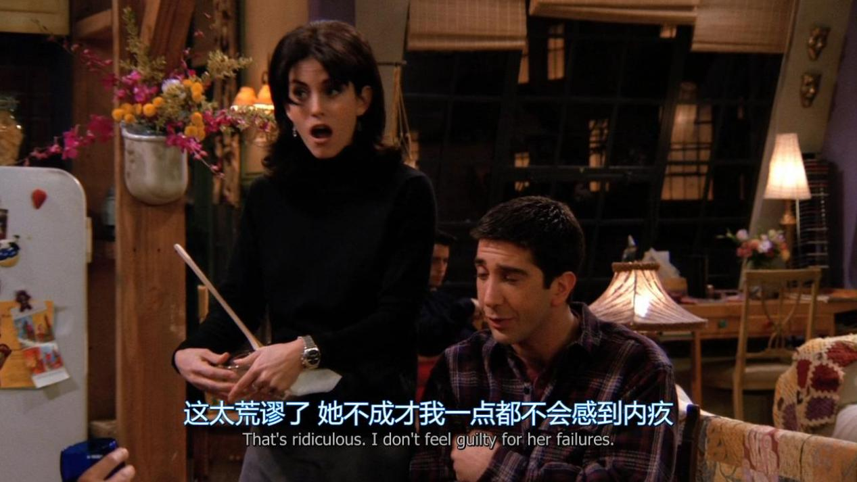

That’s ridiculous . I don’t feel guilty for her failures.

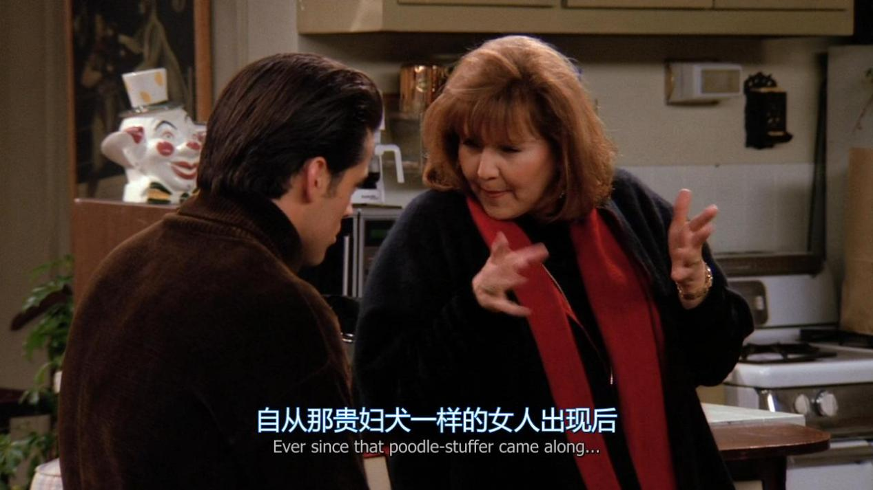

Ever since that XX came along

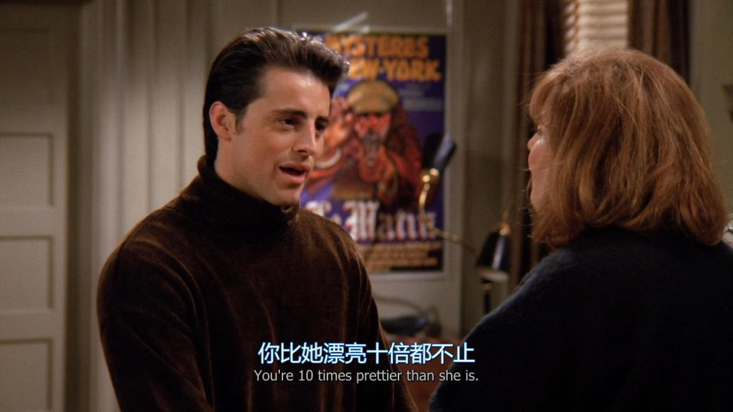

You’re 10 times prettier than she is

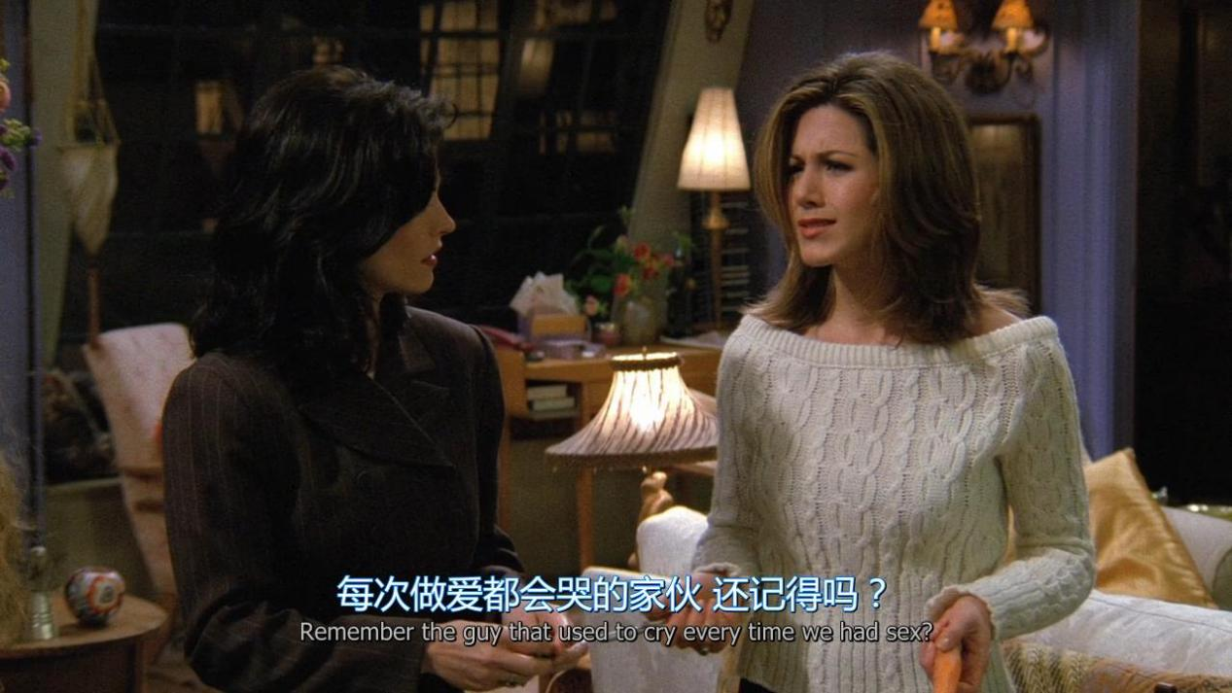

Remember the guy that used to cry every time we had sex?

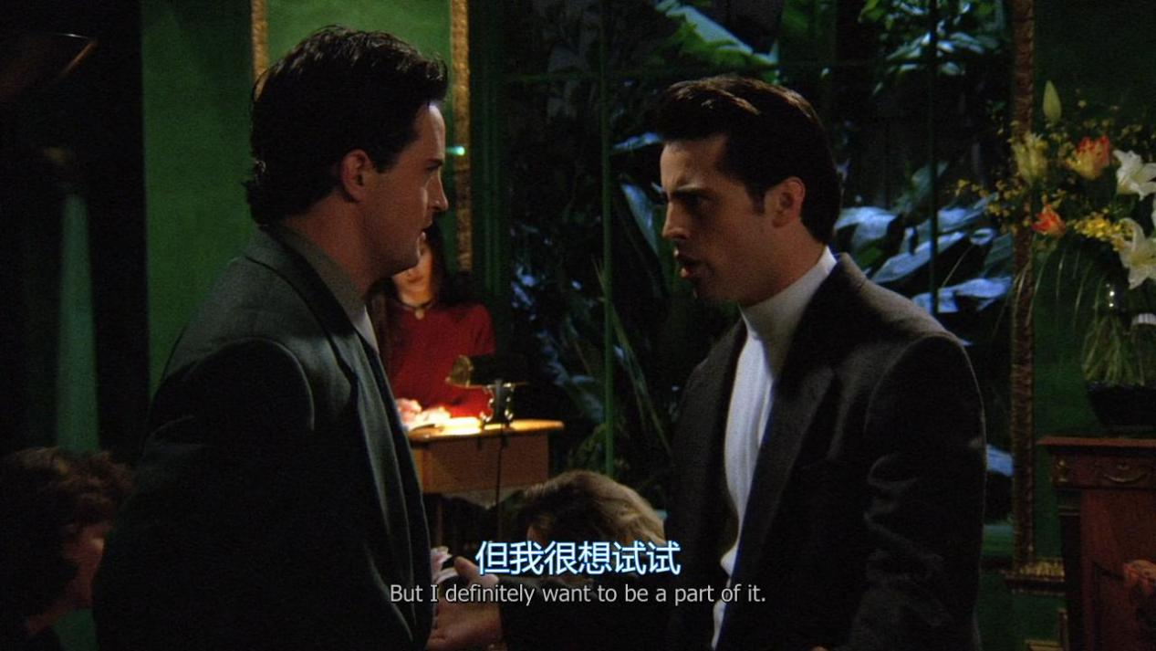

But i definitely want to be a part of it.

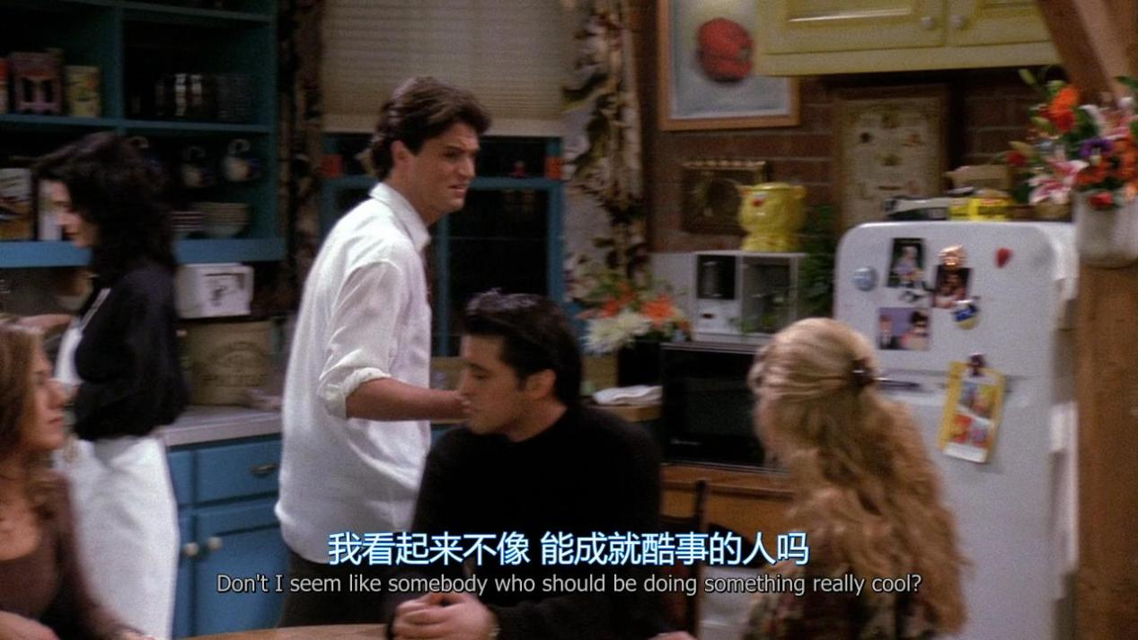

Don’t i seem like somebody who shoule be doing something really cool?

NO, you don’t(是，你不像) yes,you do(不，你是)

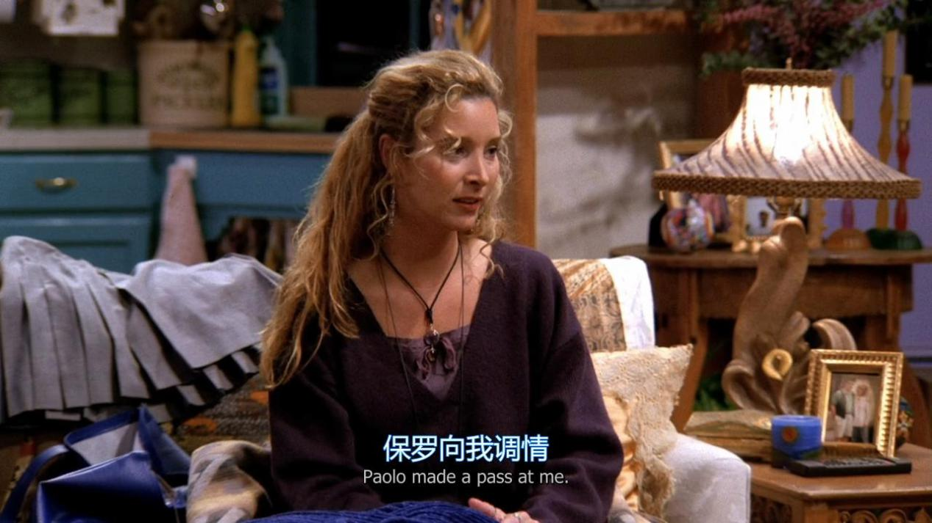

XX made a pass at me

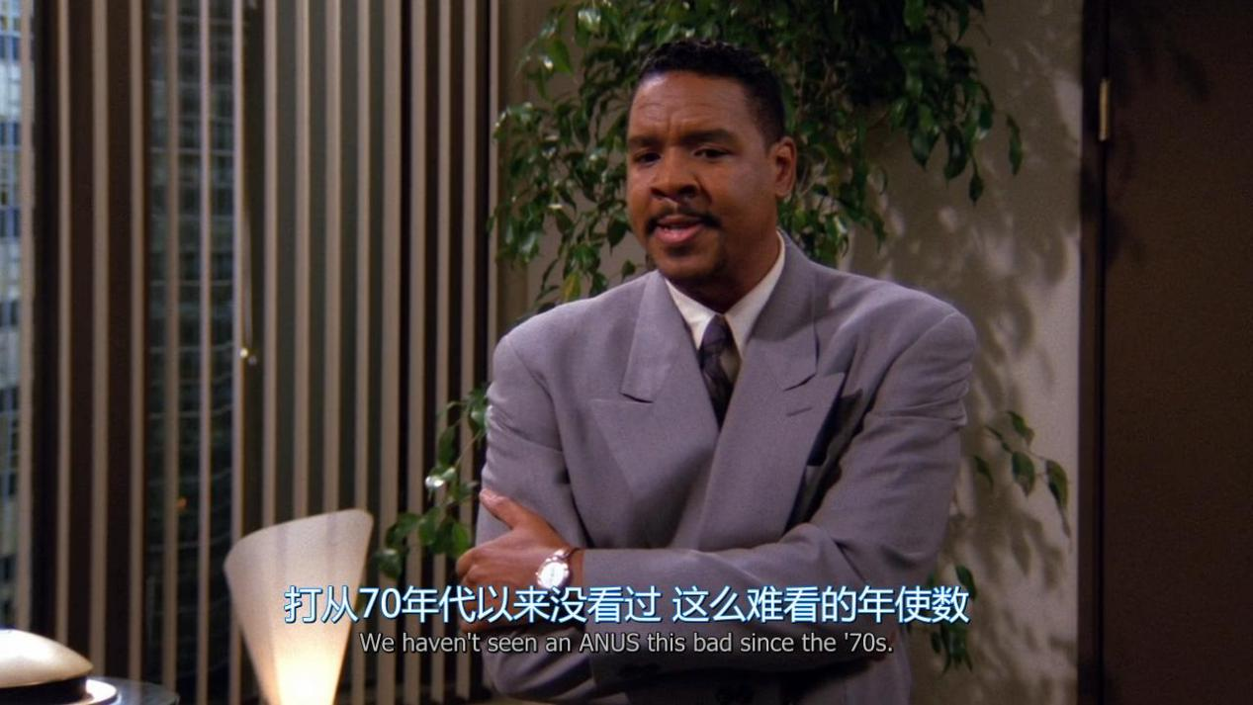

We haven’t seen an form this bad since the ‘70s.

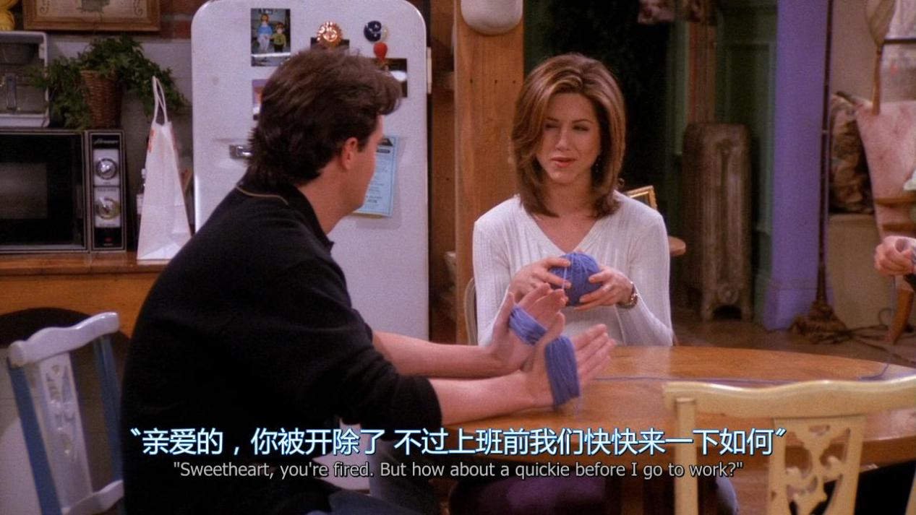

But how about a quickie before i go to work ?

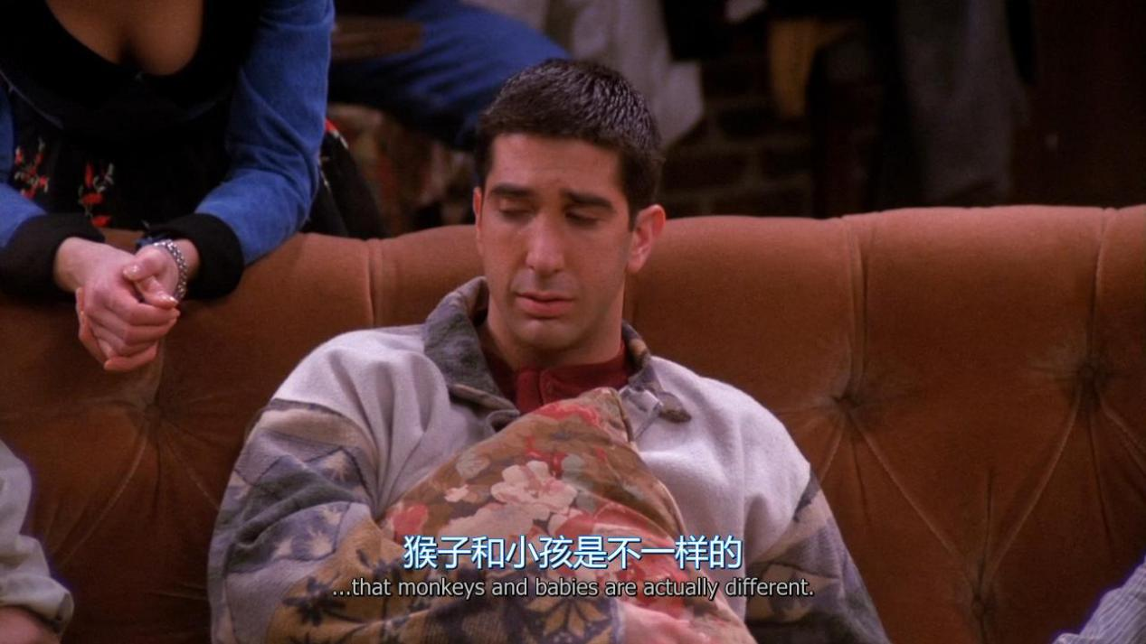

Monkeys and babies are actually different

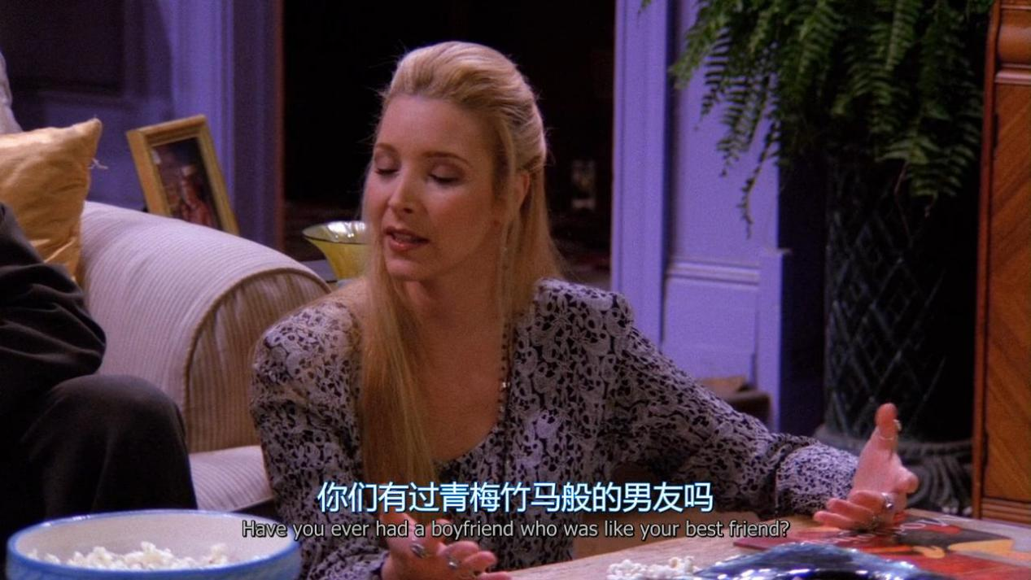

Have you ever had a boyfriend who was like your best friend ?

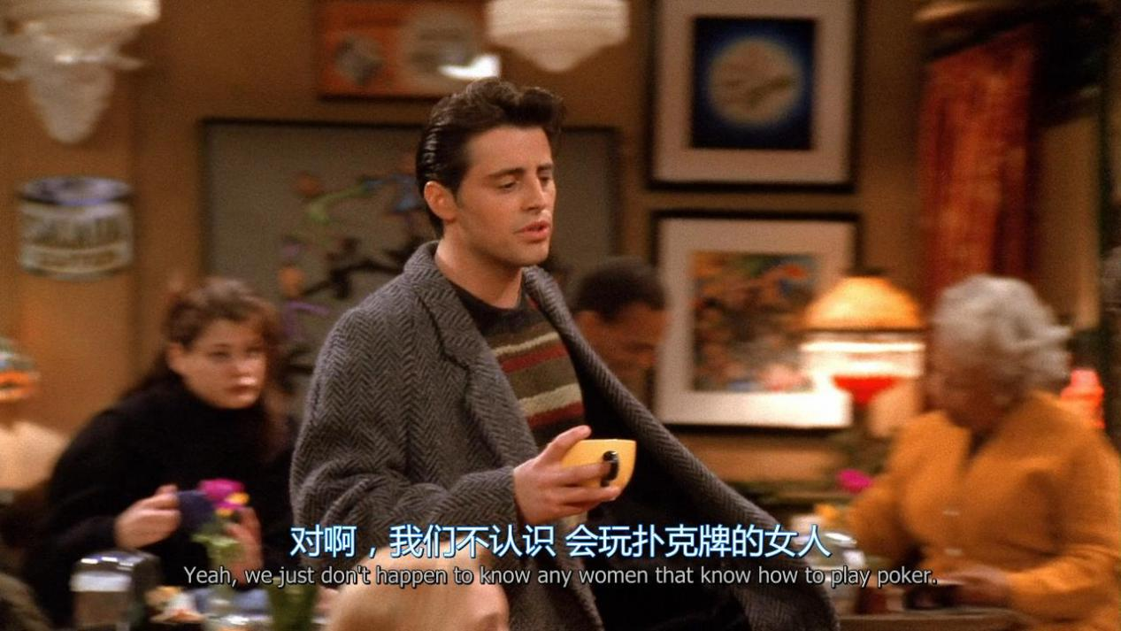

We just don’t happen to know any women that know how to play poker

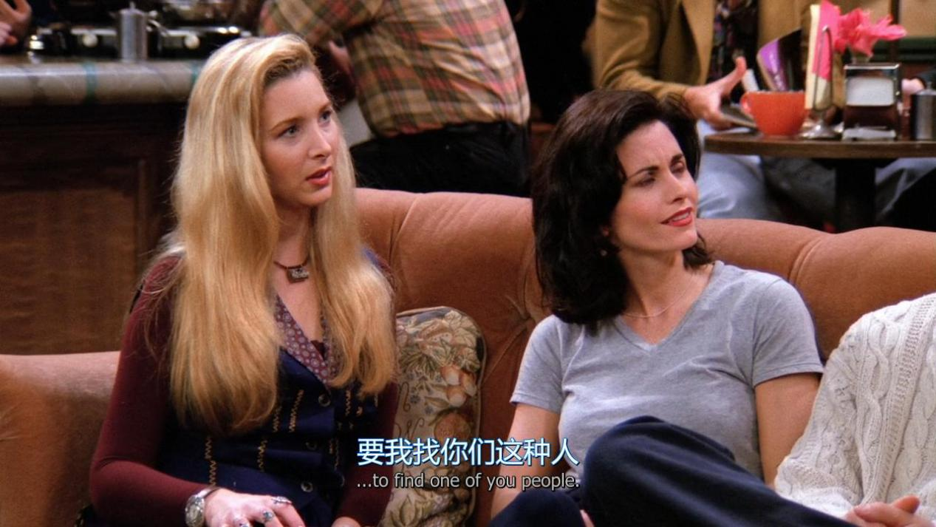

To find one of you people

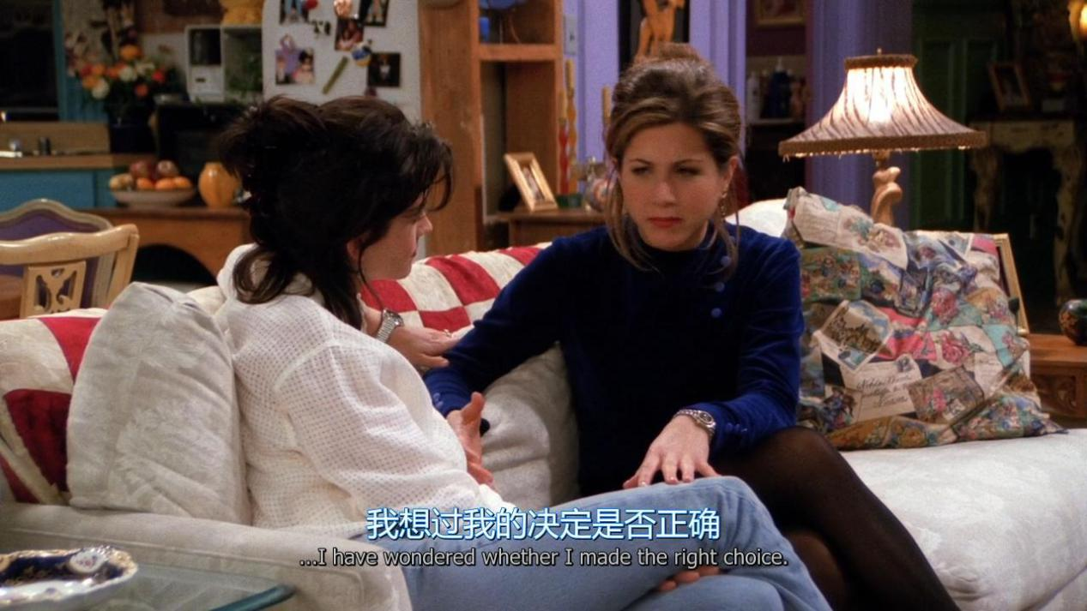

i have wondered whether i made the right choice.

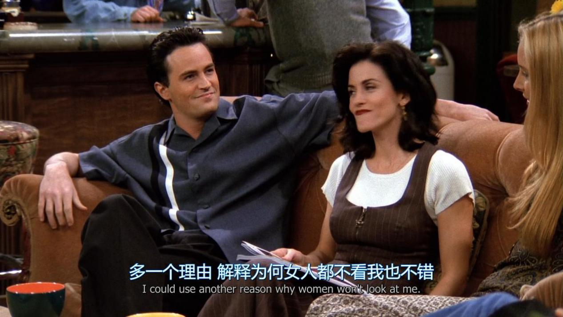

I could use another reason why women won’t look at me

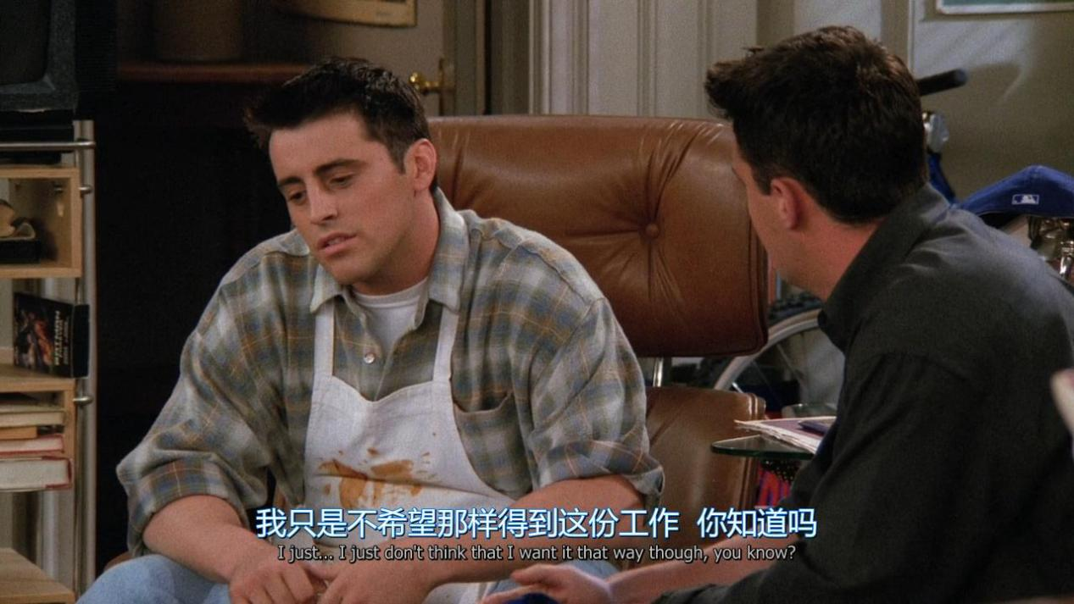

I just don’t think that i want it that way though

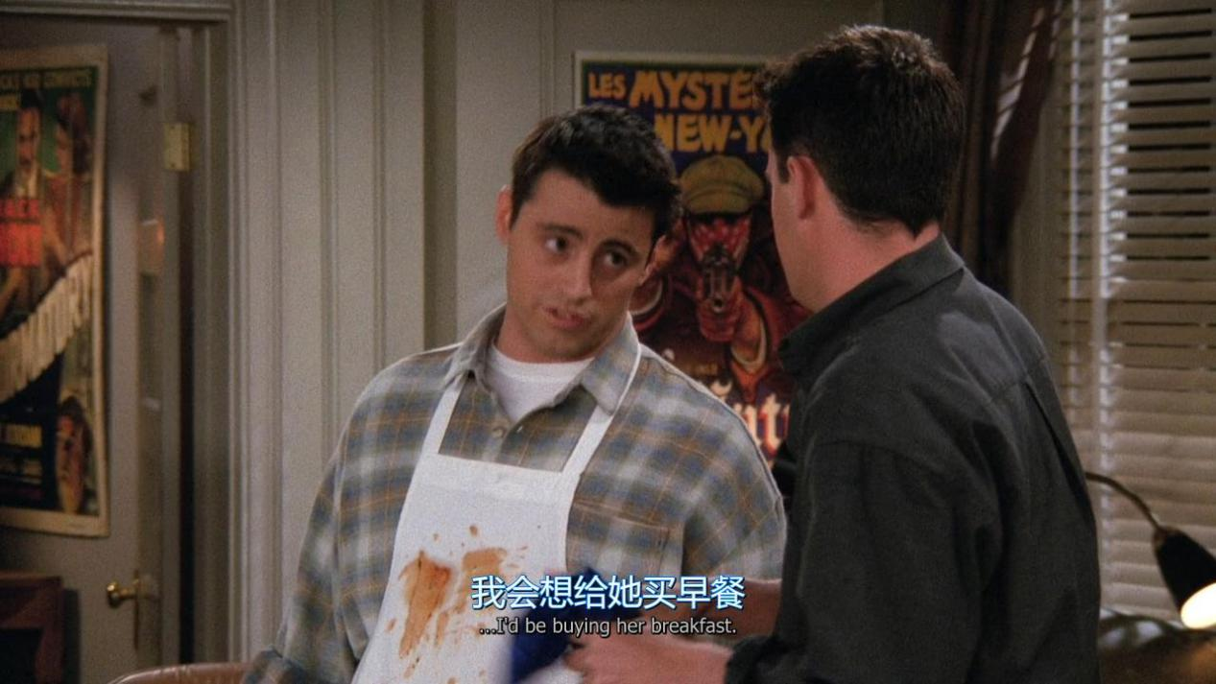

I’d be buying her breakfast

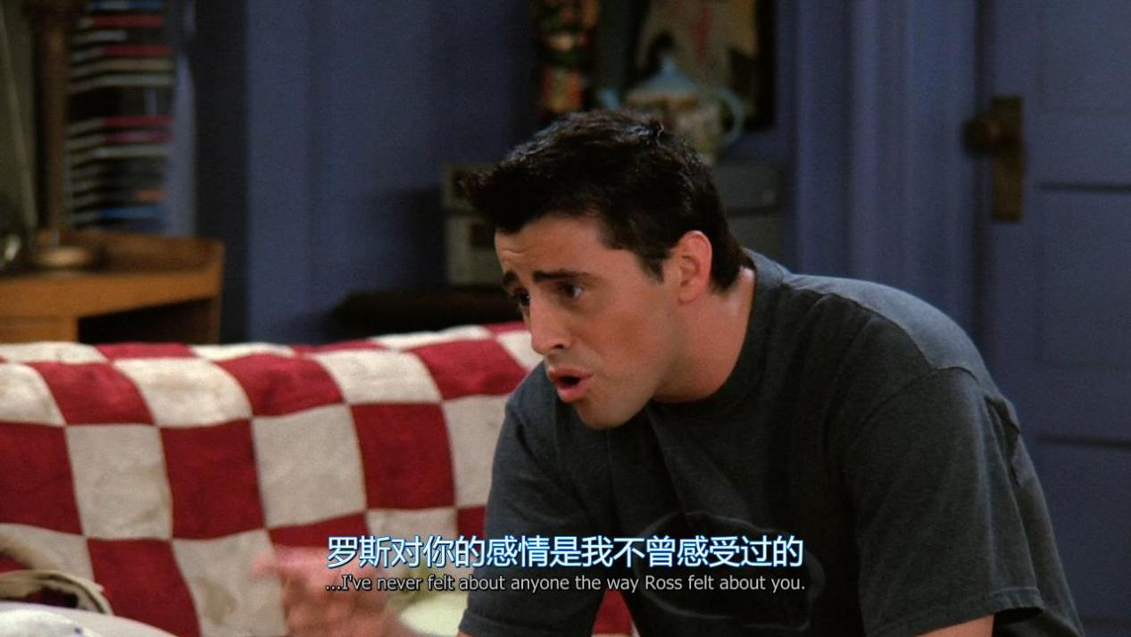

I’ve never felt about anyone the way Ross felt about you

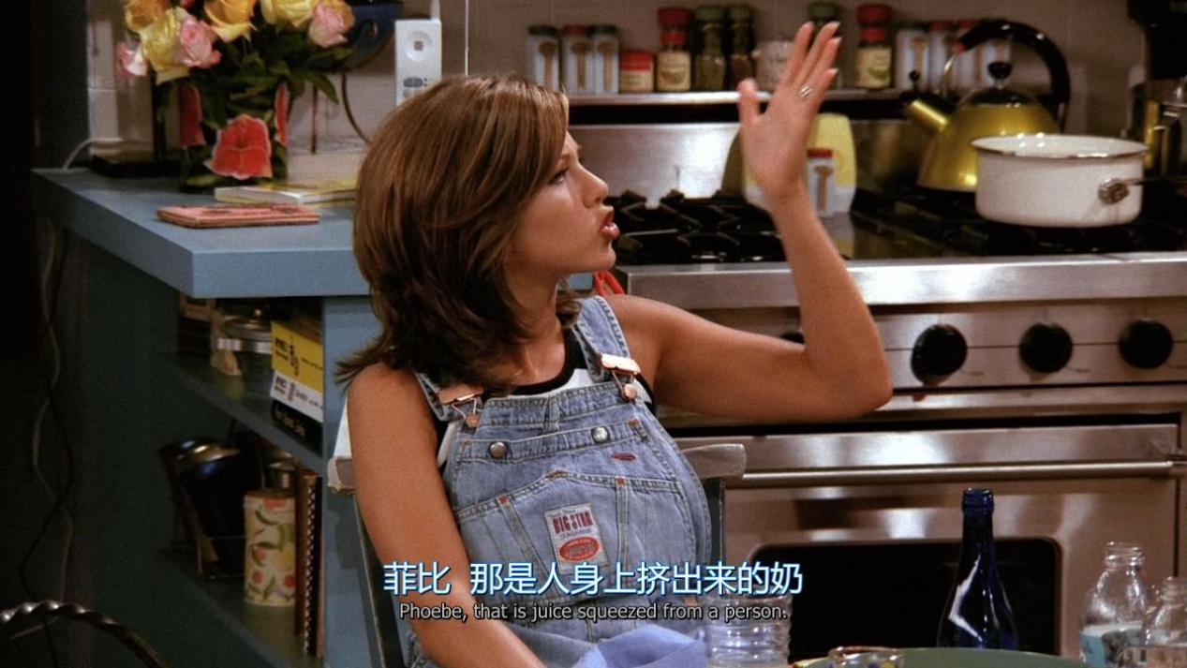

That is squeezed from a person

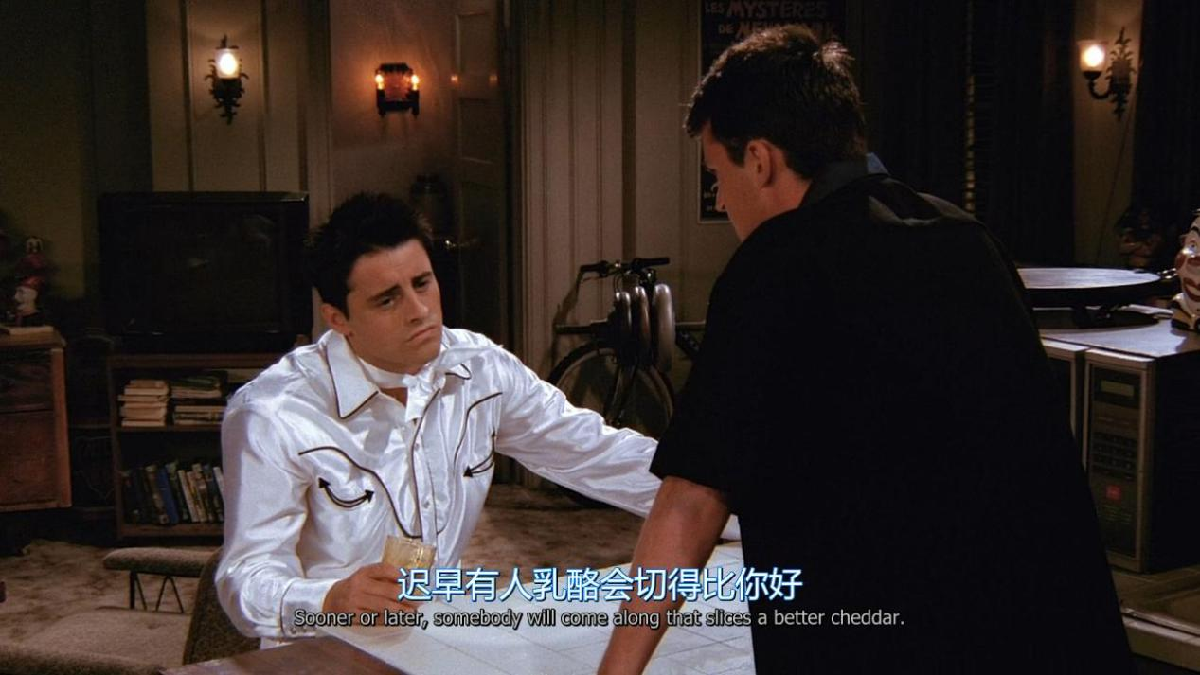

Sonner or late, sb will come along that slices a better cheddar

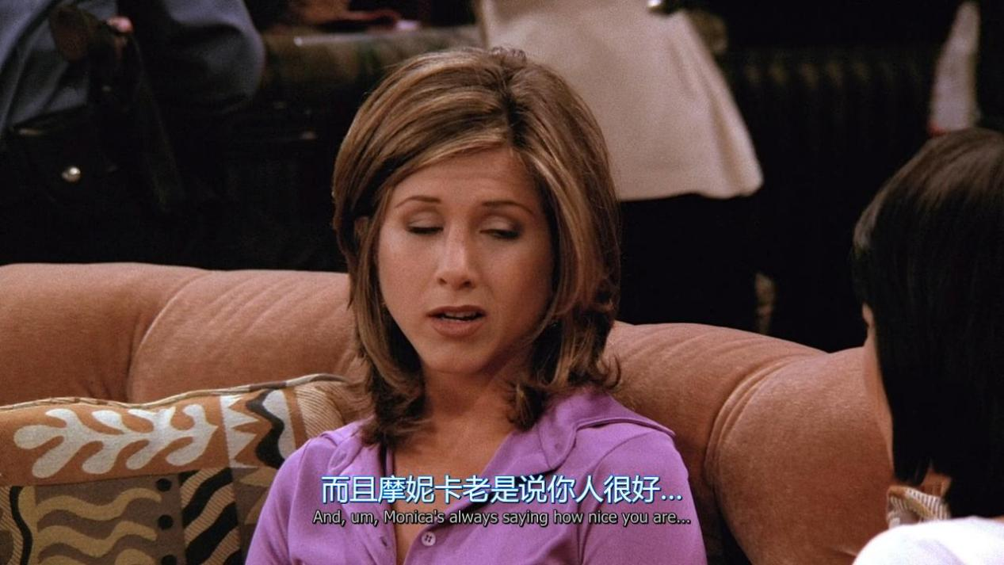

XX always saying how nice you are

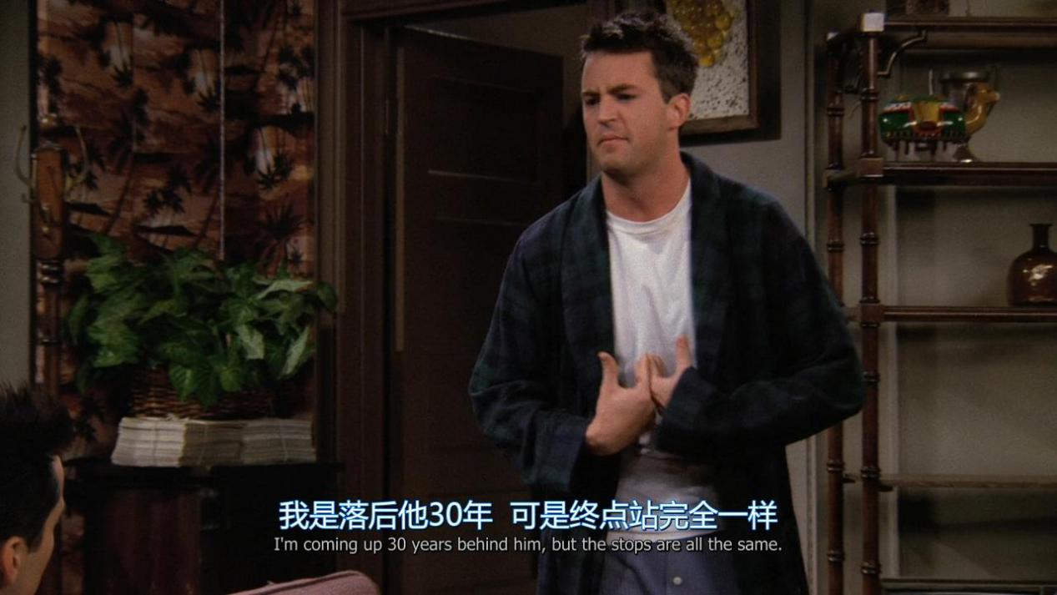

I am coming up 30 years behind him,but the stops are all the same

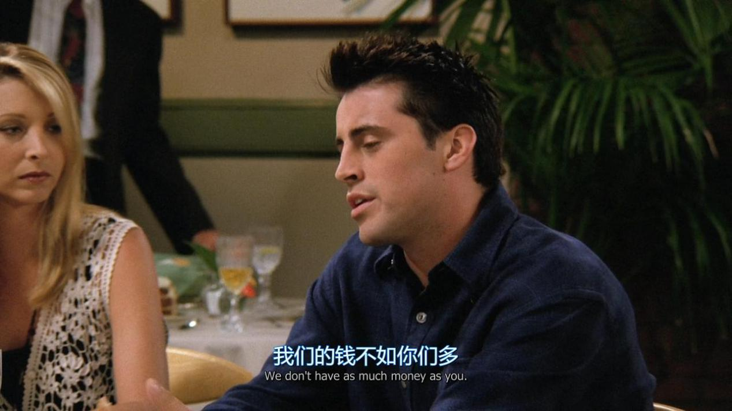

We don’t have as much money as you

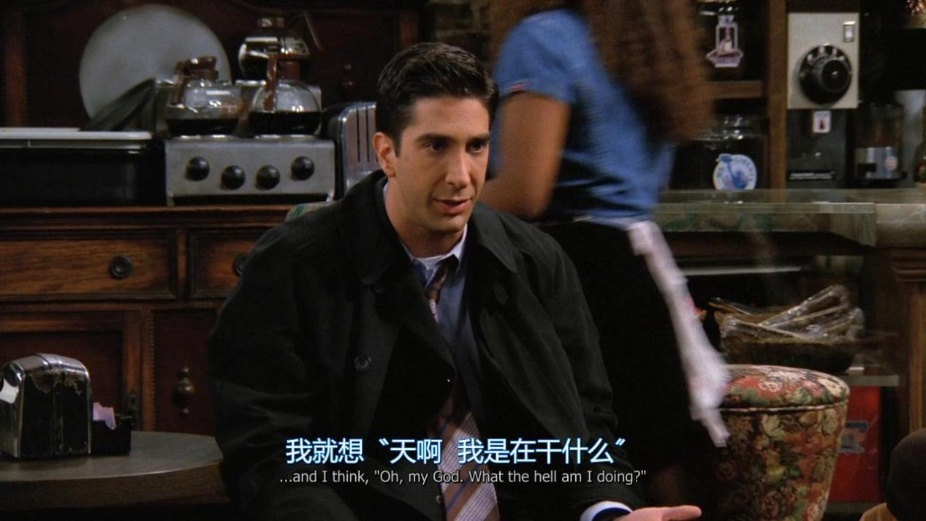

What the hell am i doing ?

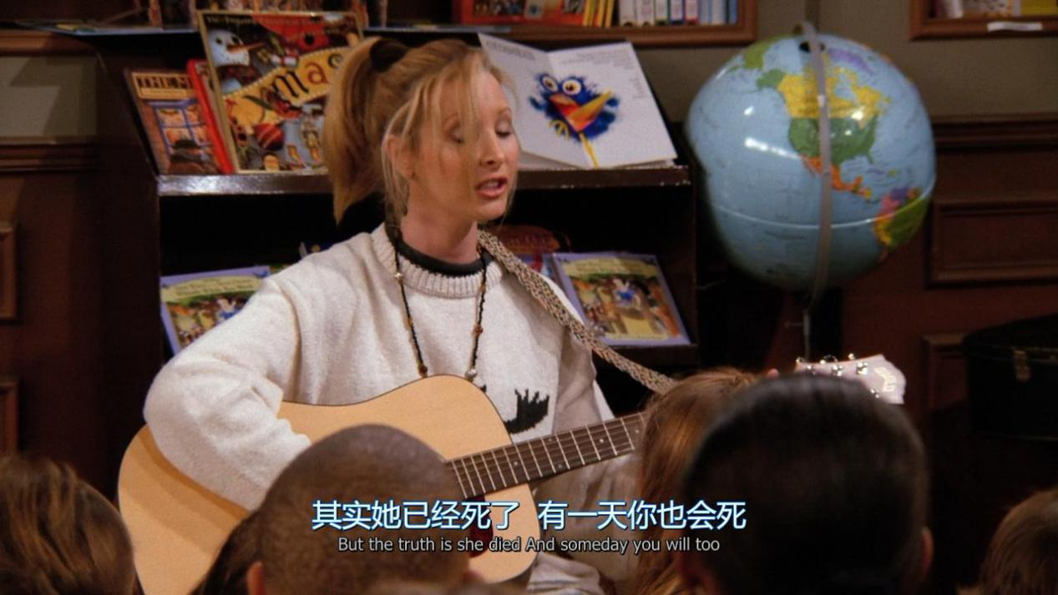

But the truth is she died and someday you will do

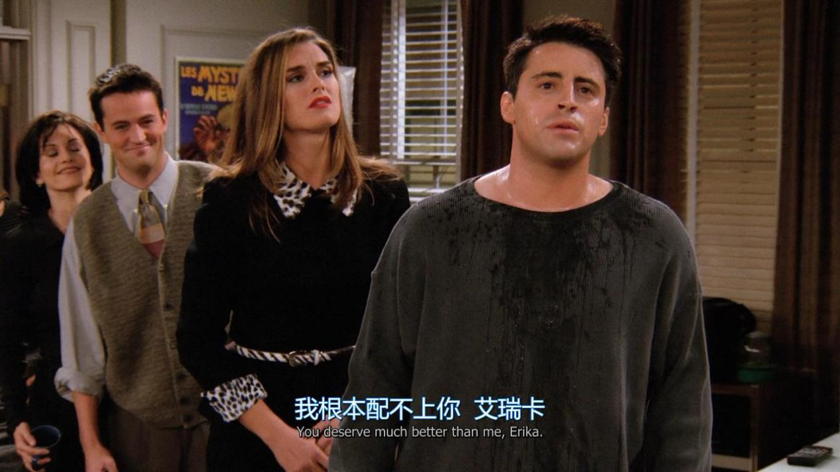

You deserve much better than me.

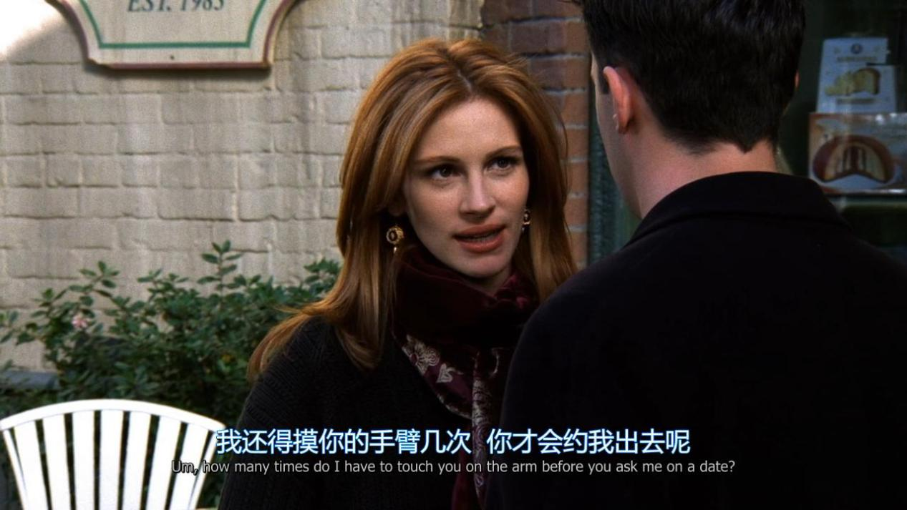

How many times do i have to touch you on the arm before you ask me out on a date?

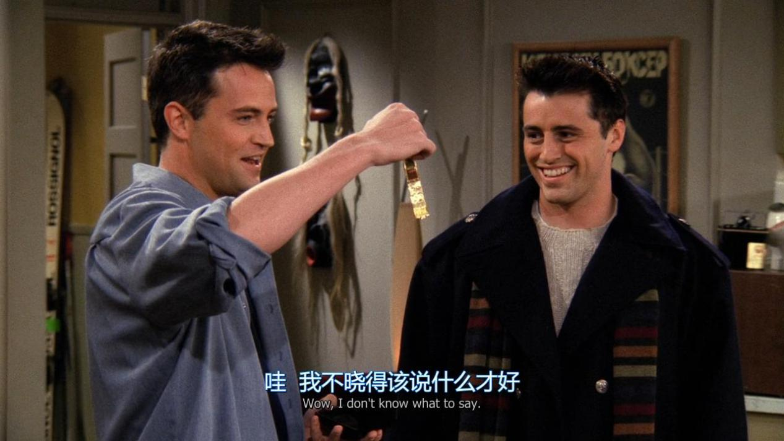

I don’t know what to say

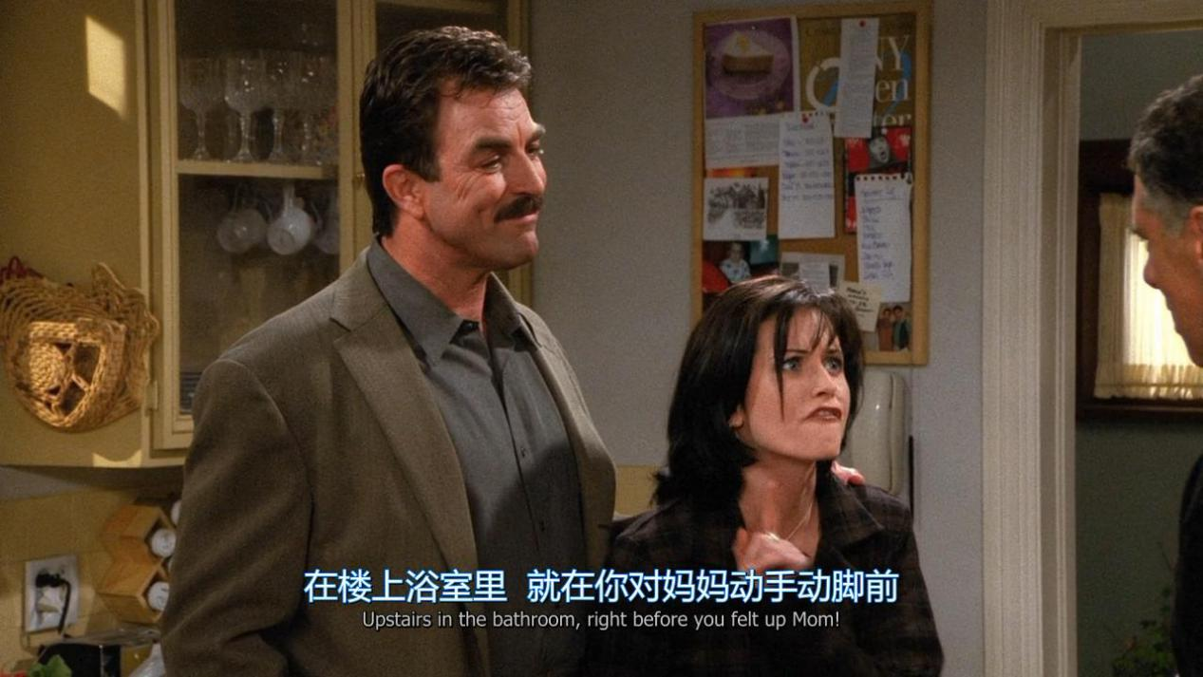

Upstairs in the bathroom, right before you felt up Mom.

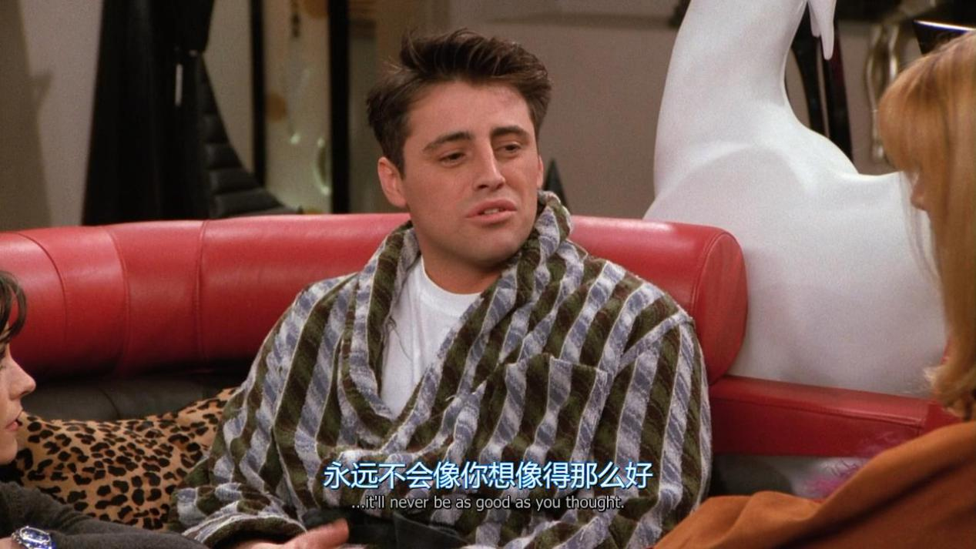

Never be as good as you thought

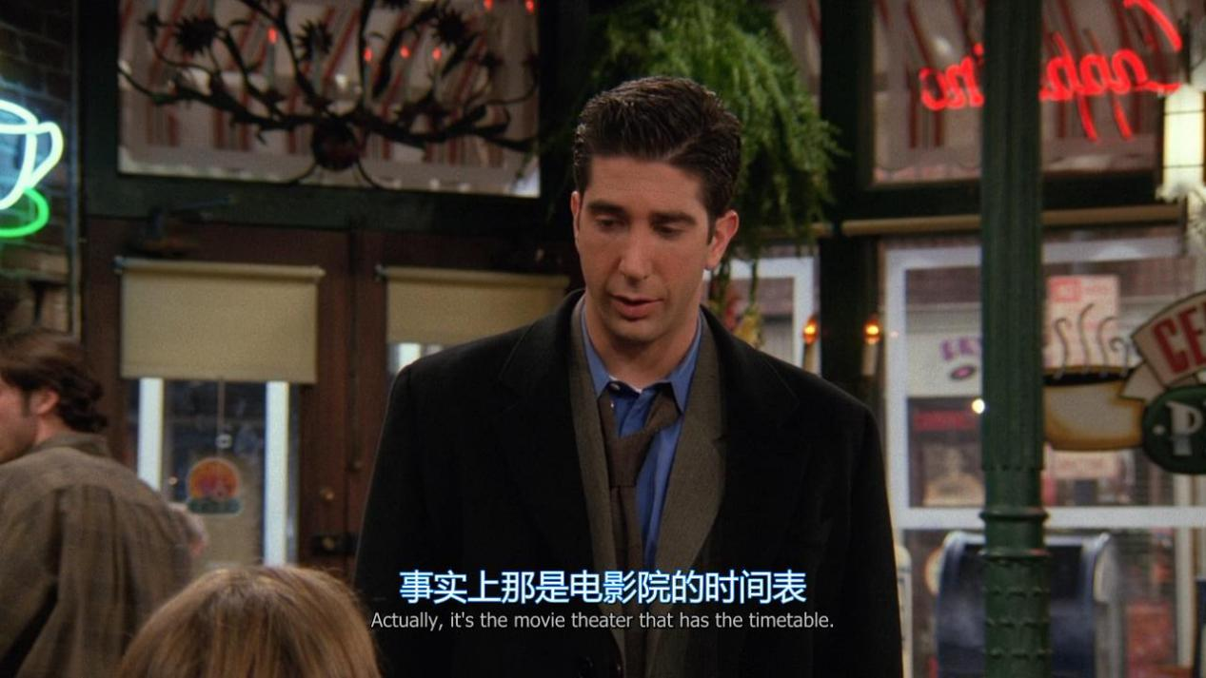

Actually ,it’s the movie theater that has the timetable

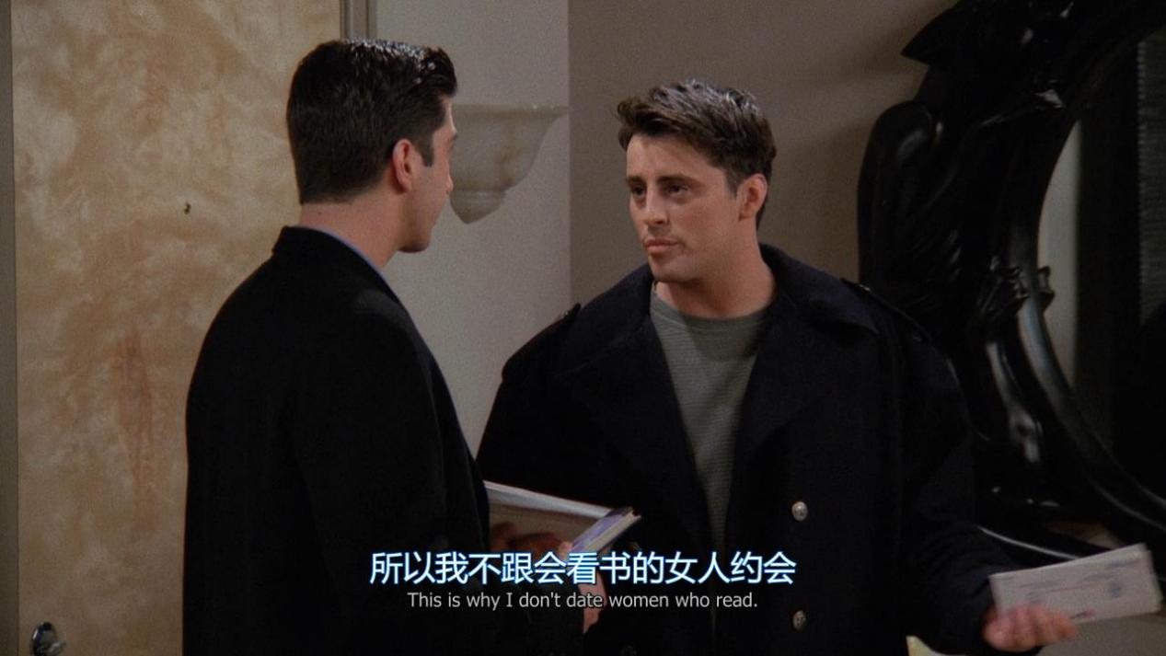

That’s why i don’t date woman who read

Put yourself into others’ shoes

In the very near future

Don’t ever let sb tell u u can’t do sth, not even me

An America where a father can tell his daughter:yes,u can be anything you want to be.Even a president of the United State.

I guess i got tired of waiting around somebody else to do it for me

If i was walking down the street and i saw some kids with a jet pack

fly over me,i would believe anything’s possible and what a wonderful world.I’d be inspired,doesn’t that make the world a better place

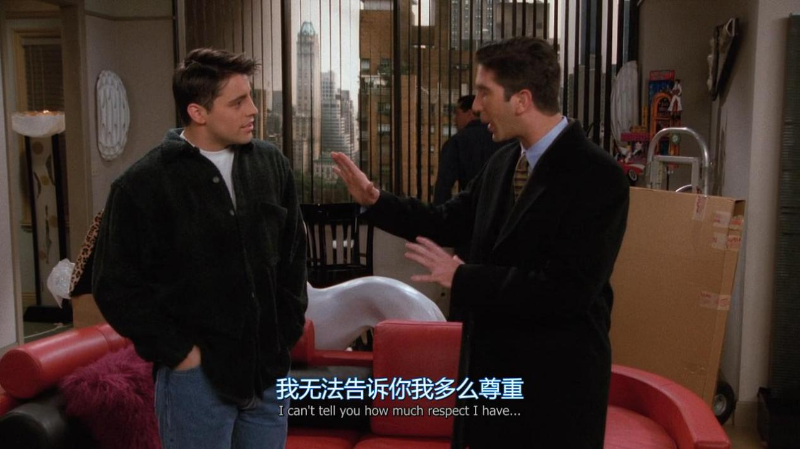

I can’t tell you how much respect i have

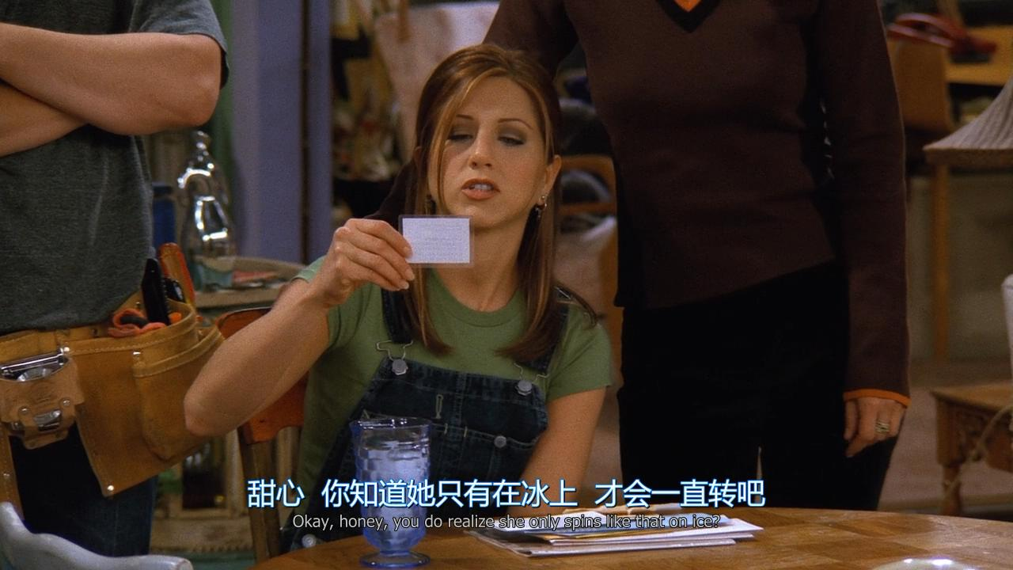

You do realize she only spins like that on ice

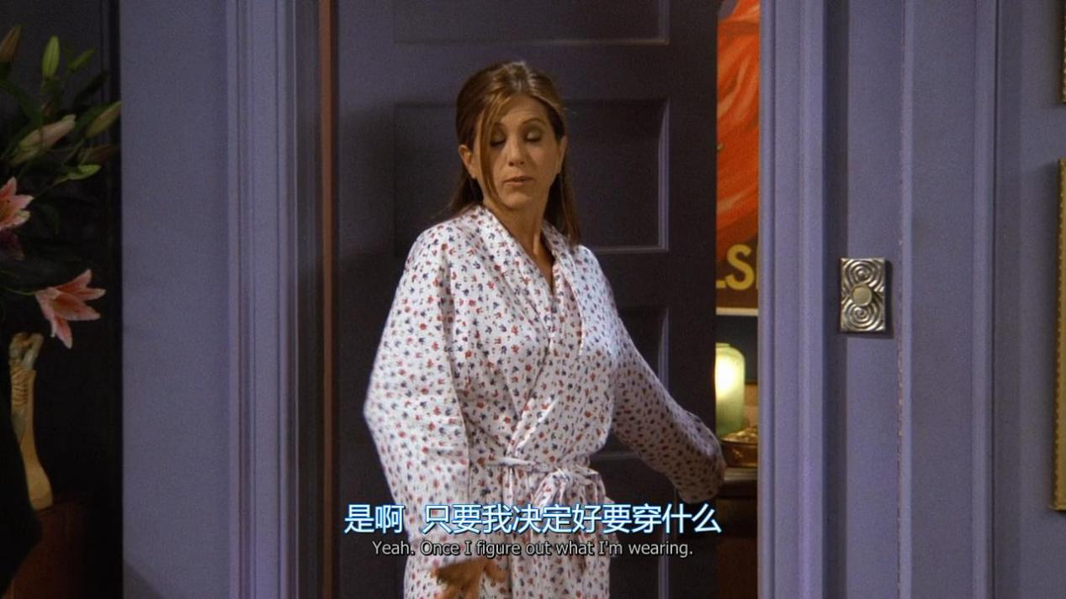

Once i figure out what i wearing

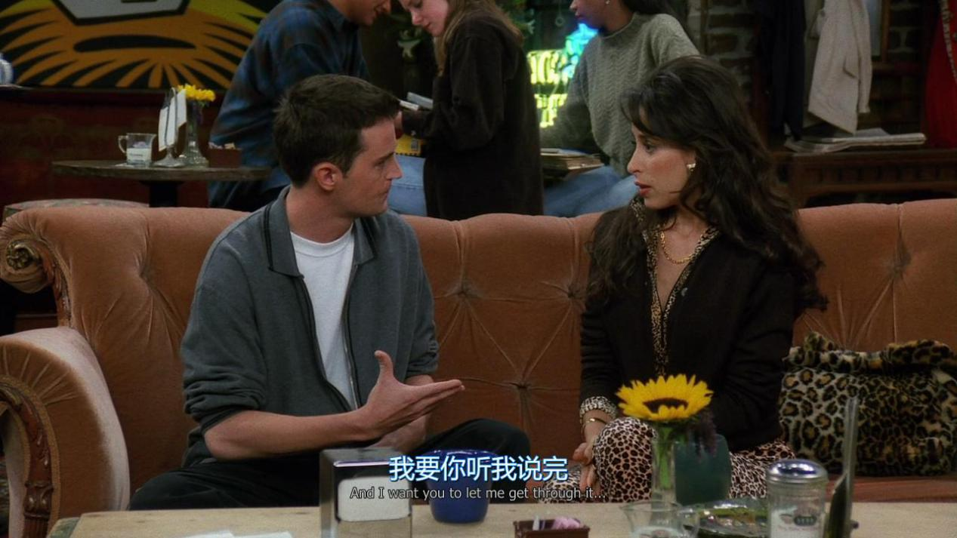

And i want you to let me get though

0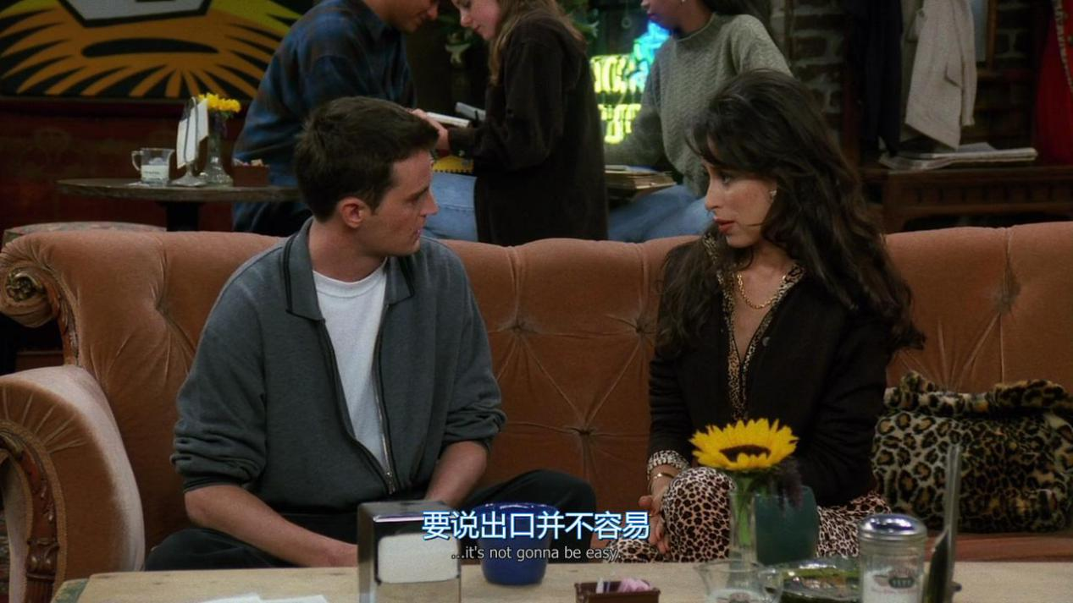

It’s not gonna be easy

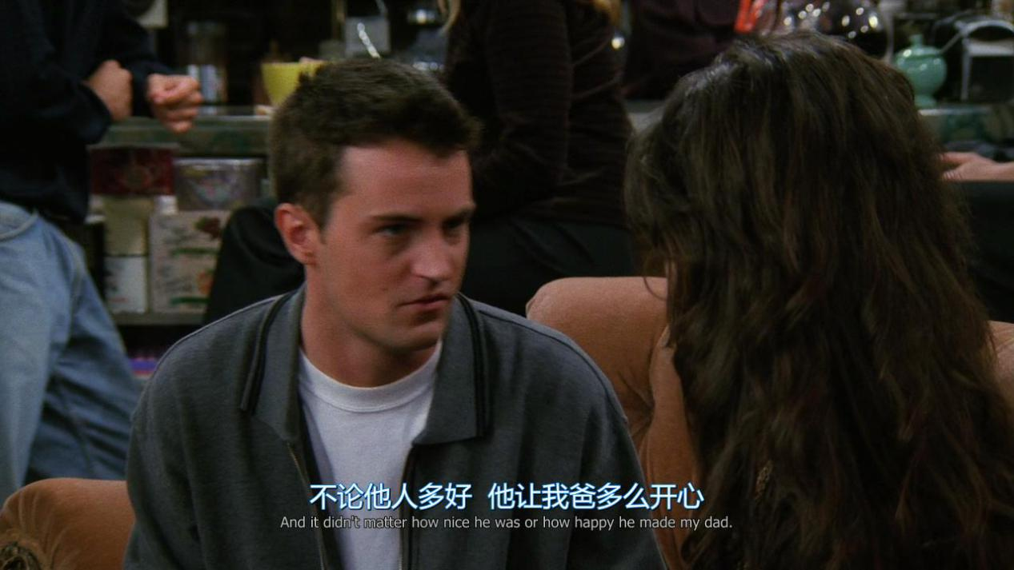

And it didn’t matter how nice he was or how happy he made my dad

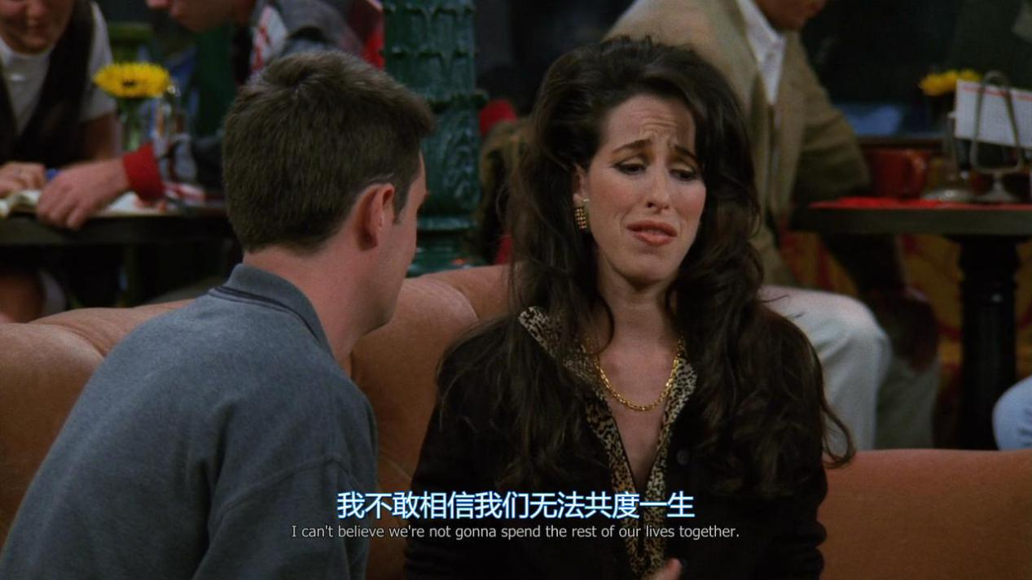

I can’t believe we’re not gonna spend the rest of our lives together

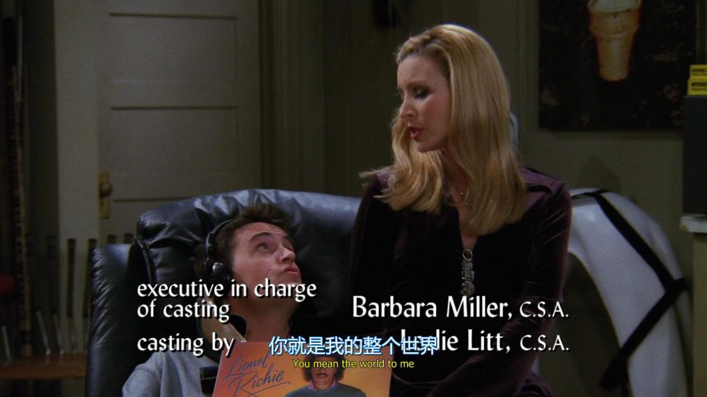

You mean the world to me

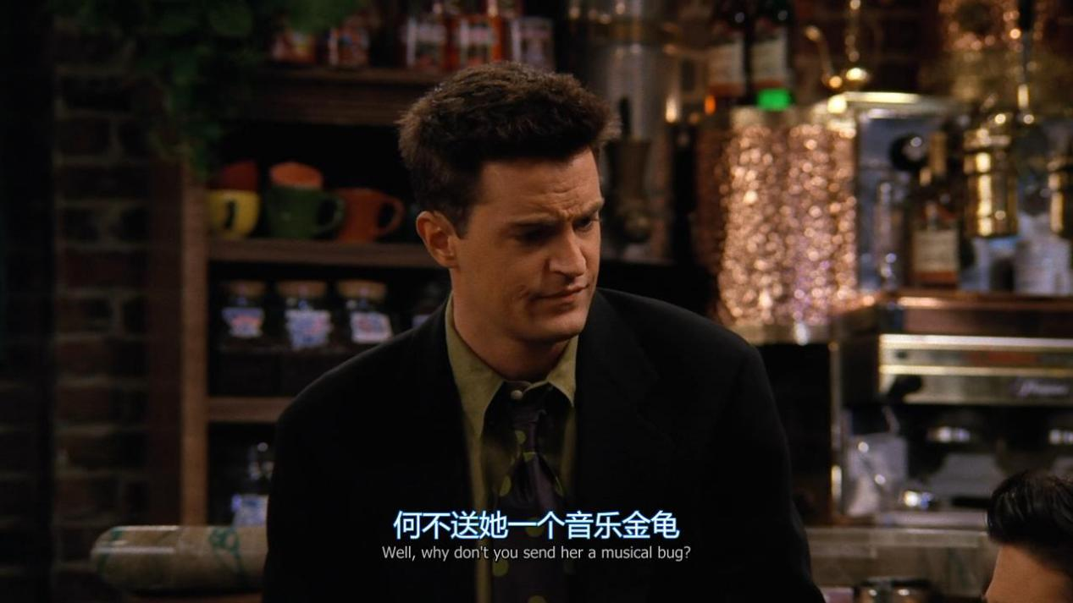

Well, why don’t you send her a musical bug ?

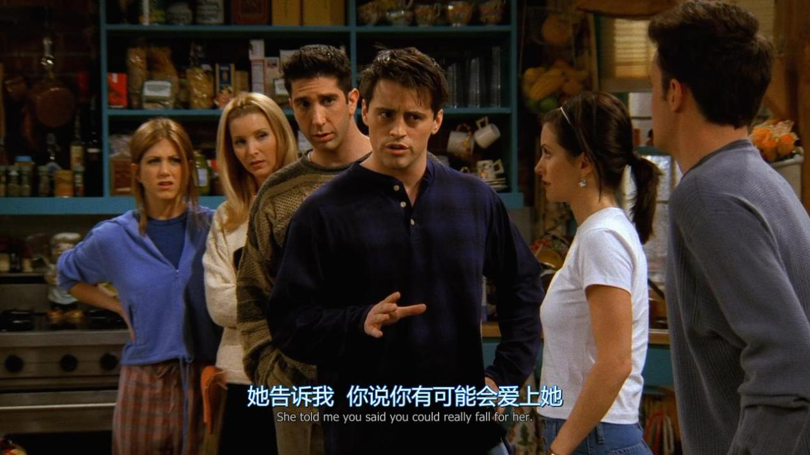

She told me you said you could really fall for her

**Used to do & be used to doing & be used to do**

Used to do:过去常常做某事（暗指现在改变了）

*Tom used to live here.*

汤姆曾在这儿住过。

Be Used to do:被用来做什么

*Bamboos are used to build houses there.*

*那儿竹子被用于建造房屋。*

Be used to doing:习惯做某事（现在也是）

*I am used to eating the food here.*

*我习惯于吃这儿的食物。*

*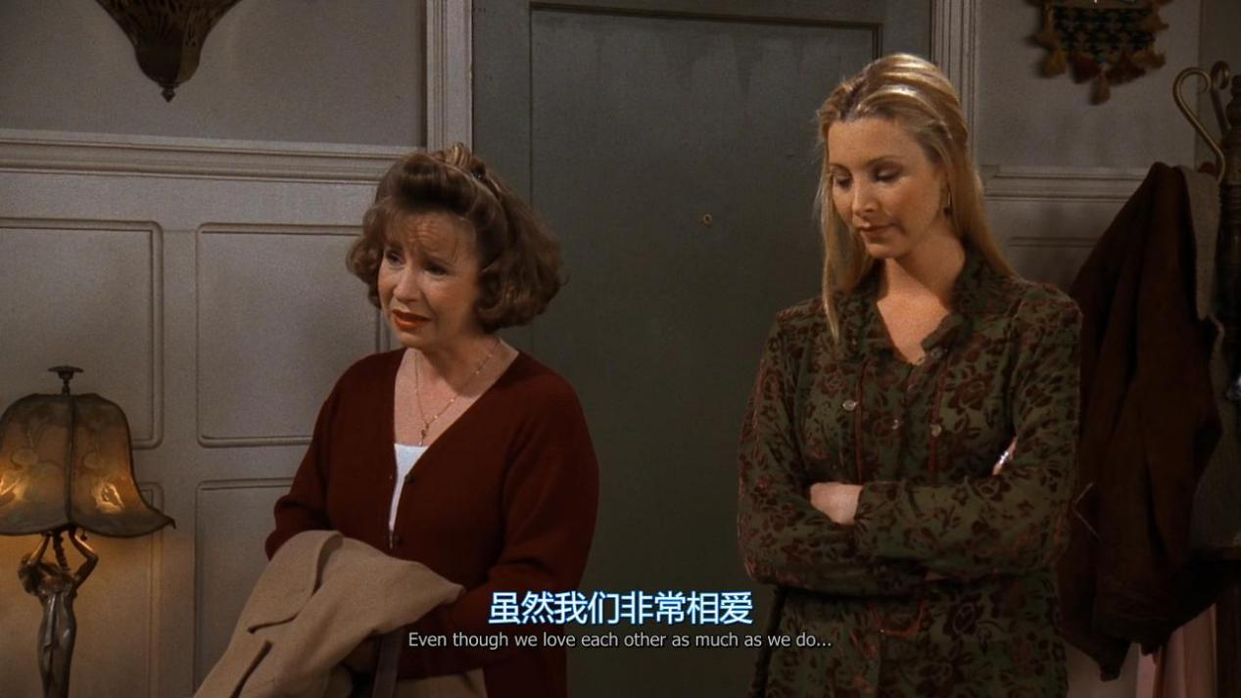Even though we love each other as much as we do*

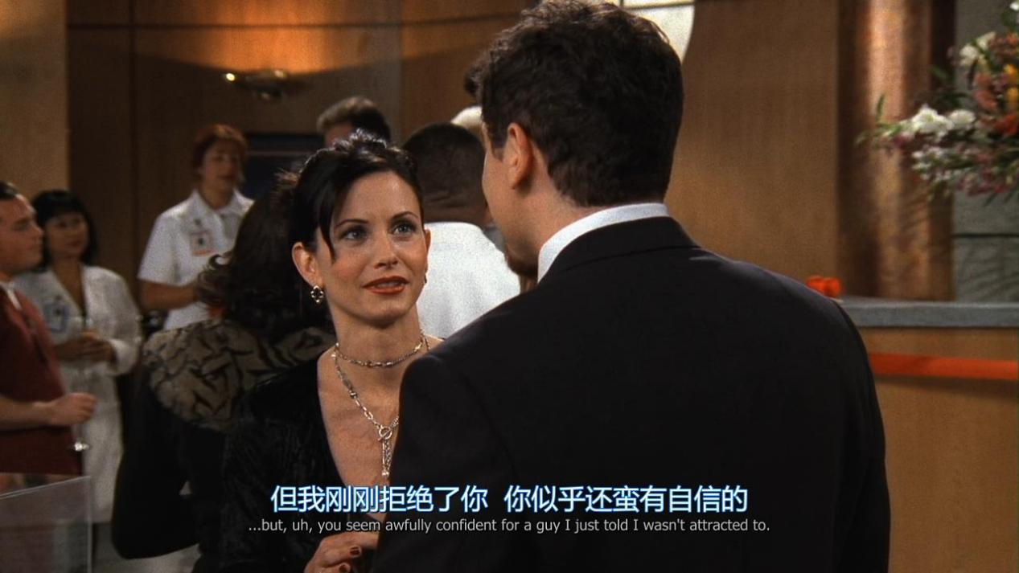

*You seem awfully confident for a guy i just told i wasn’t attracted to*

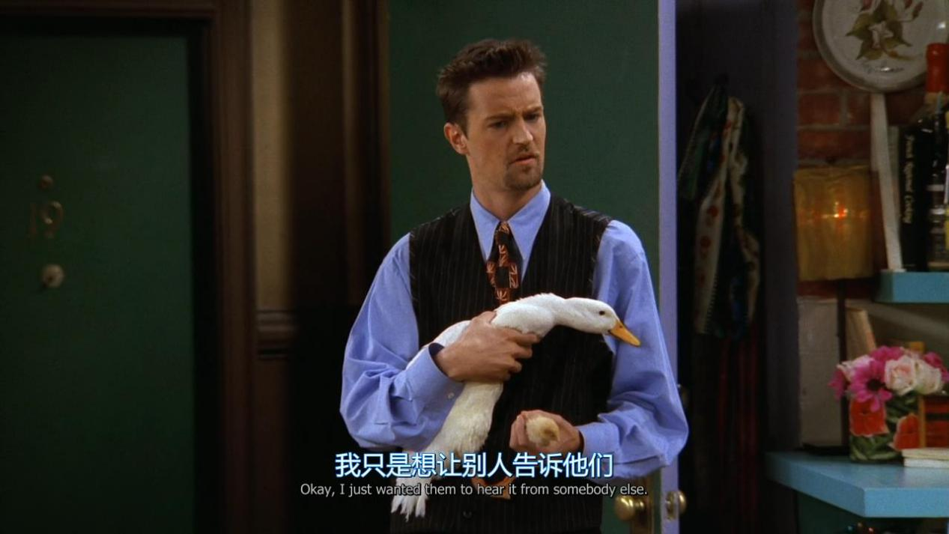

I just wanted them to hear it from somebody else

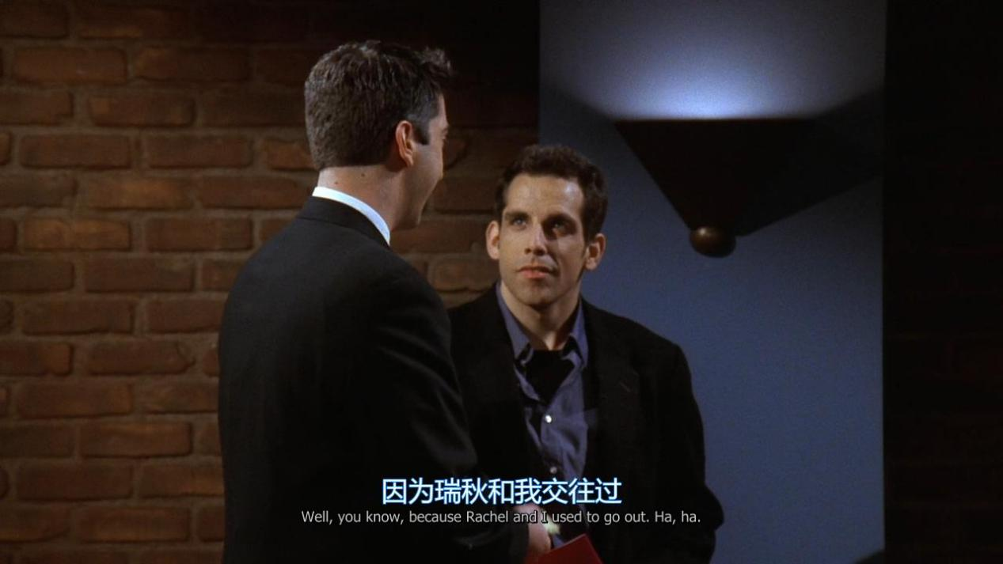

*You know ,because Rachel and i used to go out.*

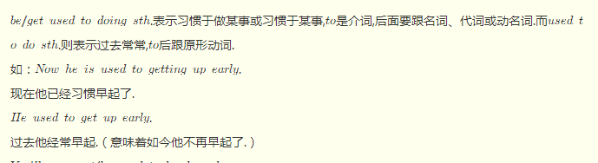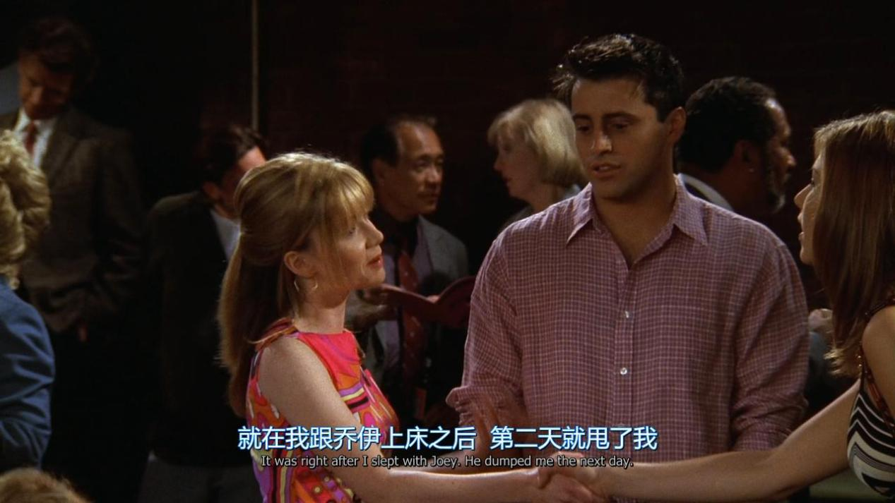

*It was right after i slept with Joey. He dumped me the next day.*

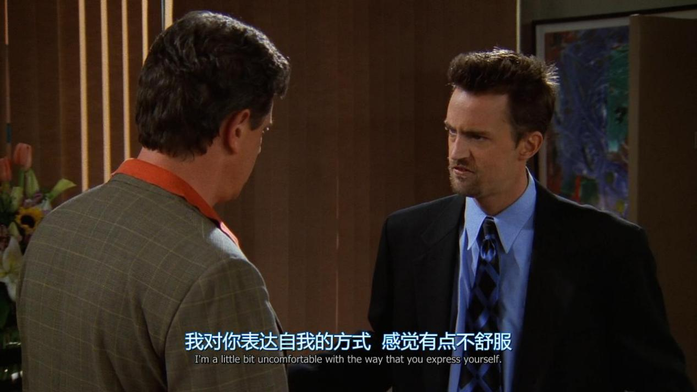

**I’m a little bit uncomfortable with the way that you express yourself**

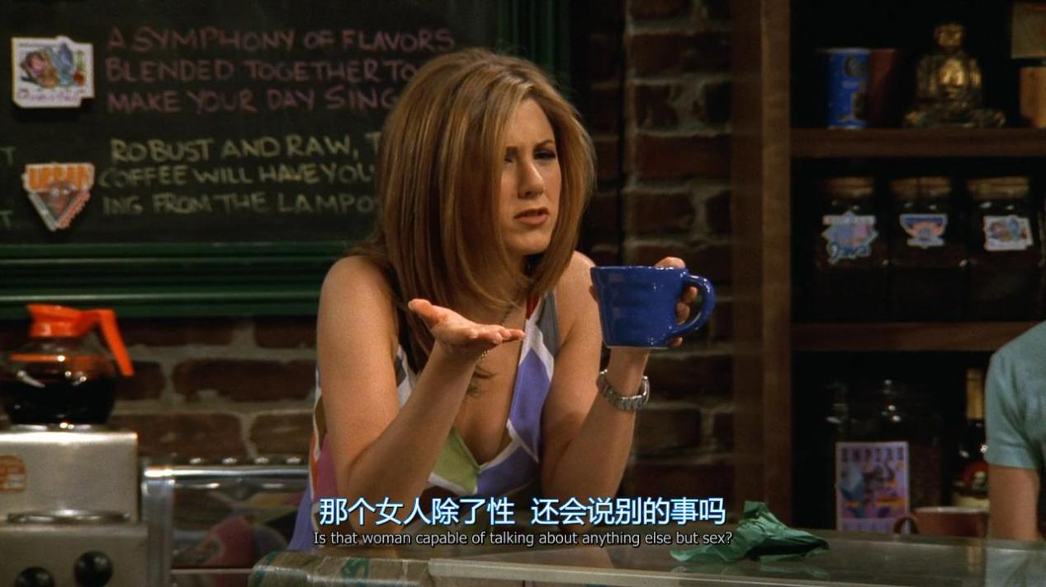

Is that woman capable of talking about anything else but sex

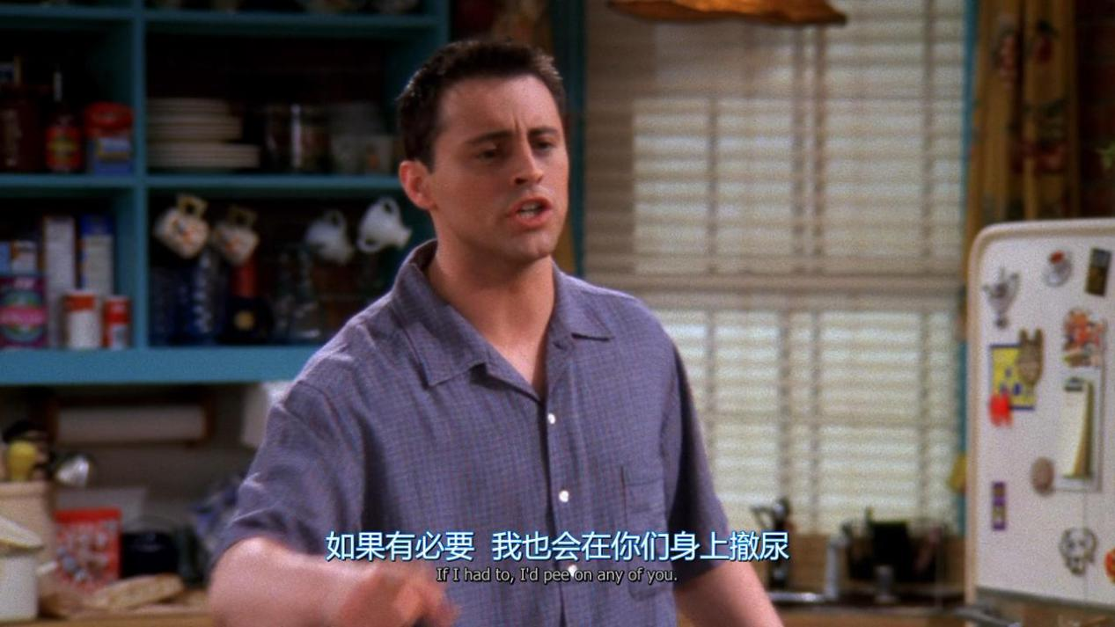

If i had to, i’d pee on any of you

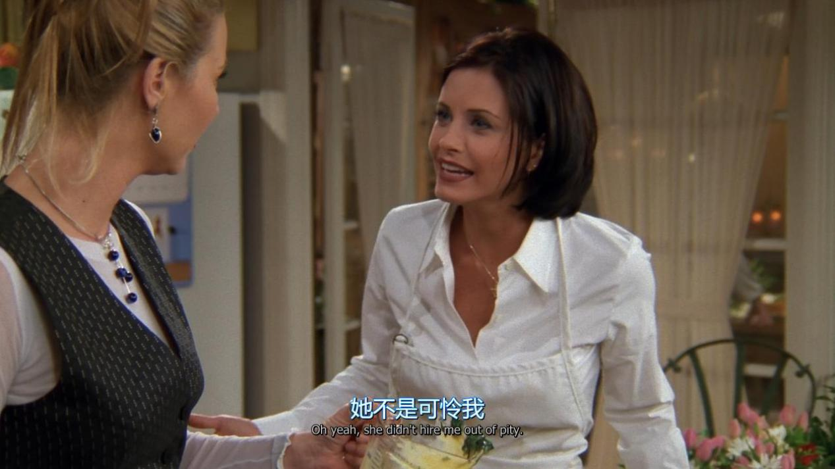

She didn’t hire me out of pity

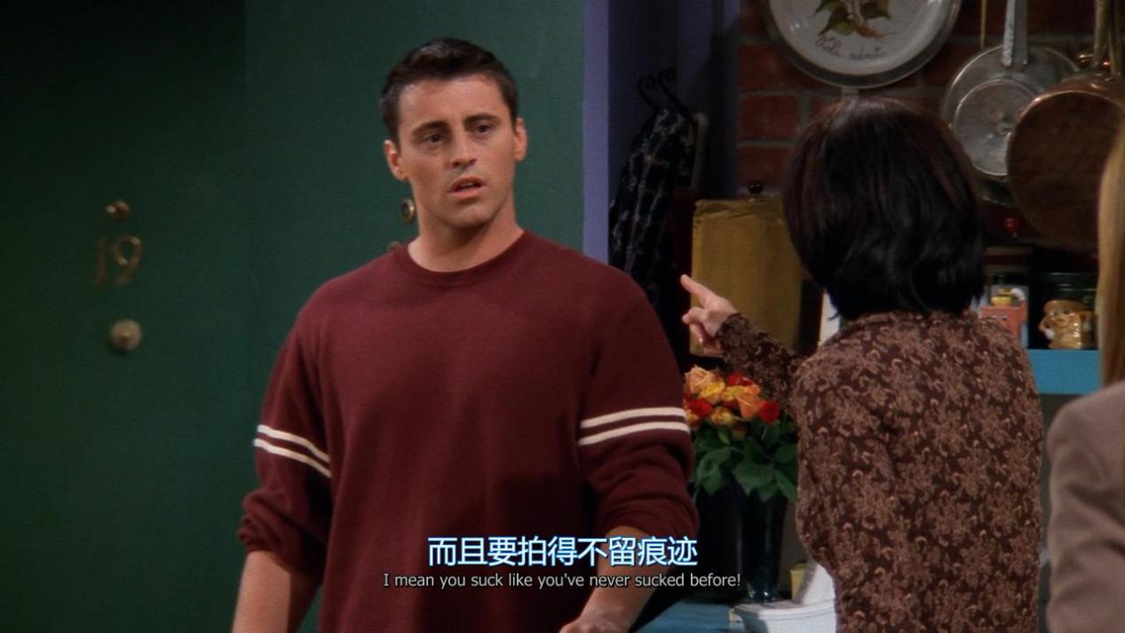

I mean you suck like you have never sucked before.

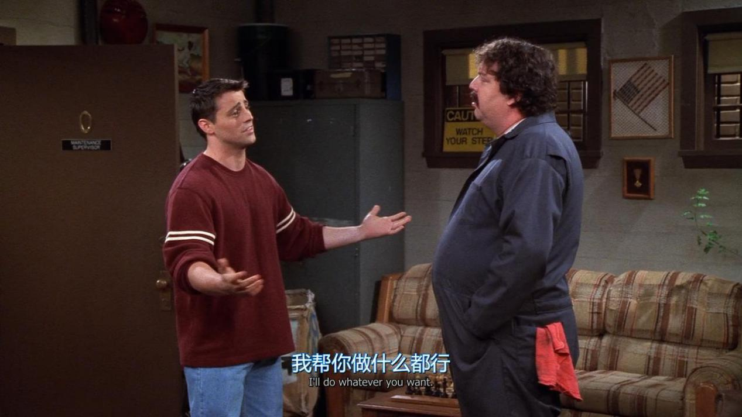

I’ll do whatever you want

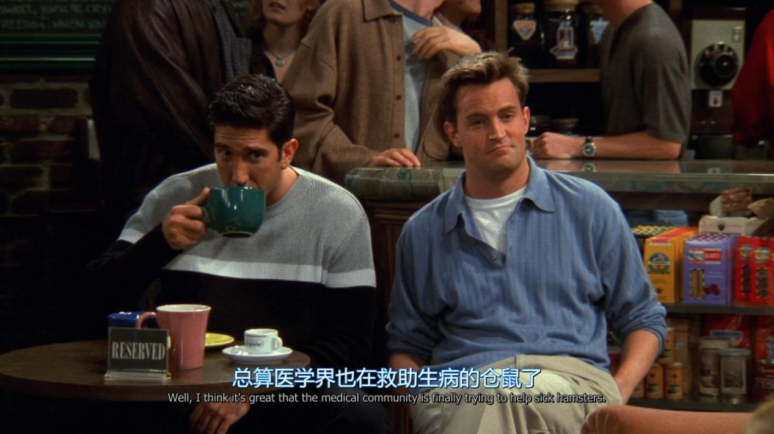

I think it’s great that the medical community is finally trying to help sick hamsters

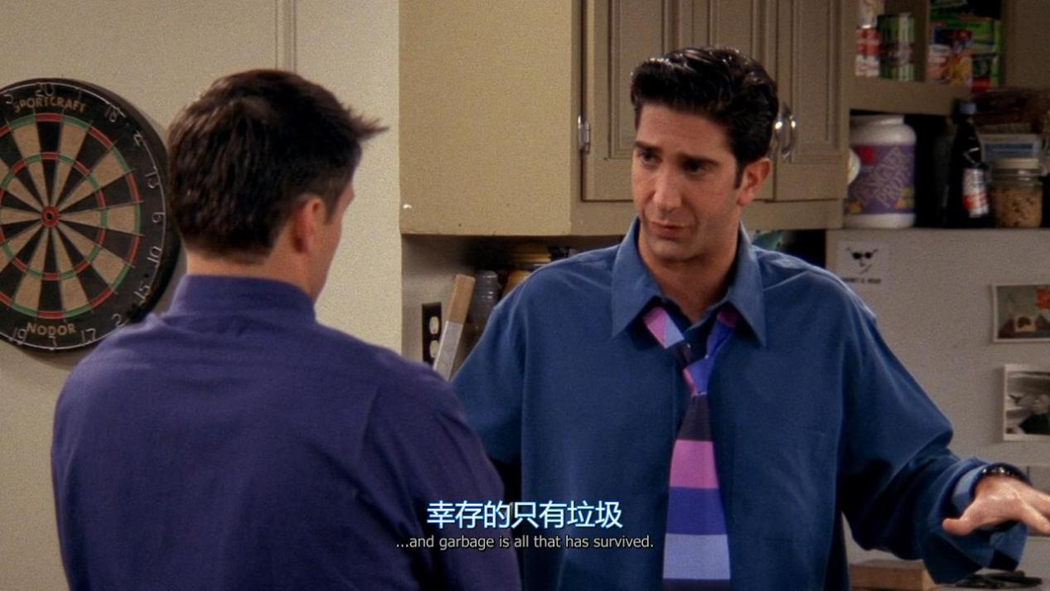

Garbage is all that has survived

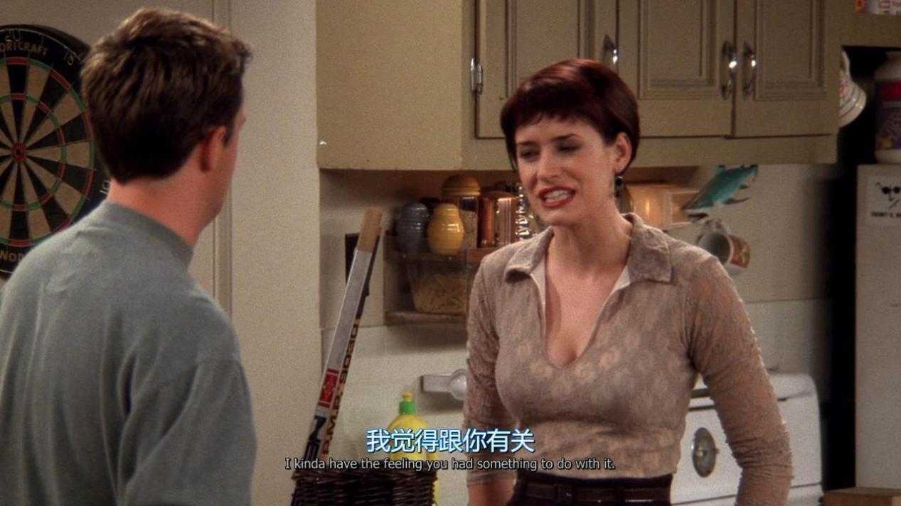

I kinda have the feeling you had something to do with it

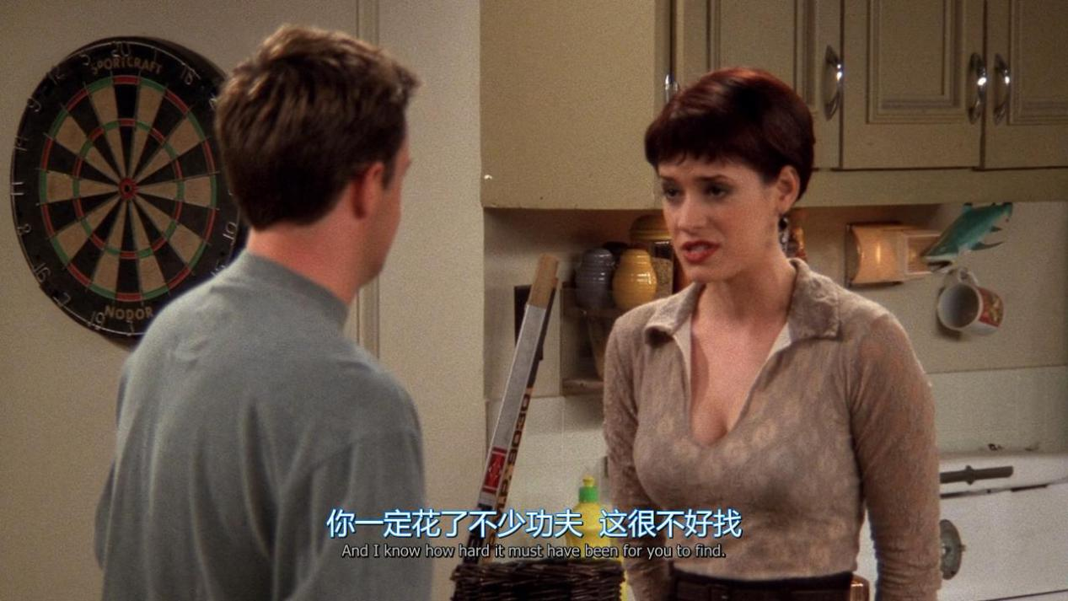

I know how hard it must have been for you to find

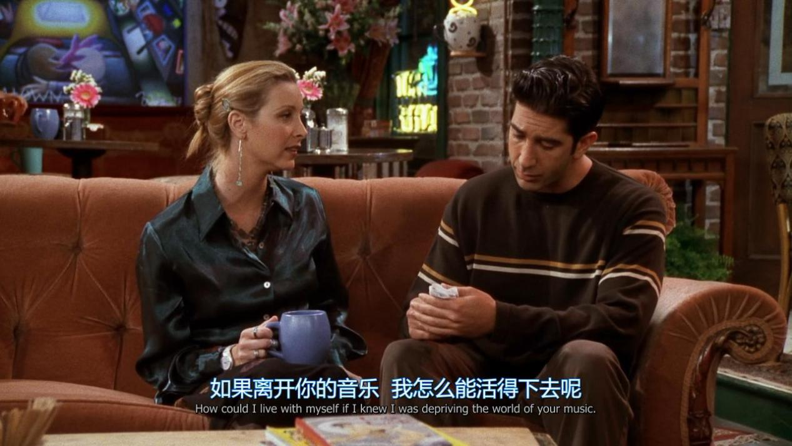

How could i live with myself if i knew i was depriving the world of your music

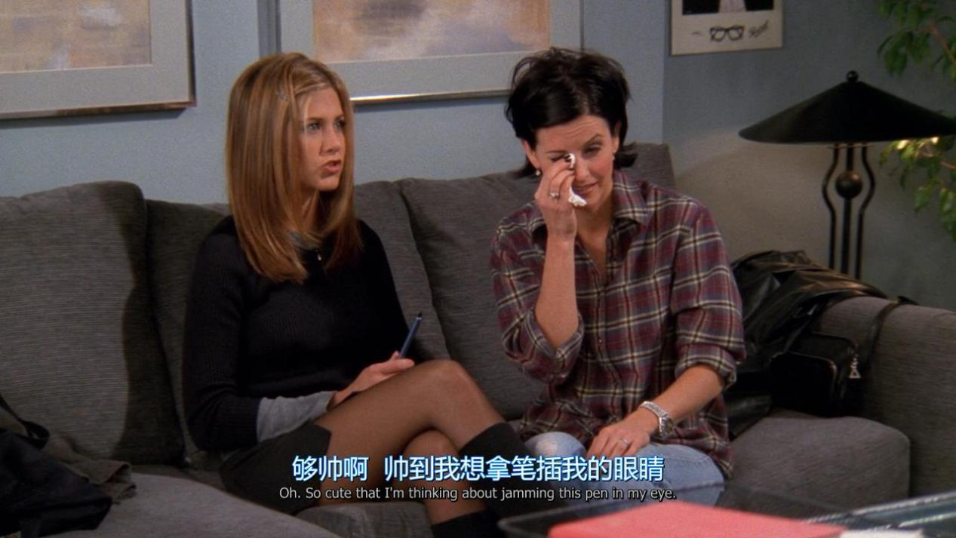

Oh,so cute that i am thinking about jamming this pen in my eye

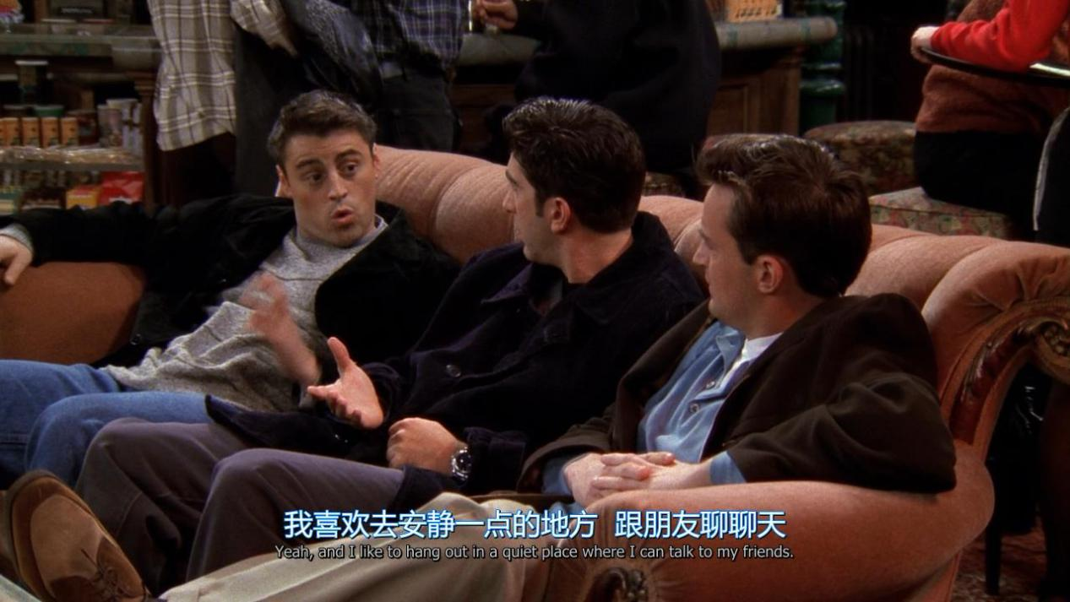

**I like to hang out in a quiet place where i can talk to my friends.**

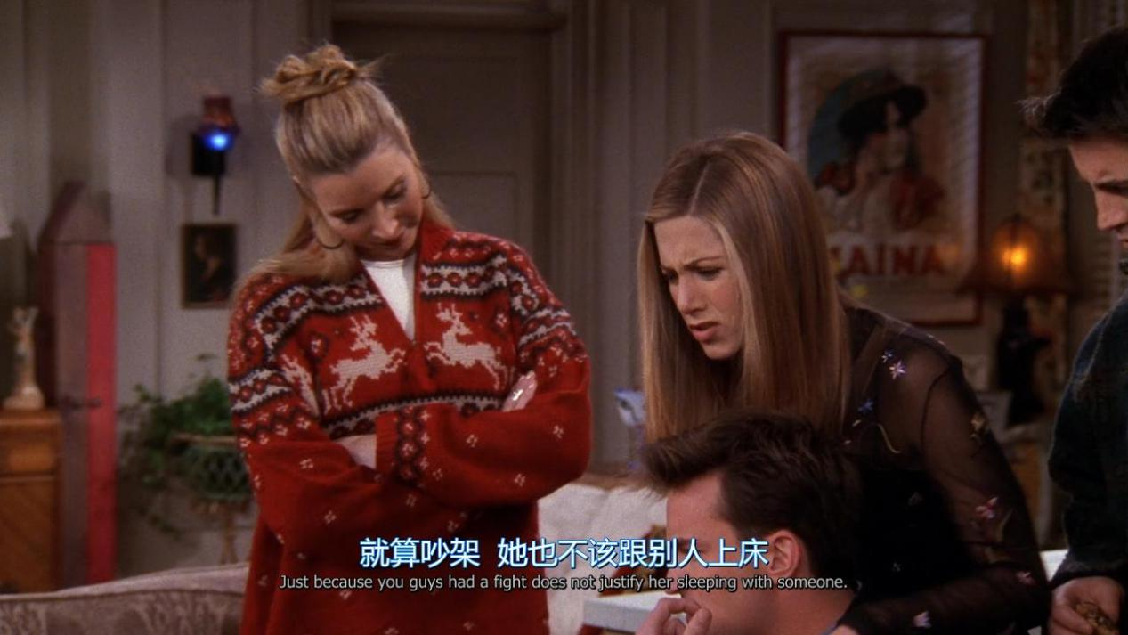

**Just because you guys had a fight does not justify her sleeping with someone**

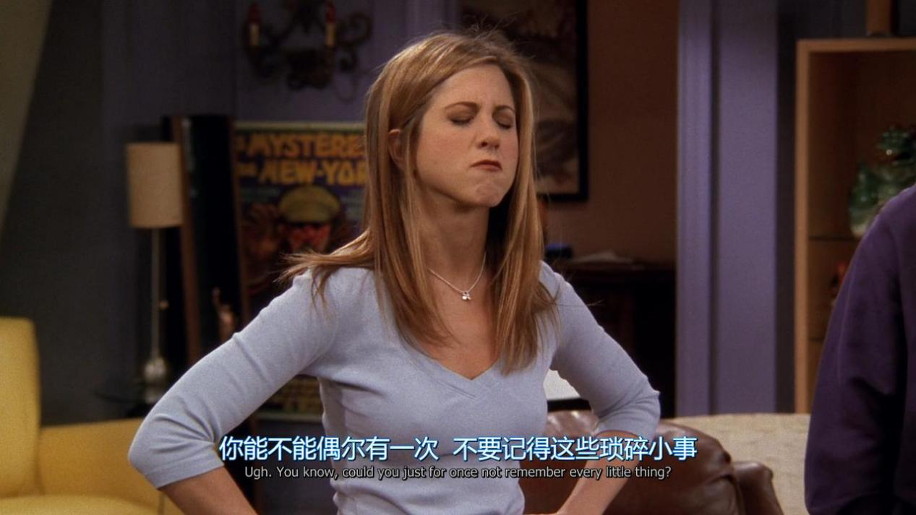

**Could you just for once not remember every litter thing?**

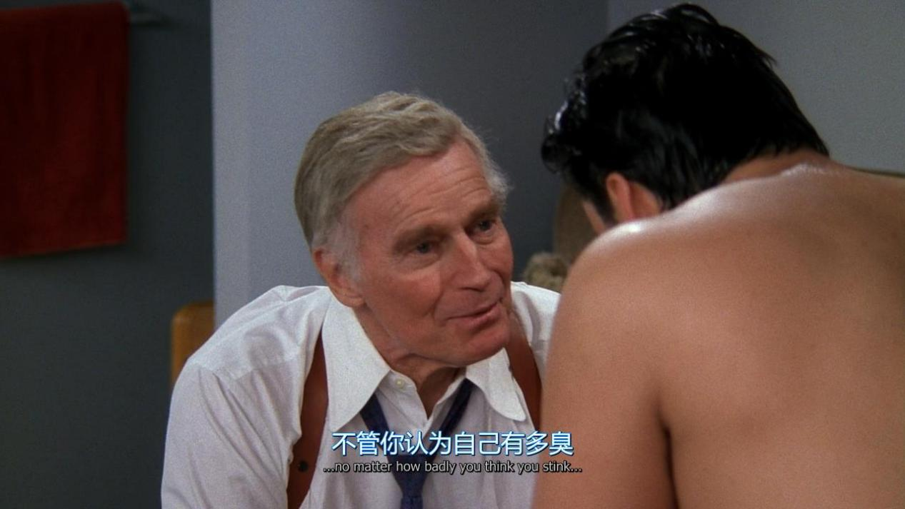

**No matter how badly you think you stink**

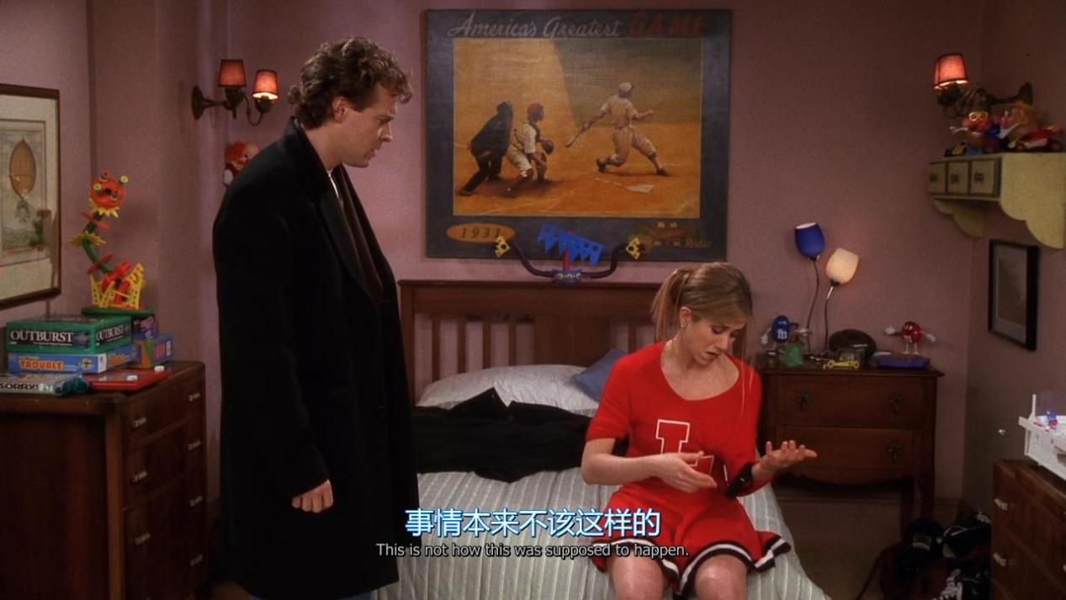

**This is not how this was supposed to happen**

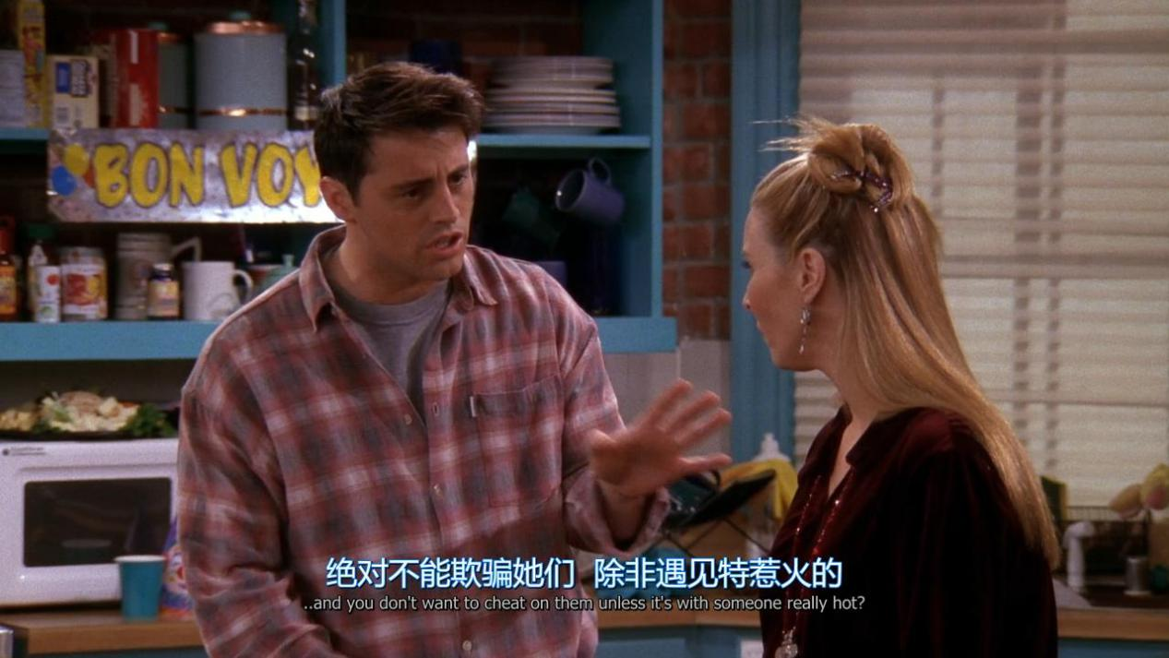

**You don’t want to cheat on them unless it’s with someone really hot ?**

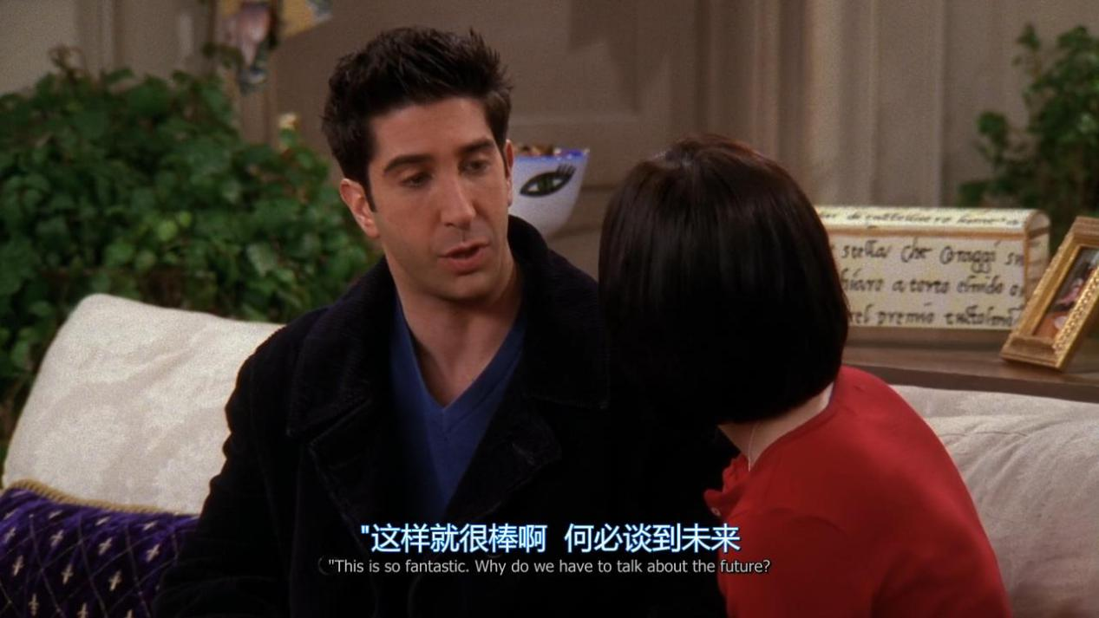

**Why do we have to talk about the future ?**

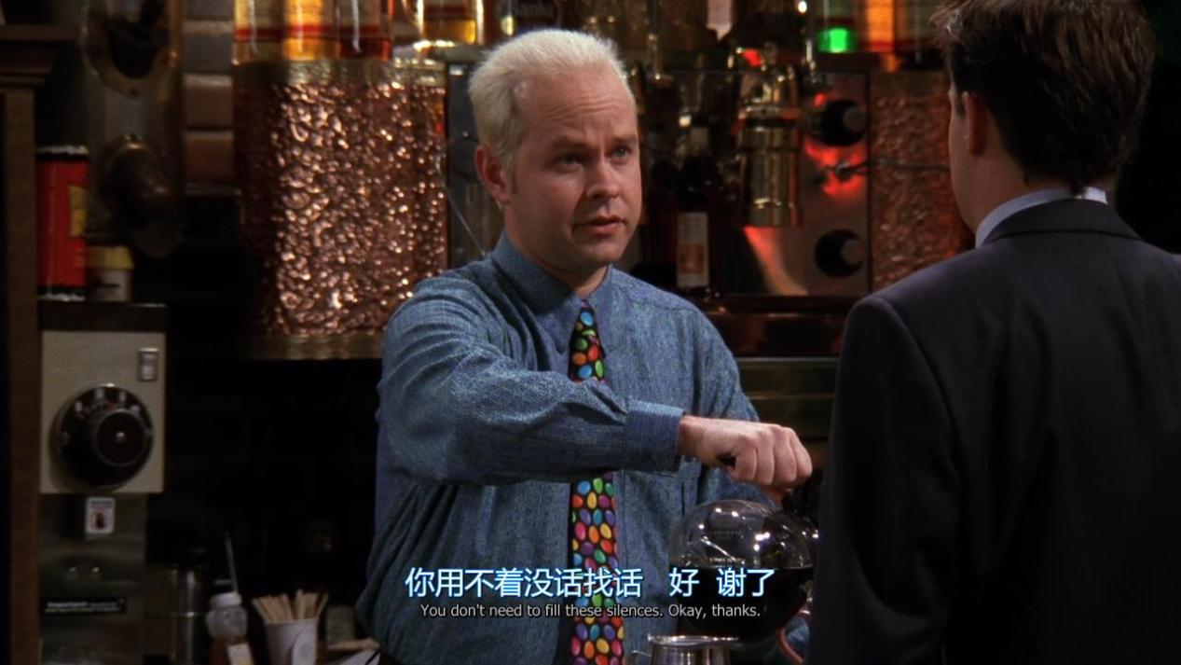

**You don’t need to fill these silences.**

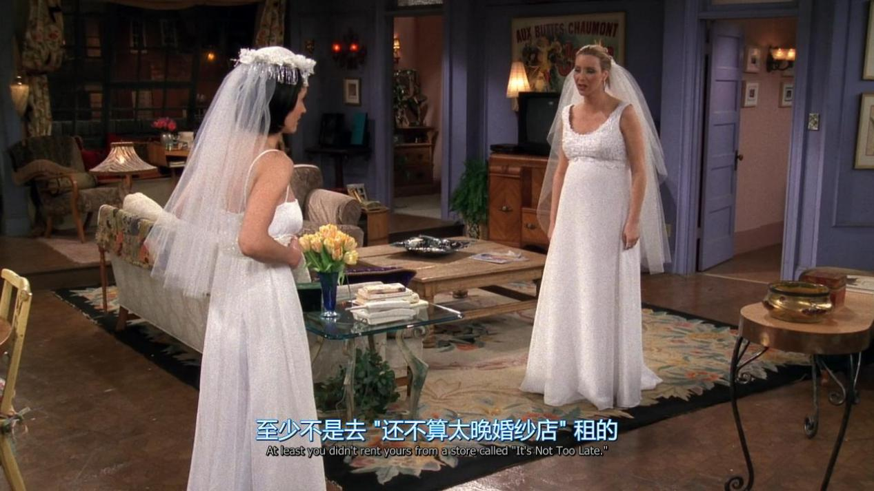

**At least you didn’t rent yours from a store called”it’s Not Too Late”.**

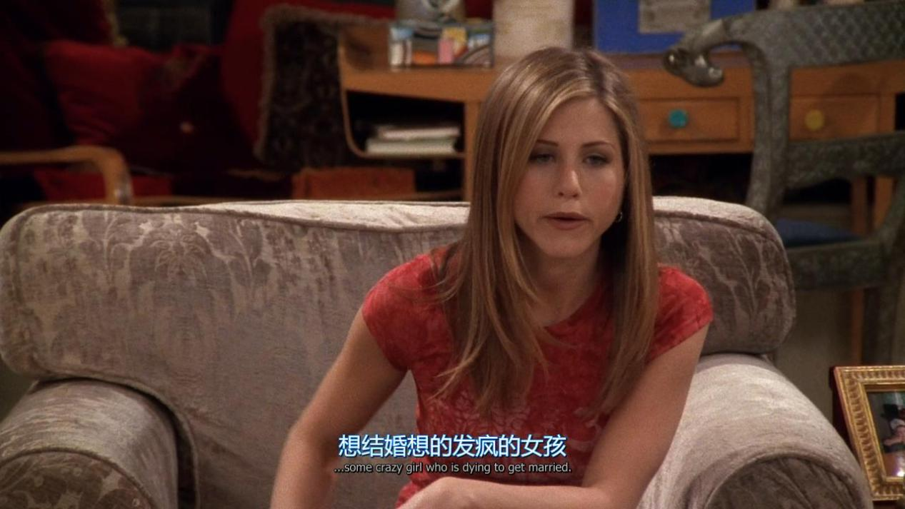

**Some crazy girl who is dying to get married**

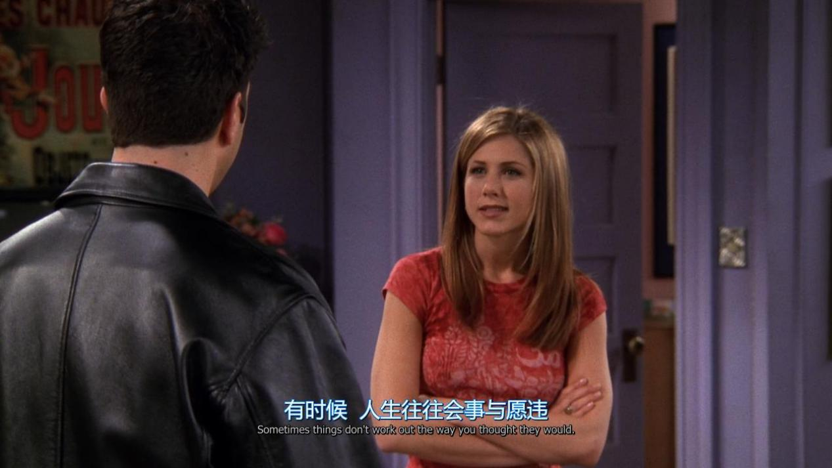

**Sometimes thing don’t work out the way you thought they would**

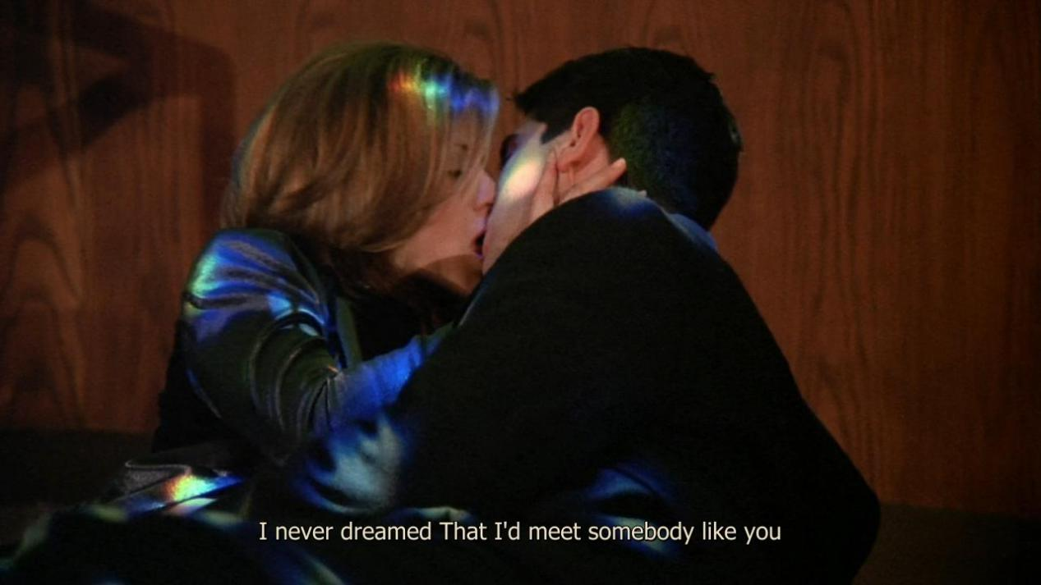

**I never dreamed that i’d meet somebody like you**

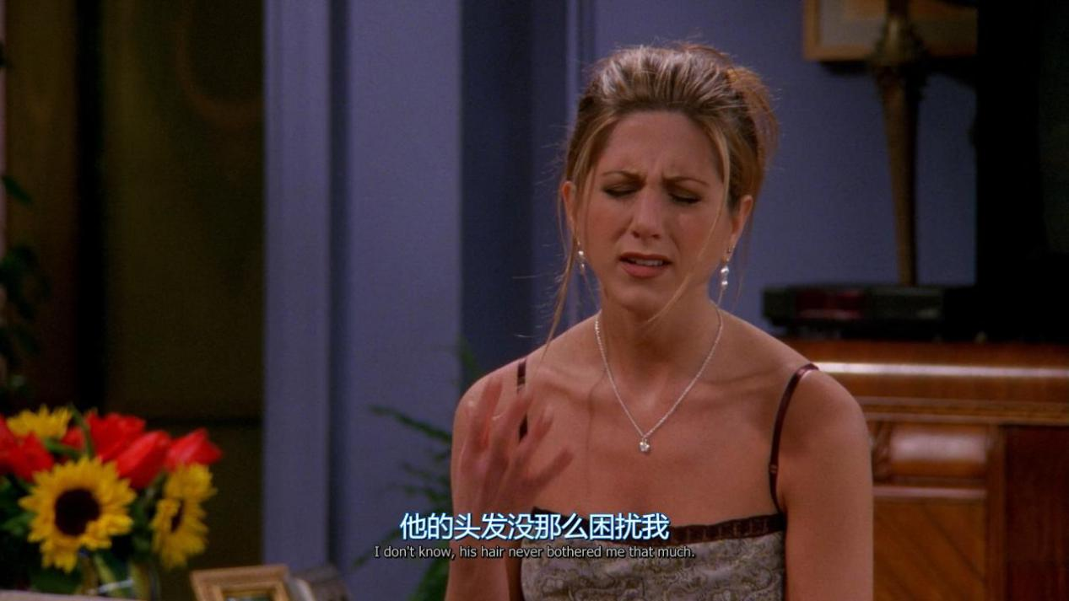

**His hair never bothered me that much**

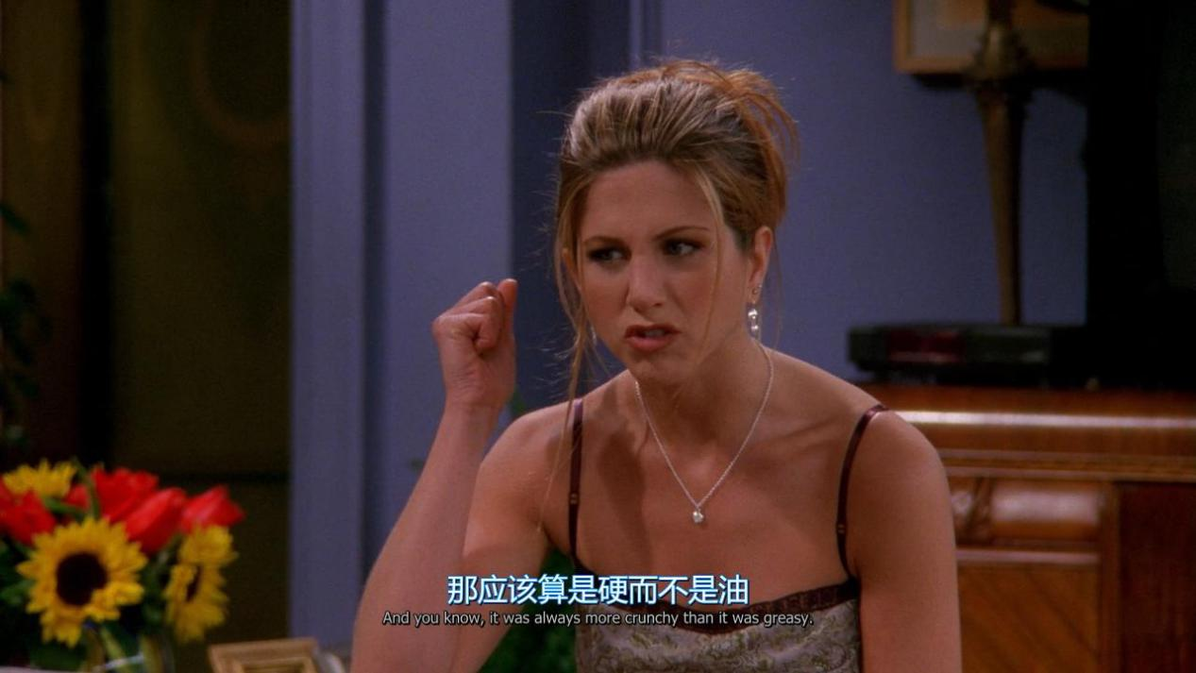

**It was always more crunchy than it was greasy**

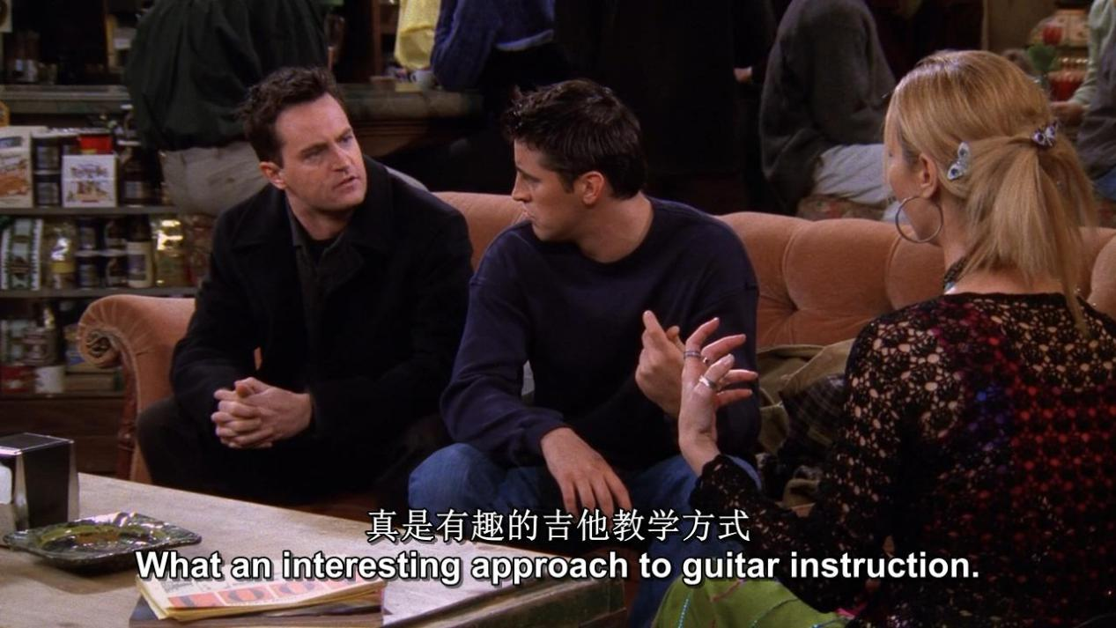

**What an interesting approach to guitar instruction**

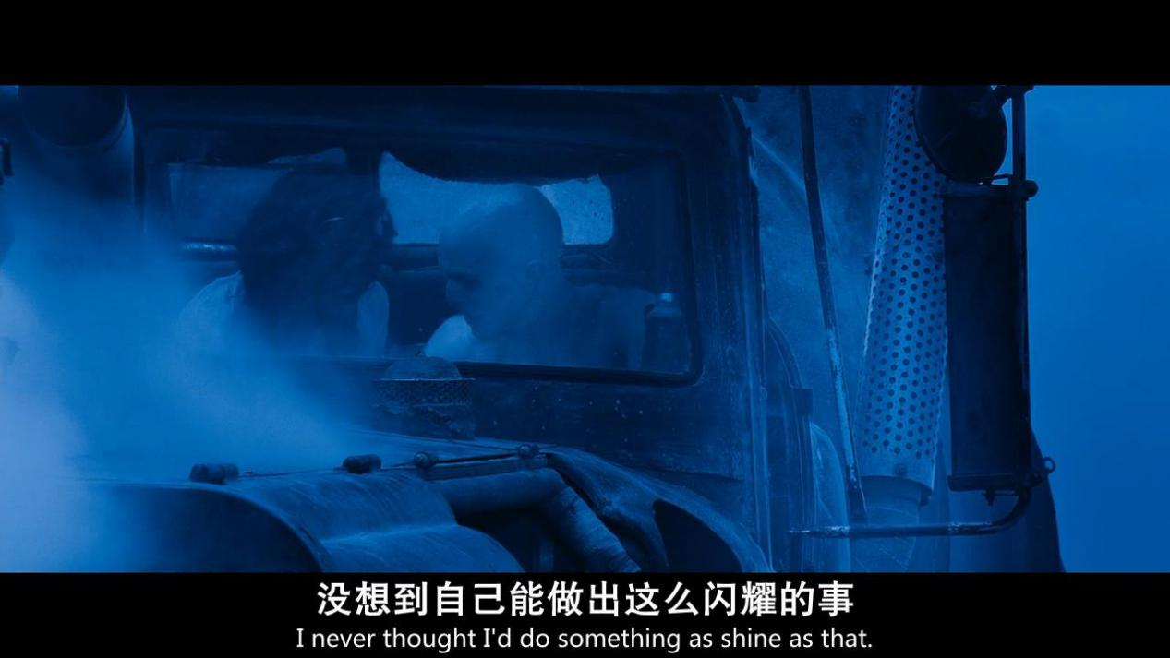

**I never thought i’d do something as shine as that**

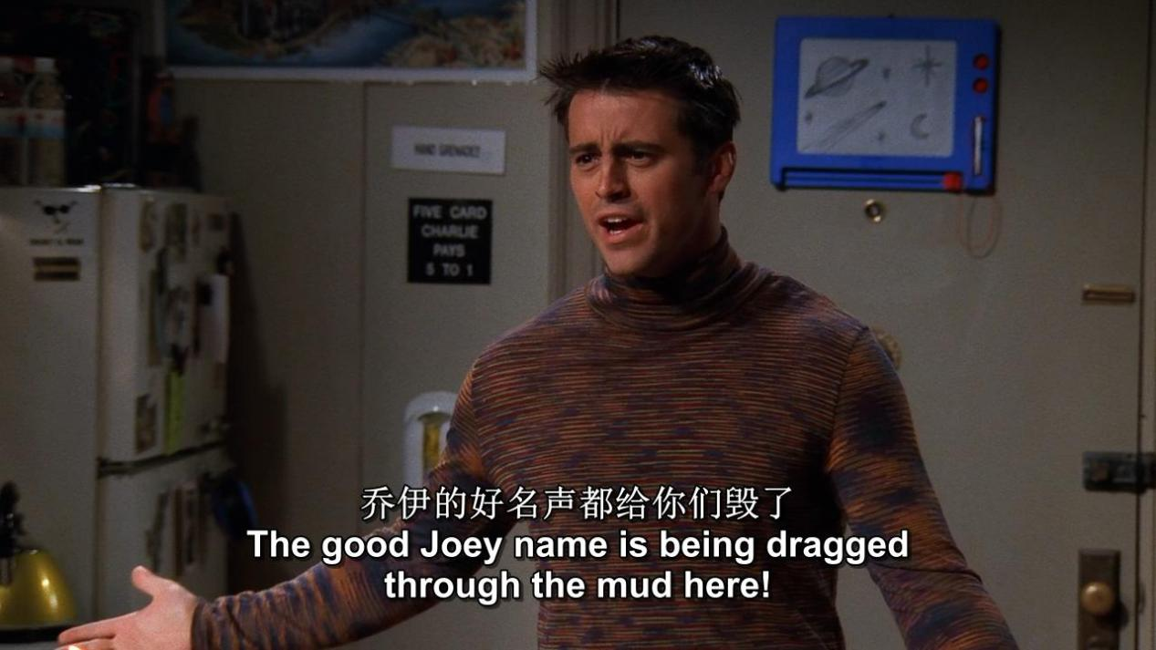

**The good Joey name is being dragged through the mud here**

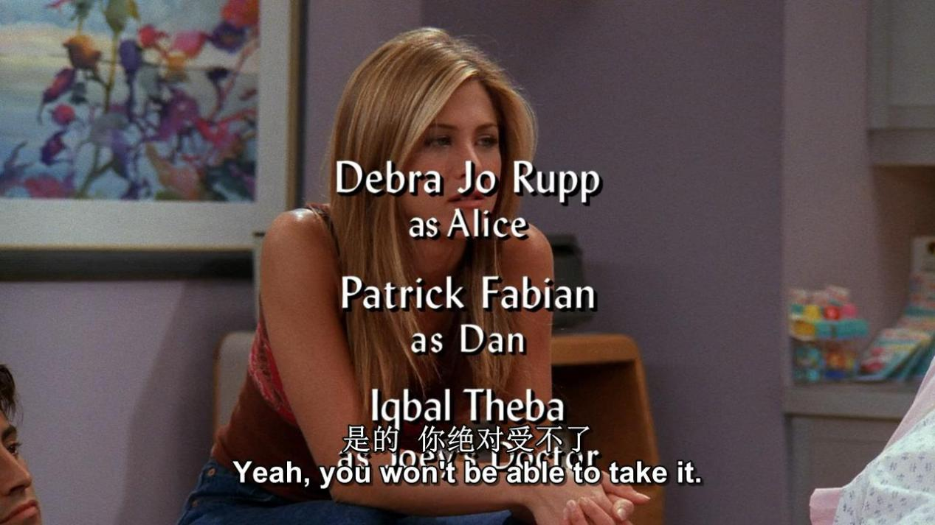

**You won’t be able to take it**

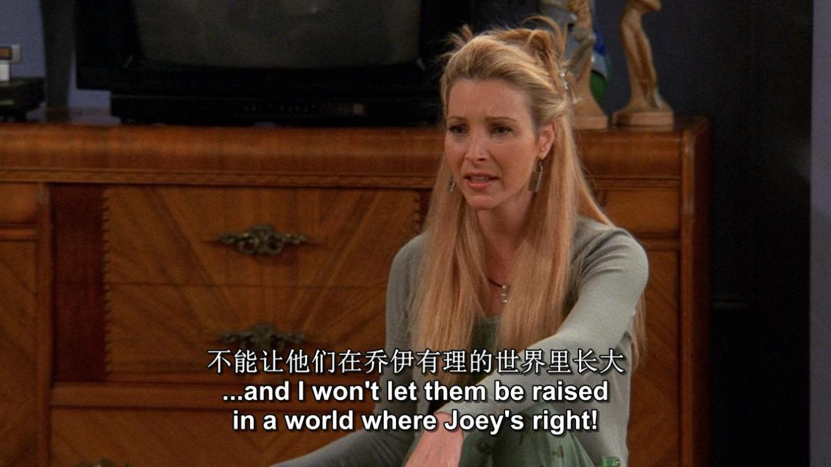

**I won’t let them be raised in a world where Joey’s right!**

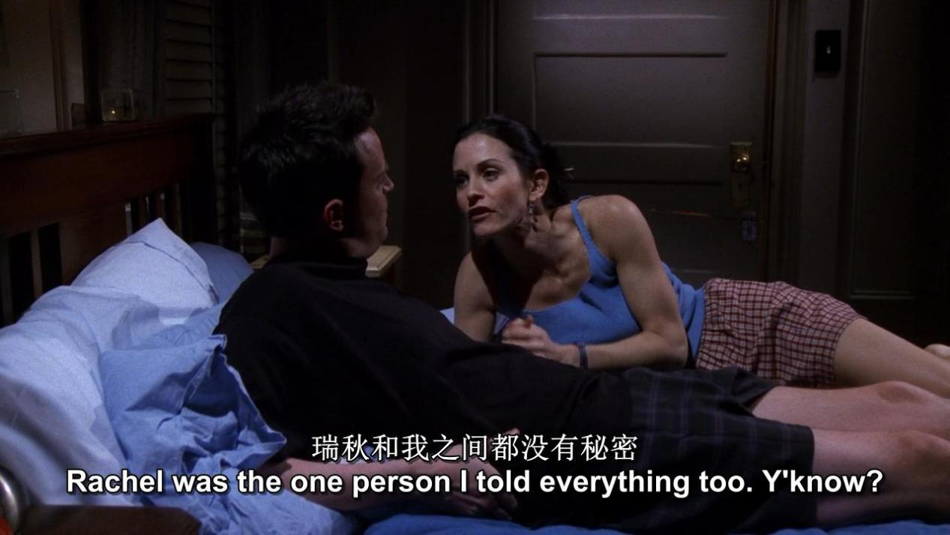

**Rachel was the one person i told everything too.**

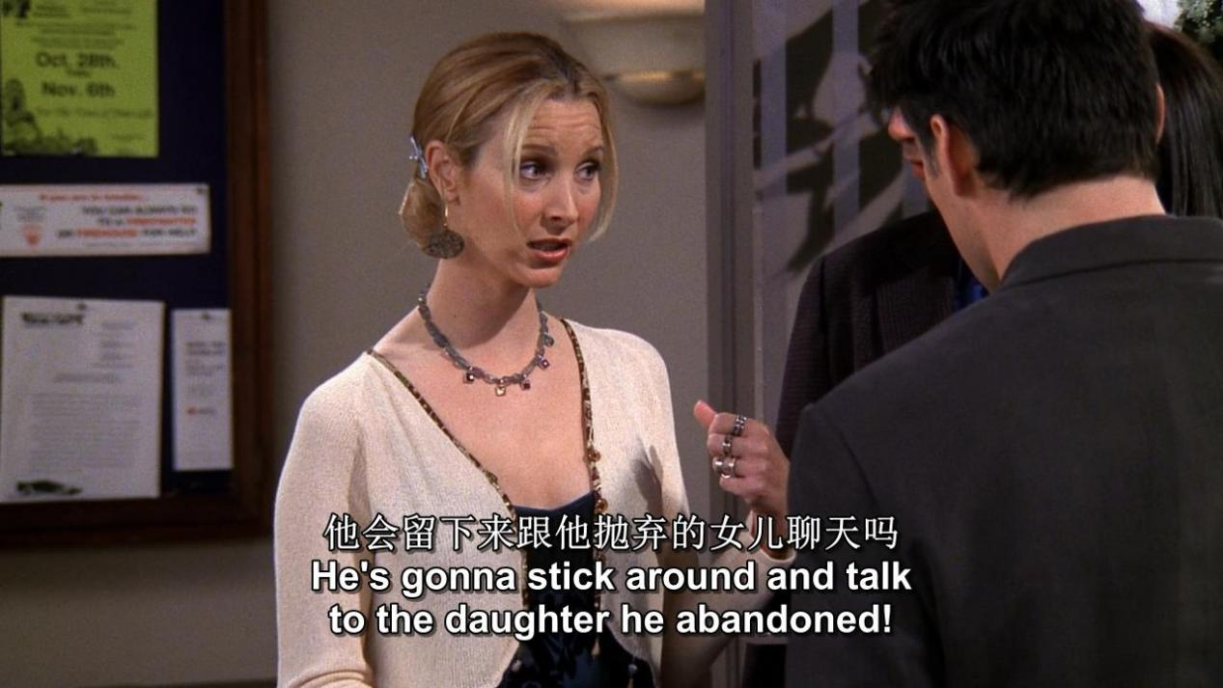

**He is gonna stick around and talk to the daughter he abandoned**

**什么是否定转移?** *主句是I ／We think ／suppose ／guess ／believe等,从句中的否定习惯上要转移到主句中,这就叫作否定转移.例如：我认为鸡不会游泳.  
误：I think chickens can not swim．  
正：I don't think chickens can swim．*

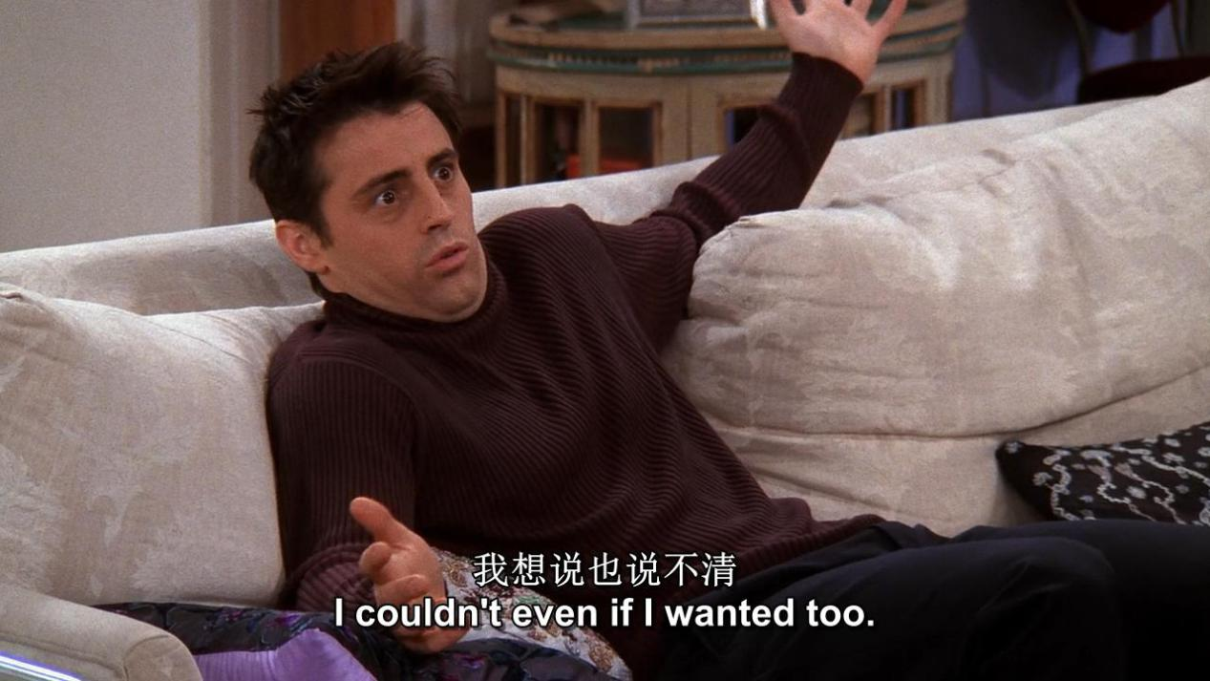

I couldn’t even if i wanted too

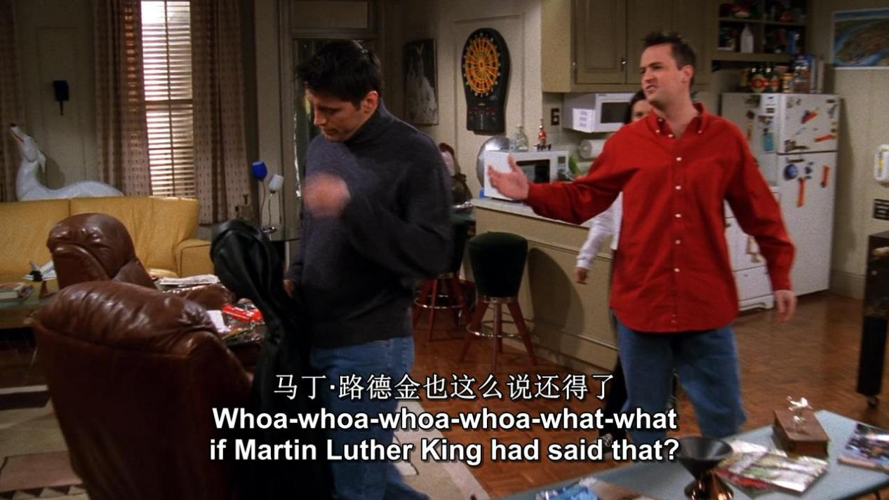

*What* if Martin Luther King had said that ?

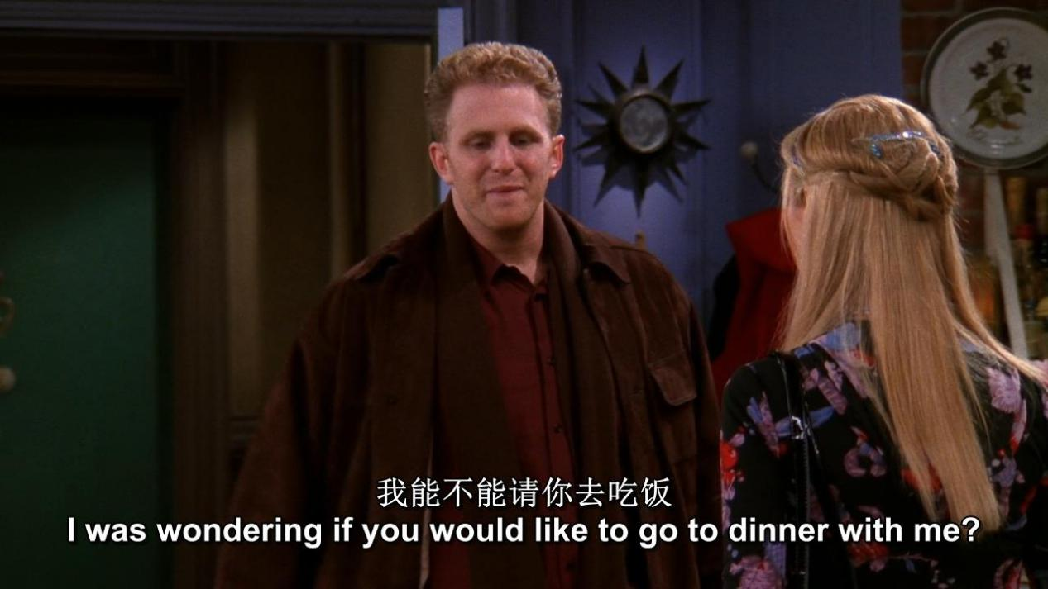

I was wondering if you would like to go to dinner with me ?

XX has no activity during this period.

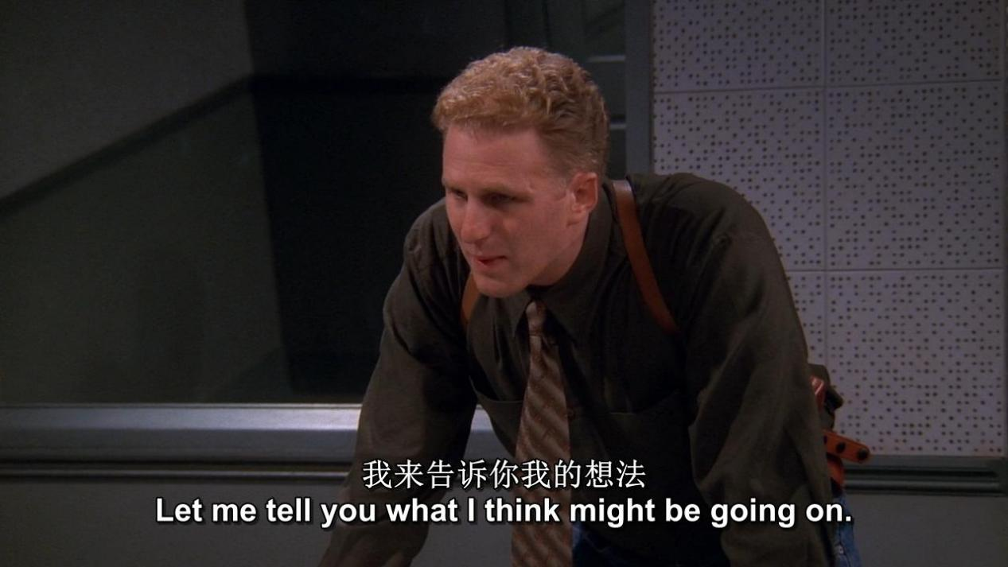

*Let me tell you what i think might be going on*

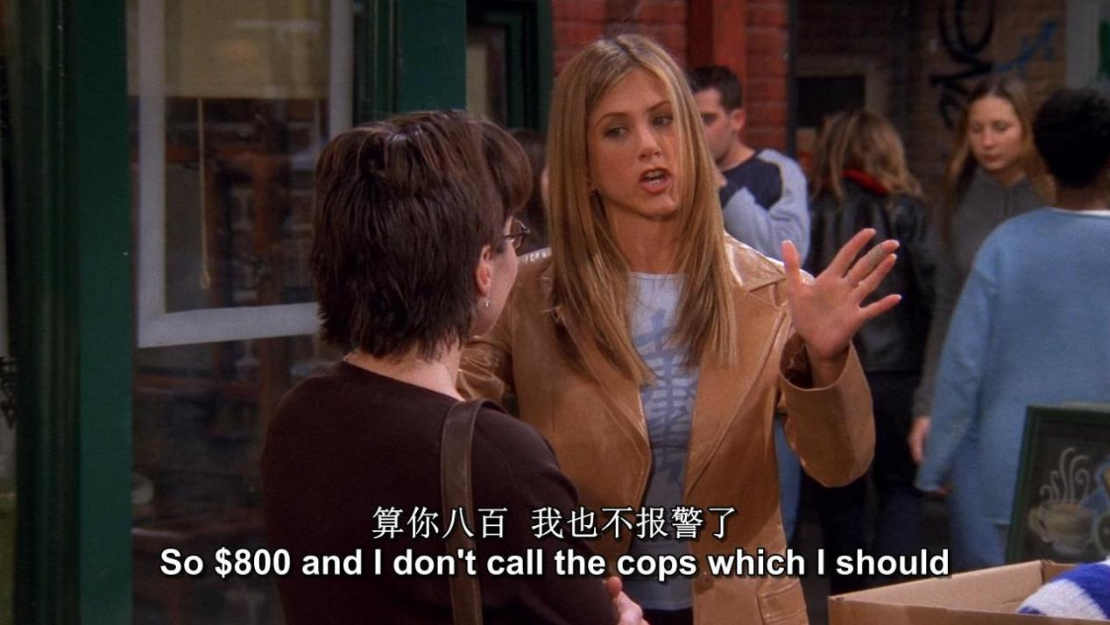

*So $800 and i don’t call the cops which i should,because you are robbing me*

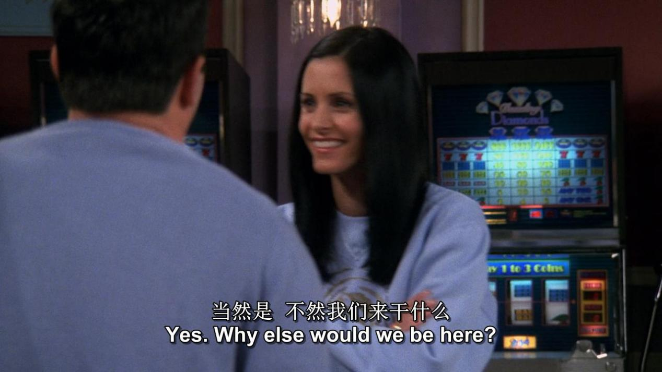

*Yes .why else would we be there ?*

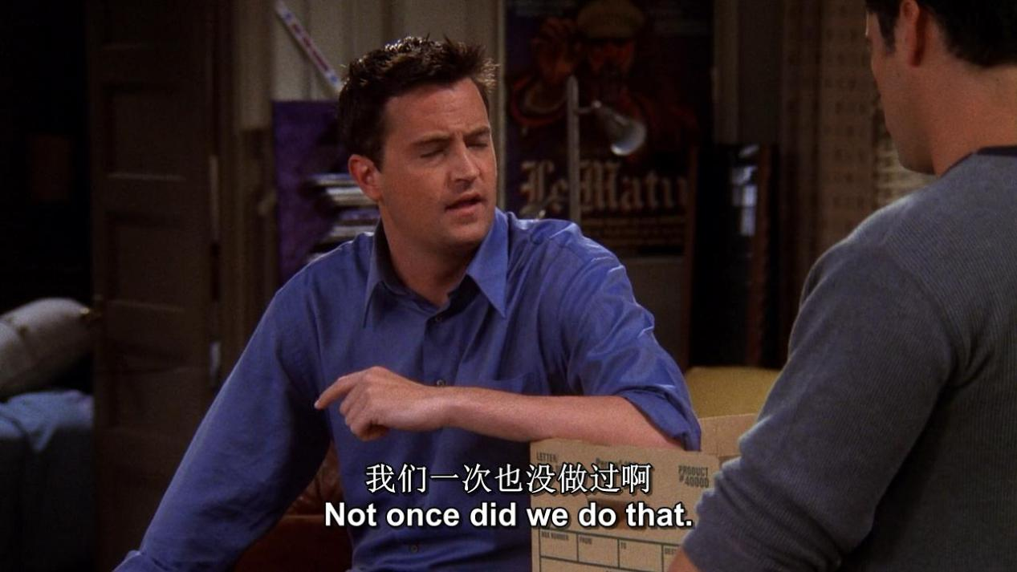

*Not once did we do that.*

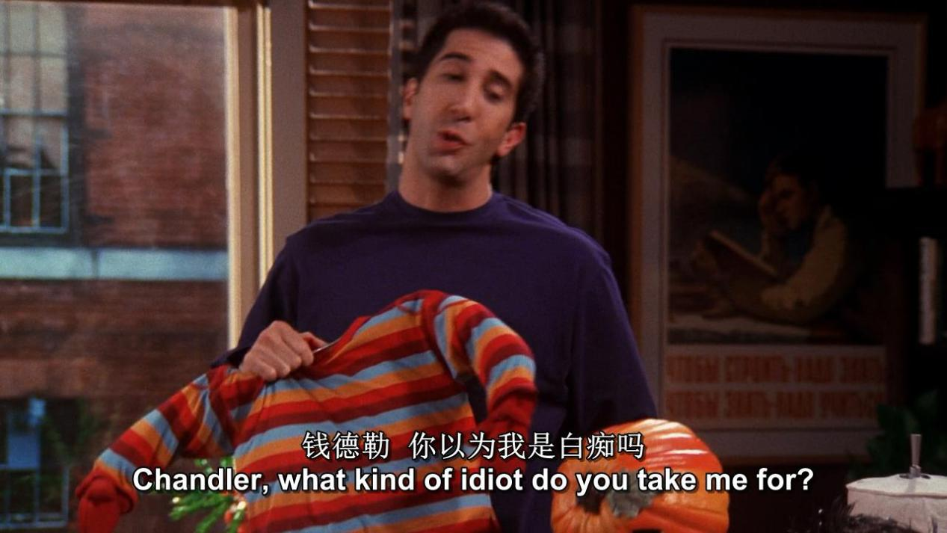

*Chandler , what kind of idiot do you take me for*

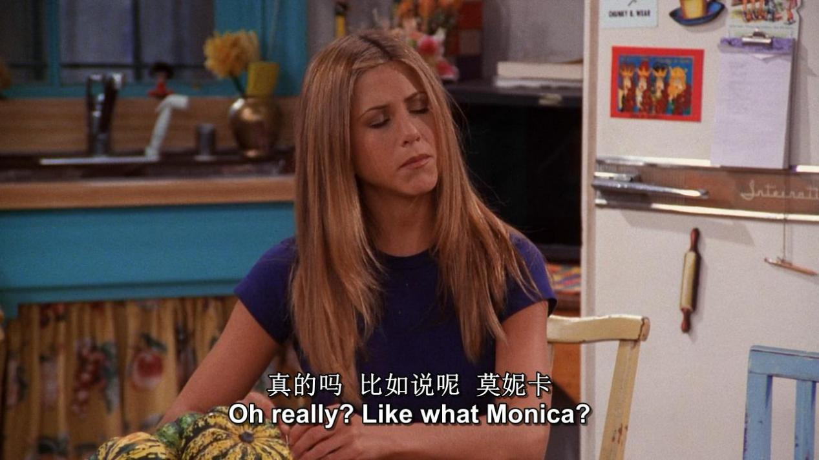

*Oh really ? Like what ?*

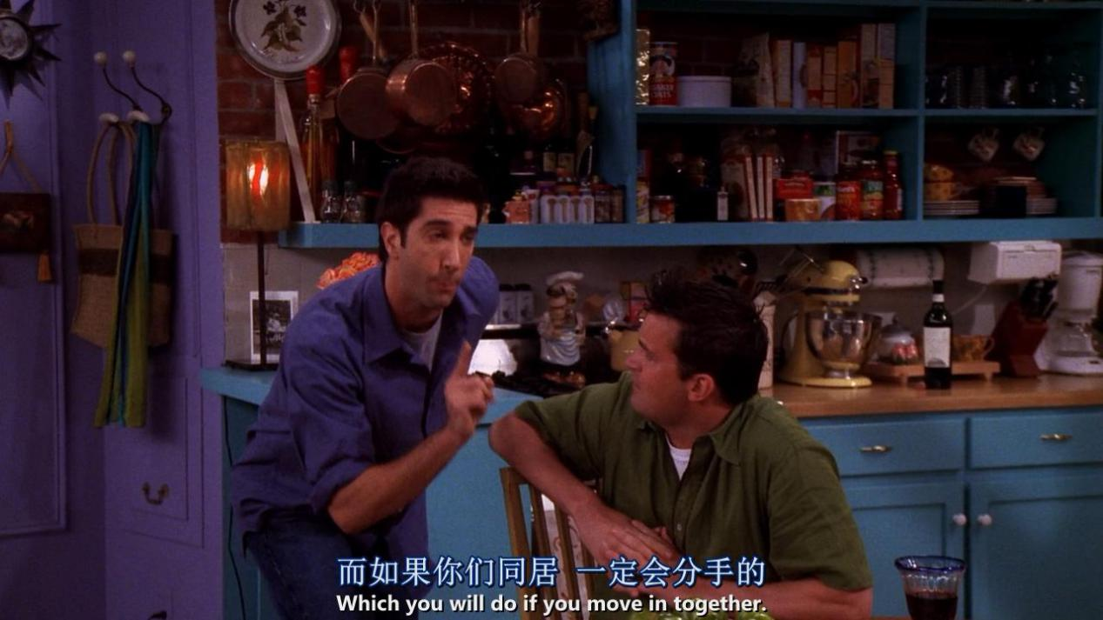

*Which you will do if you move in together*

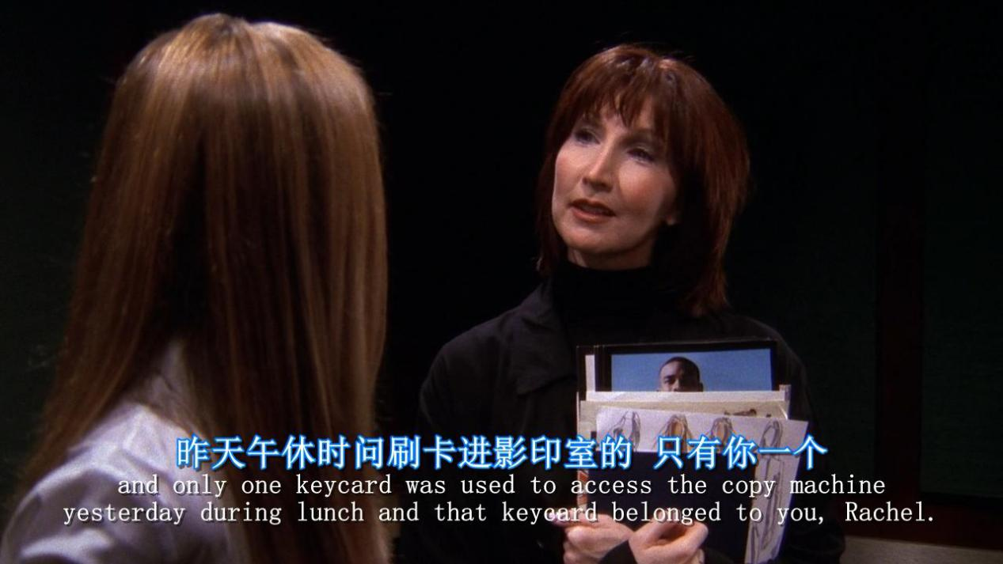

*Only one keycard was used to access the copy machine yesterday*

*During lunch and that keycard belonged to you*

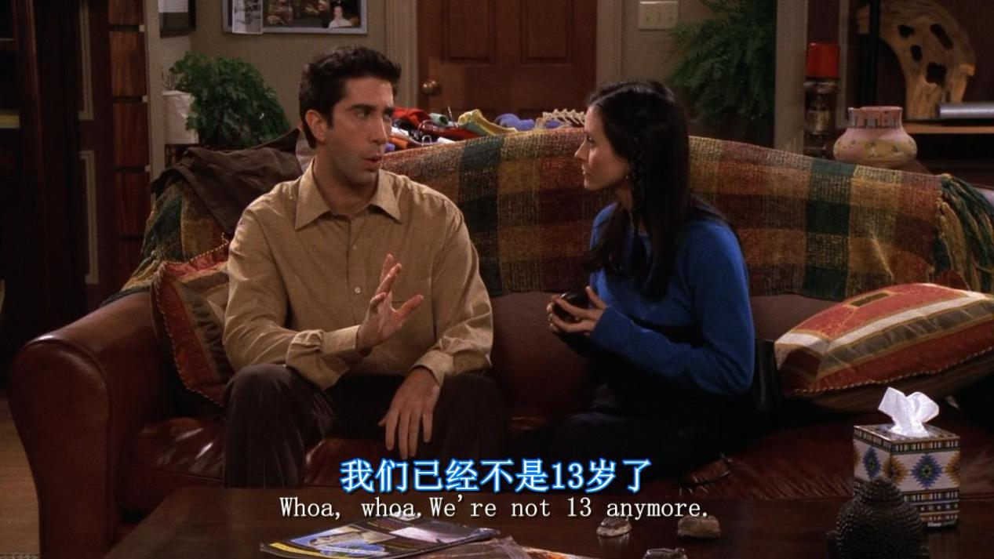

*We are not 13 anymore*

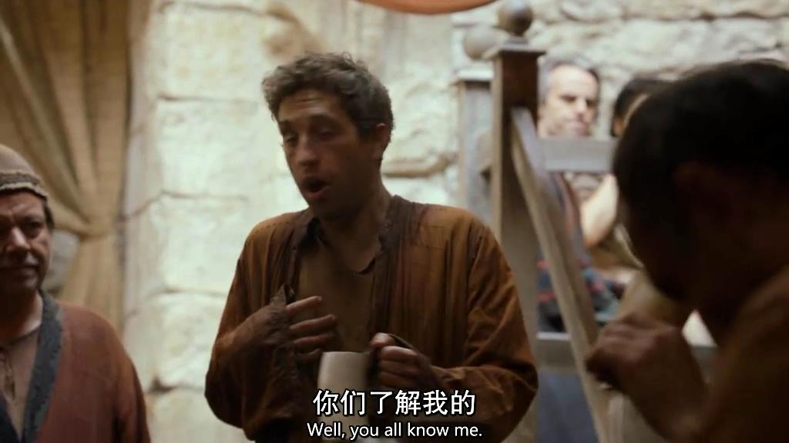

*Well,you all know me*

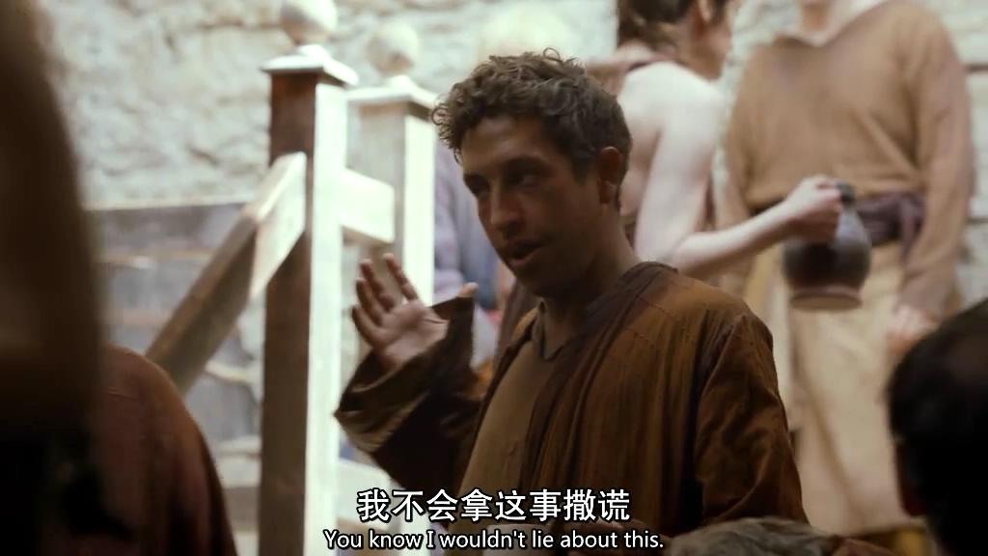

*Well,you all know me.You know i wouldn’t lie about this*